

**Balance of Payments**

**and**

**Terms of Trade**

**BOP / TOT RESOURCE**

**The Balance of Payments**

The Balance of Payments is an accounting document which records all financial transactions made between consumers, businesses and the government in one country with others.

Normally, I would get my students to think of the Balance of Payments as an Excel spreadsheet with 3 ‘sheets’ (bottom left-hand side of the application). These represent the 3 different accounts on the spreadsheet.

The fact that there are 3 separate account is not terribly interesting suffice to say that it is simply a way of categorising the different money flows (and it is on the Specification). Students should be encouraged to find definitions for the different components of each account on the Balance of Payments. Free notes on websites such as Tutor2u, Economicsonline and PMT (Physics and Maths Tutor) will be satisfactory.

*The spreadsheet is populated every time money enters or exits the country.*

As a result, the first thing I get my students to do is to roleplay being an accountant and fill in a spreadsheet.

**Stage 1. Look at spreadsheet and understand all of terms**

|  |  |  |  |
| --- | --- | --- | --- |
|  | **Debit** | **Credit** | **Net** |
| Current Account | | | |
| Exports |  |  |  |
| Imports |  |  |  |
| Trade Balance  _ |  |  |  |
| Net Investment Income |  |  |  |
| Net Current Transfers |  |  |  |
| Current Account Balance |  |  |  |
| Financial Account | | | |
| Net Direct Investment |  |  |  |
| Net Portfolio Investment |  |  |  |
| Net Asset Reserves |  |  |  |
| Financial Account Balance |  |  |  |
| Capital Account | | | |
| Net Capital Account flows |  |  |  |
|  |  |  |  |
| Statistical Discrepancy |  |  |  |
|  |  |  |  |
| Balance of Payments |  |  |  |

**Common mistakes**

1.. Students often confuse the Balance of Payments with the Trade Balance or the Current Account.

* The Trade Balance is the sum of Exports – Imports. It is one component of the Current Account.
* The Current Account is like 1 sheet on the Excel spreadsheet. It has 3 constituent parts: the trade balance, net investment income (primary account), net transfers (secondary account).
* The Balance of Payments is like the Excel spreadsheet. It has 3 constituent parts: the current account, the capital account and the financial account.

2. Debits and Credits are considered from the point of view of the country being recorded. If money enters the economy (credit). If money exits the country (debit). Always follow the money. Don’t get distracted by what is buying bought/sold. The balance of payments simply records money flows.

**Stage 2. A simple example**

A simple example showing the entire process of a transaction between countries.

* I am a UK resident.
* I want to buy a Japanese-made product (for example, a Panasonic Hair Dryer). It costs 6500 Yen in Japan.
* Somebody is willing to sell me 6500 Yen for £50 on the FOREX.
* I sell my £50 in exchange for 6500 Yen.
* I buy the Panasonic Hair Dryer from Japan.

This is a DEBIT to the UK’s Balance of Payments of £50. It is recorded in the Current Account because it is considered an IMPORT.

This is a powerful example but also one which will lead to a lot of questions from students.

*Q. Panasonic is an MNC and so doesn’t it just list its products with UK price tags (£) on websites such as Amazon or Argos.*

A. Yes, but the UK (£) price on Amazon is determined by the cost of production in Japan and the exchange rate. Moreover, the Japanese shareholders are likely to want their dividends to be paid in Yen and so the more important point is that whilst the consumer might pay in £, the shareholder in Japan receives Yen. Somebody, at some point in the process, exchanged £ for Yen.

*Q. Isn’t a big assumption that somebody will always sell you Yen for £ ?*

A. This is the market system at work: supply and demand. In the case of Japan and the UK, it is highly likely that there will be a Japanese buyer of £ but (depending on demand and supply forces) they may demand different £ values. This is simply the exchange rate changing. That said, it might be the case that no-one is willing to buy your £ - and so you will not be able to buy the Hair Dryer. This sometimes occurs with some developing countries, where no-one is prepared to accept payment in that currency and may demand a different currency instead.

*Q. Does each and every transaction balance?*

A. No. Individual transactions do not balance. This is the big difference between the Balance of Payments and say a Balance Sheet in Business. Each individual transaction can be in credit or a debit. Remember though that to sell your £, somebody had to buy them. They must have wanted them for some purpose (if only to hold as a cash asset). The total transactions will equal to zero because money must return to the country of origin in order to have any value.

**Stage 3. A little more.**

From the point of view of the UK’s Balance of Payments, which account would the following transactions be entered in? And identify if it is a credit or Debit.

1. The sale of £200m worth of German cars to the UK.
2. Japanese tourists spending £90m in London.
3. Polish immigrant worker sending money back to family in Poland.
4. UK tech firm sells IP to tech firm in China.
5. The purchase of shares (worth £500,000) by a UK citizen in an American IT firm.

**Answers**

1. Current Account (imports). Debit.
2. Current Account (exports). Credit.
3. Current Account (transfers). Debit
4. Capital Account. Credit.
5. Financial Account (Portfolio) – Debit.

**Stage 4. More complex**

There are only two countries in the world: Georgistan and Ruthania.

For each of the transactions below, record both the Debit and Credit for Georgistan. You must also decide if the transaction belongs in the Current Account, Financial Account or Capital Account.

* Georgistan buys oil from Ruthania for $50m.
* Ruthania buys agricultural goods from Georgistan for $5m.
* Ruthanian immigrants send $10m back to Georgistani relatives
* The Georgistani Government sells $75m in bonds to Ruthania.
* Ruthanian investors receive £5m in interest from Georgistani bonds.
* Ruthanian entrepreneurs build new factories in Georgistan worth $20m
* Georgistani firms pay $20m dividends to Ruthanian stockholders.
* Ruthania gives Georgistan £5m in foreign aid
* Geogistani investors buy $40m shares in Ruthanian firms.

**Balance of Payments for Georgistan:**

|  |  |  |  |
| --- | --- | --- | --- |
|  | **Debit** | **Credit** | **Net** |
| Current Account | | | |
| Exports |  |  |  |
| Imports |  |  |  |
| Trade Balance  _ |  |  |  |
| Net Investment Income |  |  |  |
| Net Current Transfers |  |  |  |
| Current Account Balance |  |  |  |
| Financial Account | | | |
| Net Direct Investment |  |  |  |
| Net Portfolio Investment |  |  |  |
| Net Asset Reserves |  |  |  |
| Financial Account BlanceBalance |  |  |  |
| Capital Account | | | |
| Net Capital Account flows |  |  |  |
|  |  |  |  |
| Statistical Discrepancy |  |  |  |
|  |  |  |  |
| Balance of Payments |  |  |  |

**Answers**

|  |  |  |  |
| --- | --- | --- | --- |
|  | **Debit** | **Credit** | **Net** |
| Current Account | | | |
| Exports |  | 5 |  |
| Imports | 50 |  |  |
| Trade Balance  _ |  |  |  |
| Net Investment Income | 5+20 |  |  |
| Net Current Transfers |  | 10+5 |  |
| Current Account Balance |  |  | -55 |
| Financial Account | | | |
| Net Direct Investment |  | 20 |  |
| Net Portfolio Investment | 40 | 75 |  |
| Net Asset Reserves |  |  |  |
| Financial Account Balance |  |  | +55 |
| Capital Account | | | |
| Net Capital Account flows |  |  | 0 |
|  |  |  |  |
| Statistical Discrepancy |  |  | 0 |
|  |  |  |  |
| Balance of Payments |  |  | 0 |

**Stage 5. Real-life.**

**Turkey’s Current Account** Source:<https://www.ft.com/content/73efa654-a3d1-11e9-974c-ad1c6ab5efd1>

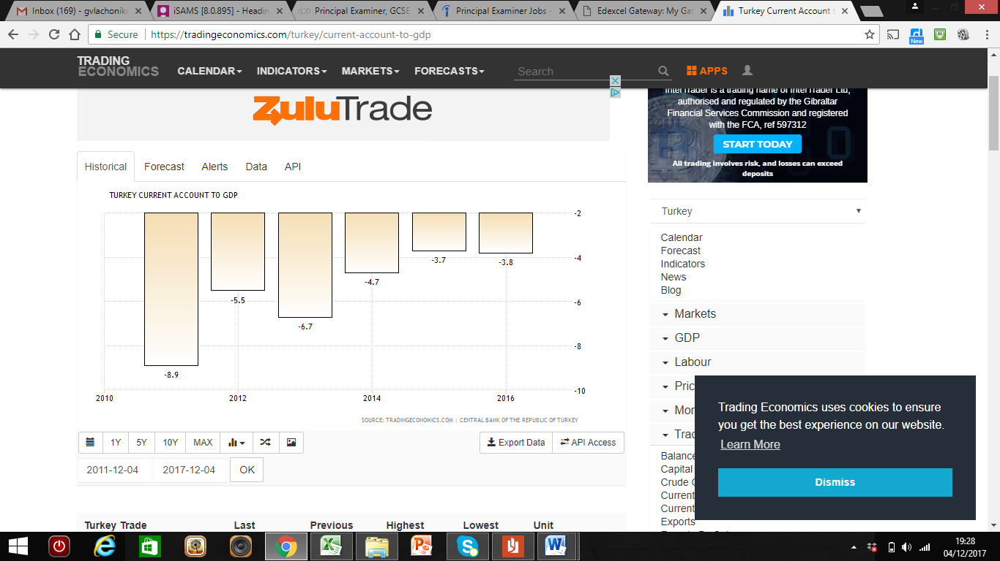

Turkey's annual current account deficit shrunk to $3.7 billion in June 2016, a fall of $1.2 billion year-on-year, the Central Bank said Friday. Considering June's deficit data, the 12-month rolling deficit stands at $34.3 billion, the bank said.

The import-export balance of goods was reduced by $670 million in Turkey's favor to $4.57 billion while the country's credits from services rose by $491 million to $1.68 billion.

The Governor of the Turkish Central Bank, however, warned the public to be cautious. "The recovery in the current account deficit in June is backed by lower foreign trade deficit for now. But I think the current account deficit will reach $38 billion at the end of this year, due to increasing energy/gold imports and momentum in the economic growth," he added. Turkey's economy grew by 5 percent in the first quarter of 2017 compared with the same period last year.

The Financial Account surplus has, however, been limited by the fact that “the Turkish Central Bank has been buying foreign exchange in size in past two months, building foreign exchange reserves and capping appreciation," he said.

"So, the Central Bank is managing the U.S. dollar/Turkish lira exchange rate around the 3.5 level."

**Turkey’s Balance of Payments: What is happening and why?**

**Terms of Trade**

**The terms of trade r**efer to the relative price of imports in **terms**of exports and is defined as the ratio of export prices to import prices. It can be interpreted as the amount of import goods an economy can purchase per unit of export goods.

The formula is given as:

**(Export Price Index) / (Import Price Index) x 100**

The Price Indices are measured from a weighted basket of goods (much like a price index that measures inflation).  They represent the most popular/most important exports and imports for that country.

All countries should aim to produce high value exports and import low value imports. If they do so, they will be able to import more goods and services for each export sold abroad. This is particularly important for developing countries because they use export revenues to finance their purchase of imported manufactured goods.

If export prices increase and import prices decrease (as is the aim), then the terms of trade will increase. The numerator increases and the denominator decreases, so the sum increases. This is known as an improvement in the terms of trade. And, this would generally be a sign of success.

There are many things that can affect the price of exports relative to imports in the short-run. Therefore, we cannot read too much into short-term changes in the terms of trade. For example: exchange rates fluctuations, changes in commodity prices, short-run demand and supply factors may all affect export and import prices in the short-term and give a false impression of the terms of trade. In the long-run, however, we should pay more attention to the trend line; are the terms of trade improving or deteriorating. Long-run changes to technology and productivity factors may decrease the value of certain goods and services over time and lead to more permanent changes in the terms of trade.

**Stage 1. Do the Maths**

1. The table below shows an index for import prices and export prices over a 3 year period.

(a) Fill in the fourth row – entitled “terms of trade”.

|  |  |  |  |  |
| --- | --- | --- | --- | --- |
| Year | **2016** | **2017** | **2018** | **2019** |
| Export price index | 100 | 102 | 104 | 102 |
| Import price index | 100 | 98 | 96 | 95 |
| Terms of trade | **100** |  |  |  |

(b) State what has happened to the term of trade in each year.

(c) Suggest two reasons why the import price index may have changed over the last 3 years.

2.

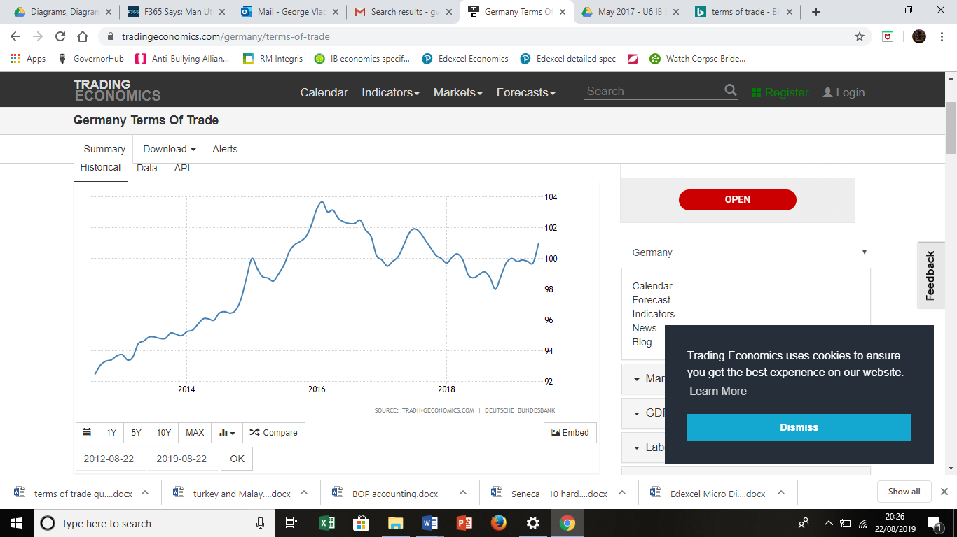

(a) Describe what has happened to Germany’s terms of trade since 2013.

(b) Suggest two reasons why Germany’s terms of trade may have changed since 2013.

3. The table below shows an index for import prices and export prices over a 3 year period.

(a) Fill in the blanks.

|  |  |  |  |  |
| --- | --- | --- | --- | --- |
| Year | **2016** | **2017** | **2018** | **2019** |
| **Export price index (base = 2000)** | 128 | 128 |  | 130 |
| **Import price index (base = 2000)** | 128 |  | 136.95 |  |
| **Terms of trade** |  | 98 | 92 | 94.925 |

(b) Which of the following statements is TRUE.

|  |  |  |
| --- | --- | --- |
| A | Imports prices fell throughout the period |  |
| B | Export prices increased throughout the period |  |
| C | The terms of trade deteriorated throughout the period |  |
| D | Terms of trade deteriorated by 6.1% 2017 to 2018 |  |
| E | Export prices decreased by 2% 2017 to 2018. |  |

**Stage 2. Link to Development Economics**

In Development Economics, the *Prebisch–Singer* hypothesis argues that the price of primary commodities declines relative to the price of manufactured goods over the long term, which causes the terms of trade of primary-product-based economies to deteriorate.

1. Using the terms of trade formula, explain why developing economies (suffering from Primary Product Dependency) are likely to see a deterioration in their terms of trade.

2. Explain why deteriorating terms of trade is undesirable for any economy.

**Stage 3. Real Life.**

**Australia’s terms of trade** [**Source: www.afr.com/news**](Source:%20www.afr.com/news)

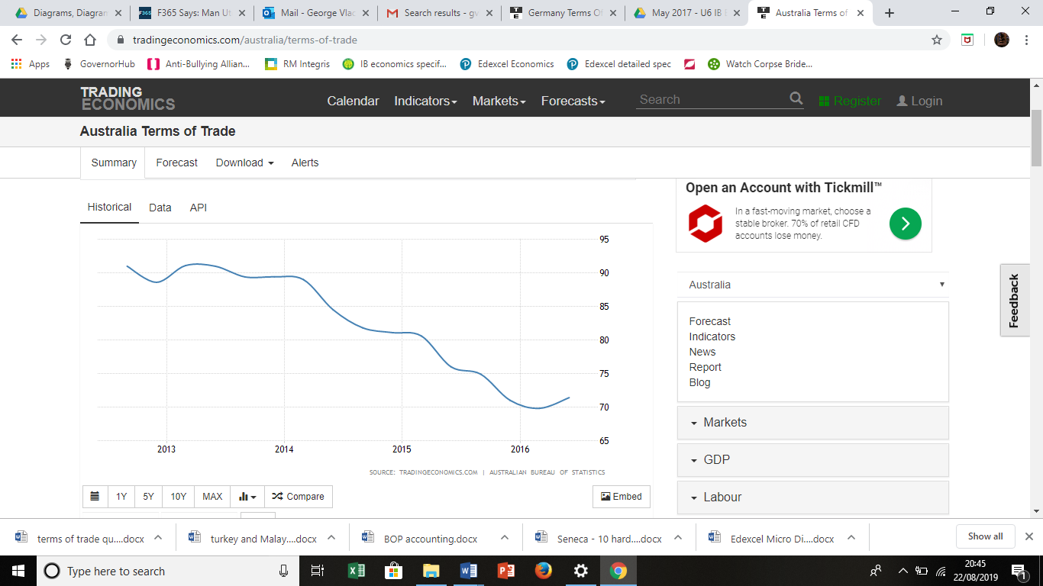

Australia’s terms of trade fell sharply from 2013 to 2016. There were worries at the time that this might worsen the current account deficit, lead to a fall in government revenue and damage expectations for economic growth in the near future.

The reason why the terms of trade index fell is mainly due to the fall in the commodity prices such as iron ore, coal and energy. Australia is a large exporter of these goods – in particular, liquefied natural gas. The quantity of exports continues to grow to near record levels, but the revenue received for them is falling.

“The golden age of commodity-driven income growth is long gone,” said an economist at

Commonwealth Bank. “The continued fall in the terms of trade reflects a pronounced fall in

the purchasing power of Australian households and businesses. This has been a familiar

theme over the past few years,” he said. “Basically, falling commodity prices, namely iron

ore and coal, have weighed heavily on export revenues and therefore, real gross national

income growth.”

**Australia’s Terms of Trade: What is happening and why?**