**Guidance for Candidates**

* **Data Sheets**

Next to some questions you will need to use a “data sheet” to help you answer the question.

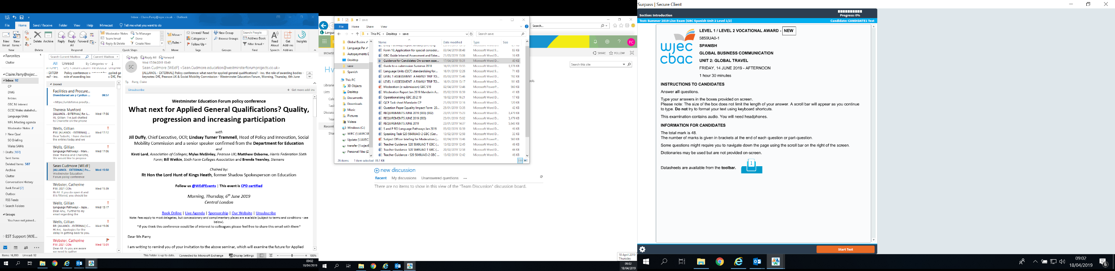**Click** on the blue icon next to each question to open the data sheet.

Click here to open data sheet

If a situation arises where you are unable to see your data sheet, please indicate to the invigilator and you will be given a hard copy of the exam paper which contains the data sheets. Please continue to answer the questions on-screen.

*  **Listening**

The exam contains audio files please make sure you have headphones.

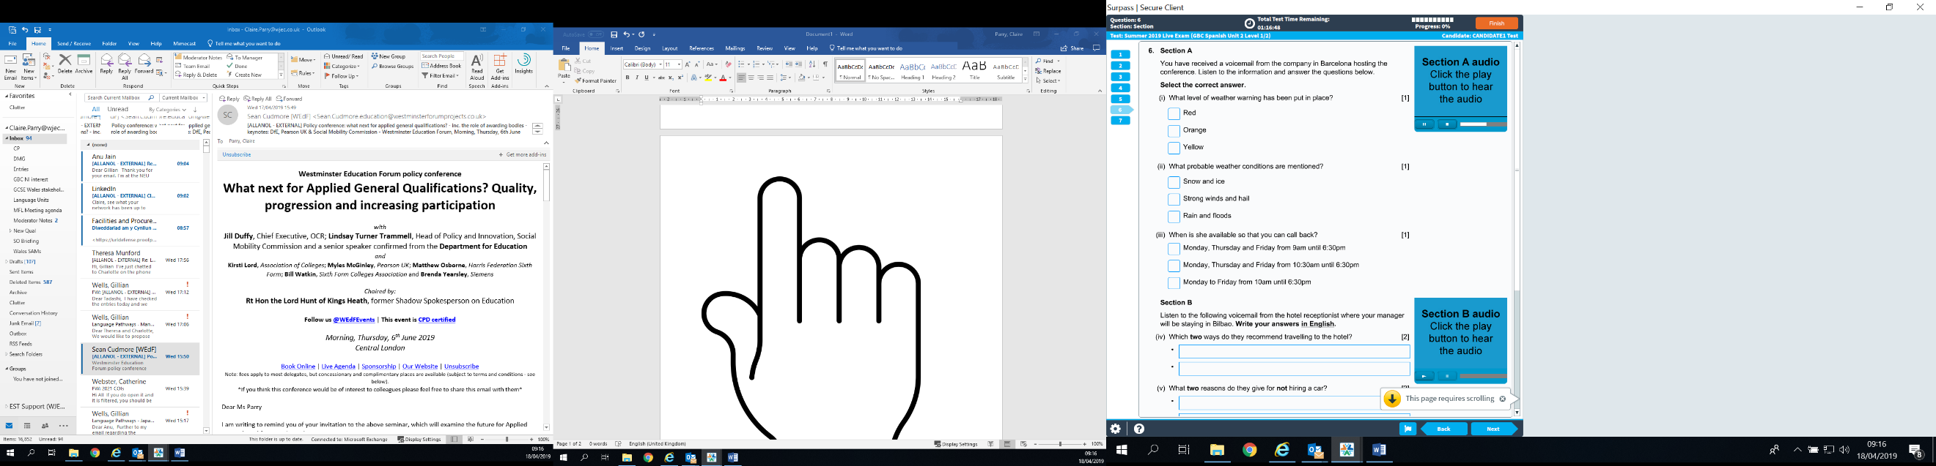

You can **start** and **pause** the audio using the buttons on the screen.

Rewind or forward the audio by sliding the hand icon across the white progress bar.



Fast Forward

Rewind

You can listen to the audio as many times as you like, however, don’t forget to manage your time to complete the rest of the exam.

* **Writing**

Remember - always **scroll down to the bottom of the page** to check that you have answered all of the questions.

Be aware that the size of the box where you will type your answer does not limit the length of your answer. A scroll bar will appear as you type and will allow you to keep typing.

For question 7, writing in the foreign language, you can select the tool highlighted below to insert accents as required.

Click here to open drop down menu with accents

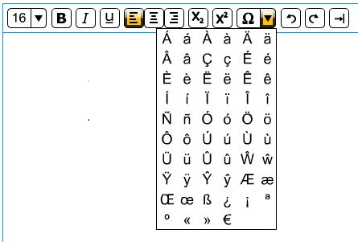

You may use a hard copy bilingual dictionary in the exam.

You can go back and check your answers at any time during the exam using the number tabs on the left-hand side of the screen or the back button.