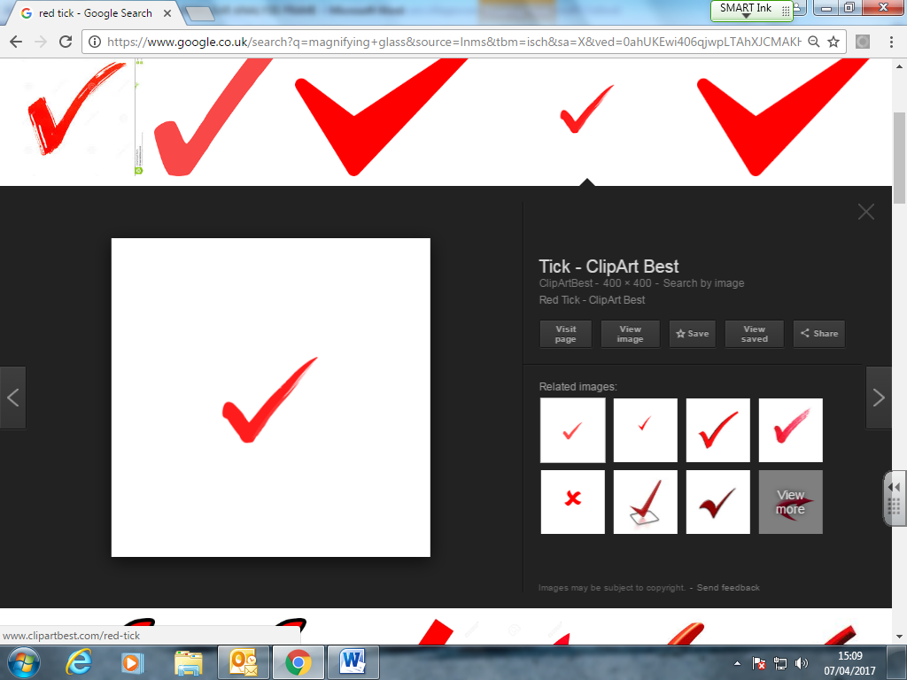

**UNIT 1: UNSEEN TEXT ANALYSIS FRAME**

1. Read through the text on the paper, making notes as you go along on what the question has asked you to focus on
2. Using ASEA, explore the writer/speaker’s techniques in some detail
3. Make links back to the set poem: move beyond general observations of similarities and differences and comment on subtle connections in context, attitude, linguistic choice and overall meaning

**Keep a focus on what the question is asking you to look at!**

**Assessment objectives:**

AO1: terminology and expression

AO2: analysis of technique and meaning

AO3: significance and influence of contexts

AO4: Connections across texts

**Form and Structure:** verse/prose, narrative voice (first person, third person, second person address), turn taking, adjacency pairs, extended speaking turns, development of ideas/argument, chronology, staging and props. **Grammar:** Sentence types, Syntax (word order) (especially: parallelism, foregrounding; end focus; nonstandard features) Mood (Declarative, Interrogative, Imperative), Tone (exclamatory), Tense, Ellipsis, A/syndetic listing. **Lexis:** Modifiers, Register, Word classes (e.g. pronouns, dynamic verbs, abstract nouns) Lexical sets, Connotations, Emotive lexis, Standard/Non-standard features, Idioms, Archaisms. **Imagery:** Literary and Rhetorical techniques including: metaphor, simile, allusion, imagery, symbolism, personification, pathetic fallacy, listing, antithesis, paradox, oxymoron, juxtaposition, tripling, repetition, hyperbole, litotes. **Sound:** Plosives, fricatives, sibilants, alliteration, assonance, onomatopoeia, elision. **Transcripts**: intonation (rising, falling), emphatic stress, pauses (timed, micro), smooth latching, turn taking, extended speaking turns.

Whilst the poem addresses issues of ___ and ___, this text presents ___ as ____...’

A ___ tone is created through the use of ___

By considering___, it is possible to see __

____ is a key feature of ___’s __ language…

It is important to consider ___ when analysing…