Teacher copy with answers
How to calculate the standard deviation
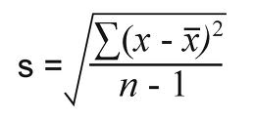
Sum of
(add them all together)
The raw score: this is the individual scores from pps
The total number of scores
The mean of each raw score
Square root
Square it!

Standard deviation



So how do we actually calculate it?
Imagine you have just done an ethics test. The score was out of 12.
Your raw scores look like this (this is the actual score each participant got on their ethics test)
Participants (pps) | Raw scores
Pp1 | 5
Pp2 | 6
Pp3 | 9
Pp4 | 2
Pp5 | 8

Step 1
First, calculate the mean of these scores
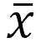 = The sum of the raw scores divided by the total number of scores
Therefore: 5 + 6 + 9 + 2 + 8 = 30
30 / 5 = 6
So our mean score is 6

Step 2
Now we need to calculate what is in the brackets ($χ-$) the participant’s raw score minus the mean
Column A | Column B
$χ$ - 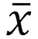 | =
5 - 6 | -1
6 - 6 | 0
9 - 6 | 3
2 - 6 | -4
8 - 6 | 2
 | NB: We do NOT total this column

Step 3
We now need to square the scores in Column B
Column B | Column C (The data squared)
-1² | = 1
0² | = 0
3² | = 9
-4² | = 16
2² | = 4

Step 4
Now you need to add up the data in column C to give you the sum (∑)
 | Column C (The data squared)
 | 1
 | 0
 | 9
 | 16
 | 4
Total | 30

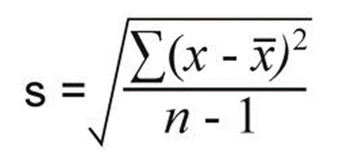
Step 5
Now you need to divide 30 by 4
(4 = the total number of scores minus one)
= 7.5 (this gives you the variance in the scores)

Step 6
Then find the square root $\sqrt{7.5}$
s = 2.75
Therefore your standard deviation is 2.75

Marvellous! We have worked out how to calculate the standard deviation. Now you might well be asking the questions: So what? What does it actually mean?

What is a standard deviation?
The standard deviation provides some idea about the distribution of scores around the mean (average). The smaller the standard deviation, the more narrow the range between the lowest and highest scores or, more generally, that the scores cluster closely to the average score. The larger the population we have, the more likely we are to have a normal distribution.
Assuming that we have a normal distribution, 68 % of scores should be within one standard deviation (sd) each side of the mean. 95% should be within two sd of the mean. 99% should be within three sd of each side of the mean.
Therefore if our mean is 6, 68% of participants should have score between 3.25 (6 – 2.75) and 8.75 (6 + 2.75).
Consider participant three who scored 9 on the ethics test. Did they do well compared with the other participants in the test?
The answer, of course would be yes! As they scored just above one standard deviation, they performed better than 68% of the other participants.
What is a normal distribution?
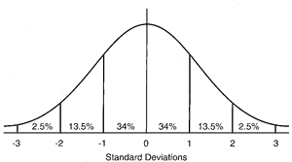
Figure 1.
It is often called a ‘Bell curve’ because of the shape it makes. It looks at how certain traits, such as IQ are distributed amongst a population. In a normal population, the bell curve would look like the image above with the majority of the population having an IQ falls within one standard deviation on either side of the mean (the mean in figure 1. is represented by ‘0’). So if an average IQ is 100, and the standard deviation is 15, then 68% of the population would have an IQ that ranged between 85 and 115 (one SD either side of the mean – 100 plus or minus 15). 99% of the population would fall within three standard deviations. That is between 55 and 145. 1% of the population would fall outside of this. So therefore only a tiny percentage of people would be considered to have genius IQ of 160 or above.
However, if you had a population made up of mainly members of Mensa, your bell curve would probably look like figure 2.

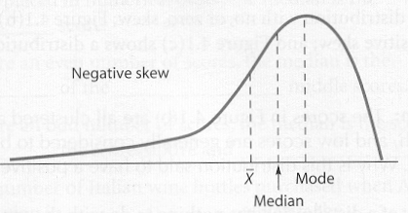

Figure 2.
A negative skew means the majority of participants score highly on a test (there were not enough challenging questions). A positive skew would mean the majority of participants got a low score (the test was too hard)

Now over to you – it’s time to calculate a standard deviation yourselves.
Practice

Imagine you have tested two groups of participants (based on two different classes) on a test of the understanding of the Behaviourist approach which was scored out of a possible total of 60. You found that the following scores
Group 1 | Raw data for behaviourist approach test | Group 2 | Raw data for behaviourist approach test
Pp1 | 15 | Pp1 | 33
Pp2 | 18 | Pp2 | 32
Pp3 | 12 | Pp3 | 42
Pp4 | 58 | Pp4 | 28
Pp5 | 49 | Pp5 | 30
Pp6 | 53 | Pp6 | 40

Now use the formula and tables provided to calculate the standard deviation on your data for the two groups. (Remember, you need to calculate each group separately).

Pps group 1 | Raw data  (scores) | Column A  (show your working out i.e 107 – the mean for pp1) | Column B  (write the answer to column A in column B) | Column C  (use your calculator to square the individual results in column B and write the answer below)
 |  | $χ$ - | =
Pp1 | 15 | 15 – 34.2 | -19.2 | 368.64
Pp2 | 18 | 18 – 34.2 | -16.2 | 262.44
Pp3 | 12 | 12 – 34.2 | -22.2 | 492.84
Pp4 | 58 | 58- 34.2 | 23.8 | 566.44
Pp5 | 49 | 49 – 34.2 | 14.8 | 219.04
Pp6 | 53 | 53 – 34.2 | 18.8 | 353.44
 | Total 205 /6 = 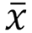 |  |  | 2,262.84 Total
 | Mean = 34.2

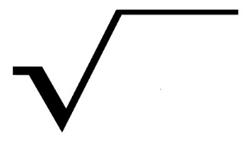
s =
2,262.84
5

= square root of 452.57
S = 21.27
Pps group 2 | Raw data  (scores) | Column A  (show your working out i.e 107 – the mean for pp1) | Column B  (write the answer to column A in column B) | Column C  (use your calculator to square the individual results in column B and write the answer below)
 |  | $χ$ - | =
Pp1 | 33 | 33 – 34.16 | -1.16 | 1.34
Pp2 | 32 | 32 – 34.16 | -2.16 | 4.67
Pp3 | 42 | 42 – 34.16 | 7.84 | 61.47
Pp4 | 28 | 28 – 34.16 | -6.16 | 37.95
Pp5 | 30 | 30 – 34.16 | -4.16 | 17.31
Pp6 | 40 | 40 – 34.16 | 5.84 | 34.11
 | Total 205 /6 = |  |  | 156.85 Total
 | Mean = 34.16

s =
156.85
5

= 31.37(variance) Square root of 31.37 = 5.60 s = 5.60
Task: once you’ve calculated the standard deviation of both of the groups, compare you findings. Is the standard deviation similar in both groups? If not, why not? What does it say about both of the classes in terms of their results on the Behaviourist Approach test? If the test score data of two classes has the same mean, can the teacher assume each class has shown the same level of understanding?
If the teacher just looked at the mean scores they would assume that the level of understanding across the two groups was quite similar. However, the standard deviations are very different. Group one has a high standard deviation meaning the scores are more widely distributed, whereas group two’s scores are more tightly clustered around the mean, as the group has a small standard deviation. This means that in group two, most participants did ok but in group one there was a much wider spread between those who did very well and those who performed poorly. (you could discuss with the class which they think is better)
Task: in group 2, participant 6 went home and told his dad that he’d got 66% in his test. His dad wasn’t very pleased with his result. Can participant 6 argue that he actually performed quite well compared with the rest of the class or not? (refer to the standard deviation in your answer and please show any calculations in the box provided).
Box to show any calculations
P6 got 40
One sd either side of the mean = 28.56 – 39.76


Assuming a normal distribution, participant 6 scored greater than one standard deviation from the mean, meaning he did better than 68% of a normal population. So he can tell his dad that he actually did ok on this particular test compared to the others (unless of course he was predicted an A…)

