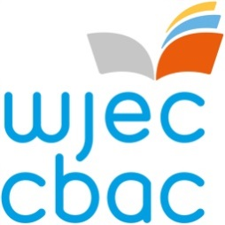

Chair of Examiners
Global Business Communication
Role Profile and Application Form

ROLE PROFILE
Purpose:
WJEC is recruiting for a Chair of Examiners. The successful candidate will be responsible for the assessment of WJEC Level 1 / 2 Global Business Communication French, German and Spanish.

The Chair of Examiners is responsible for the maintenance of standards within the subject across the specification from year to year. The Chair is also responsible for monitoring the standards of the Principal Examiners / Moderators for each of the languages.

Responsibilities:

- assist WJEC staff in maintaining standards within a specified subject and across different specifications, where appropriate, from series to series
- chair a range of meeting(s) including the Question Paper Evaluation Committee (QPEC) and Awarding meetings.
- ensure the question paper(s) and mark schemes meet the requirements of the assessment criteria as set out in the specification and are of a comparable standard that is maintained year on year
- recommend mark boundaries for each grade in each of the qualifications at the conclusion of the awarding process
- prepare detailed reports on the processes, as requested.

The Chair of Examiners will need to be available for a minimum of ten days a year which may be during term time, at weekends and during holiday time. Release payment to centres is available. This will enable the post holder to attend QPECs and the awarding meetings.

Experience/qualifications needed:

- degree in one (or more) of the subjects specific to this qualification
- relevant assessment and teaching experience
- experience of managing people
- the ability to work well and meticulously under pressure.

For further information, please contact Claire Parry on 029 20265 402 or at claire.parry@wjec.co.uk. The closing date for applications is 4th June 2021.
How to apply:
If you wish to apply for the role and are not currently working for the WJEC please go to https://appointees.wjec.co.uk and click 'Apply to become an Examiner' to fill out the application form.
If you currently work for WJEC, please log in to your Appointees Management Portal Account (using your new username) and click on the 'My Application' icon on the home screen. Please ensure you add the role of Chair for Level 1/Level 2 Global Business Communication on the 'subject area' tab and fill in the other fields of the application.

If you require any further assistance in completing the application please contact:-

Rob Reynolds  rob.reynolds@wjec.co.uk  0290 265 050 | or | Beth Edgar  beth.edgar@wjec.co.uk  02920 265 476

