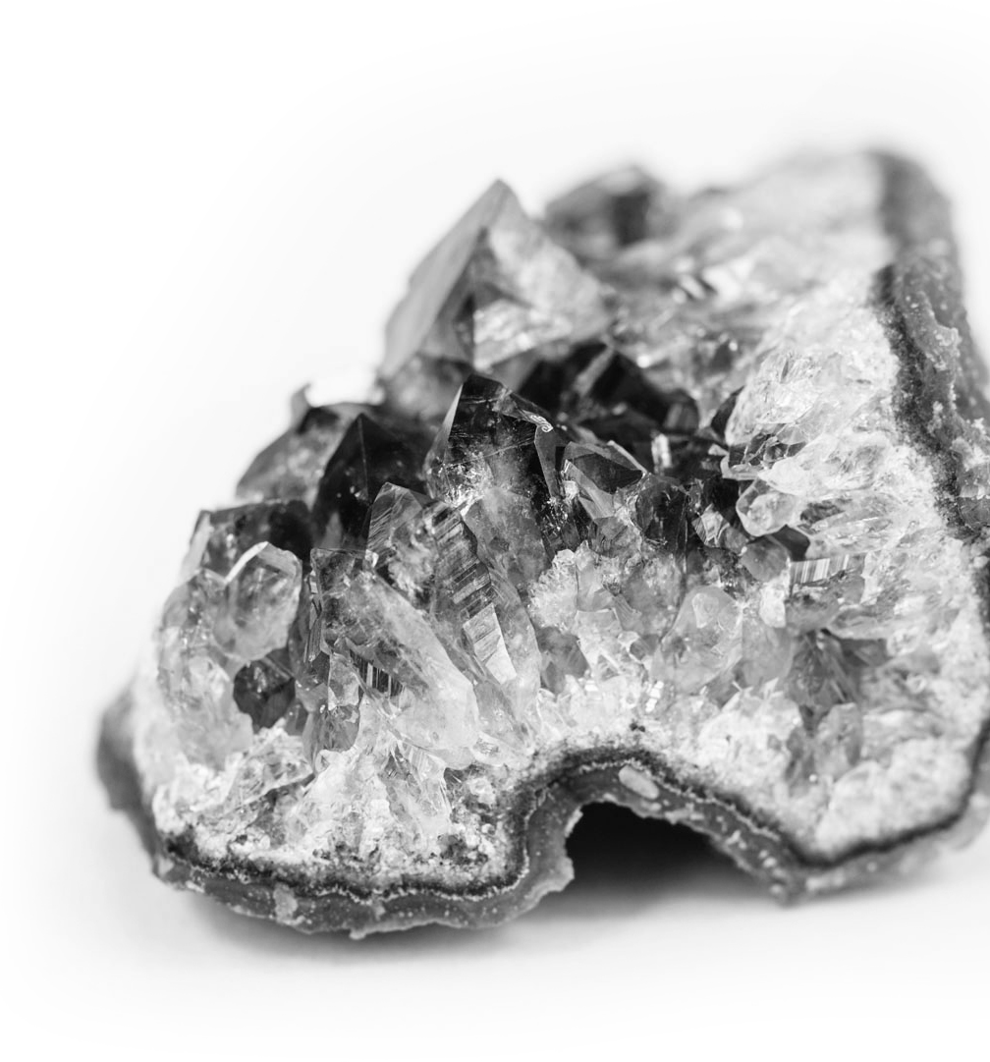

GCE A LEVEL

WJEC Eduqas GCE A LEVEL in
GEOLOGY
ACCREDITED BY OFQUAL DESIGNATED BY QUALIFICATIONS WALES

GUIDANCE FOR TEACHING
Teaching from 2017 For award from 2019

Version 3 May 2020

SUMMARY OF AMENDMENTS

Version | Description | Page numbers
2 | Replacement of hyperlinks | 29,34,67
3 | Replacement of hyperlinks | 27, 36, 59, 66,  71, 92, 94, 96,  105 and 109
 | Deletion of a hyperlink | 51
 | Text change to referring to use of specimens in addition to photographs | 110
 | Changes to text and hyperlinks for SP19 ‘Preparation’ and ‘Method for using the data’ sections | 116 - 117
 | Changes to text and hyperlinks for SP20 Teacher/technician notes | 124


Introduction | 3
Aims of the Guidance for Teaching | 4
Possible Delivery Model | 5
Assessment Objectives | 6
F1 Elements, Minerals and Rocks | 9
F2 Surface and Internal Processes of the Rock Cycle | 12
F3 Time and Change | 24
F4 Earth Structure and Global Tectonics | 29
G1 Rock Forming Processes | 33
G2 Rock Deformation | 37
G3 Past Life and Past Climates | 38
G4 Earth Materials and Natural Resources | 42
T1 Geohazards | 46
T2 Geological Map Applications | 53
T3 Quaternary Geology | 56
T4 Geological Evolution of Britain | 60
T5 Geology of the Lithosphere | 65
Useful additional resources | 71
SP1 Specified Practical Activity Sheet | 72
SP2 Specified Practical Activity Sheet | 75
SP3 Specified Practical Activity Sheet | 77
SP4 Specified Practical Activity Sheet | 79
SP5 Specified Practical Activity Sheet | 82
SP6 Specified Practical Activity Sheet | 84
SP7 Specified Practical Activity Sheet | 91
SP8 Specified Practical Activity Sheet | 93
SP9 Specified Practical Activity Sheet | 94
SP10 Specified Practical Activity Sheet | 95
SP11 Specified Practical Activity Sheet | 96
SP12 Specified Practical Activity Sheet | 97
SP13 Specified Practical Activity Sheet | 100
SP14 Specified Practical Activity Sheet | 102
SP15 Specified Practical Activity Sheet | 106
SP16 Specified Practical Activity Sheet | 110
SP17 Specified Practical Activity Sheet | 114
SP18 Specified Practical Activity Sheet | 115
SP19 Specified Practical Activity Sheet | 116
SP20 Specified Practical Activity Sheet | 122

The WJEC Eduqas A level Geology qualification, accredited by Ofqual for first teaching from September 2017, is available to:
- All schools and colleges in England
- Schools and colleges in independent regions such as Northern Ireland, Isle of Man and the Channel Islands

The A level will be awarded for the first time in Summer 2019, using grades A*- E.

The qualification provides a broad, coherent, satisfying and worthwhile course of study. It encourages learners to develop confidence in, and a positive attitude towards, geology and to recognise its importance in their own lives and to society.

The specification is intended to promote a variety of styles of teaching and learning so that the course is enjoyable for all participants. The optional topics have been developed to allow learners to gain an insight into more specialised topics within geology.

Practical work is an intrinsic part of geology, and is highly valued by higher education. It is imperative that practical skills are developed throughout this course and that an investigatory approach is promoted.

Additional ways that WJEC Eduqas can offer support:
- Specimen assessment materials
- Face-to-face CPD events
- Question paper database
- Examiners’ reports on each question paper
- Free access to past question papers and mark schemes via the secure website
- Direct access to the subject officer
- Free online resources
- Exam Results Analysis
- Online Examination Review
If you have any queries please do not hesitate to contact: David Evans
Subject Officer – Geology david.evans@eduqas.co.uk

The principal aim of the Guidance for Teaching is to support teachers in the delivery of the new WJEC Eduqas A level Geology specification and to offer guidance on the requirements of the qualification and the assessment process.

The guidance is not intended as a comprehensive reference but as a support for professional teachers to develop stimulating and exciting courses tailored to the needs and skills of their own learners in particular institutions.

The guidance offers assistance to teachers with regard to the depth of coverage required as well as links to useful digital resources (both our own, freely available, digital materials and some from external resources) to provide ideas for engaging lessons.

Possible Delivery Model

 | AS Geology | A level Geology
Year 12  Term 1 | Topic 1 Elements minerals and rocks  Topic 2 Surface and internal processes of the rock cycle | F1 Elements minerals and rocks  F2 Surface and internal processes of the rock cycle
Year 12  Term 2 | Topic 3 Time and change  Topic 4 Earth structure and global tectonics | F3 Time and change  F4 Earth structure and global tectonics
Year 12  Term 3 | Revision AS exams | (Revision)  (Internal Examinations/AS exams) G1 Rock forming processes G2 Rock deformation
Year 13  Term 1 |  | G3 Past life and past climates  G4 Earth materials and natural resources T1 Geohazards KI 1 and 2
Year 13  Term 2 |  | T1 Geohazards KI 3  T2 Geological map applications Option Key Idea 1
Year 13  Term 3 |  | Option Key Ideas 2 & 3 Revision

Note: The WJEC Eduqas A level specification is designed to be co-teachable with the specification for the WJEC Eduqas AS in Geology. The content within the A level specification Fundamentals of Geology section (F1-F4) forms the entire content required in the AS specification (Topics 1-4), with the exception of:
- some additional exemplification of mathematical skills required at A level but not at AS
- a practical activity required at AS but not A level.

Assessment Objectives

 | Objective
AO1 | Demonstrate knowledge and understanding of geological ideas, skills and techniques.  1a: Demonstrate knowledge of geological ideas  1b: Demonstrate knowledge of geological skills and techniques 1c: Demonstrate understanding of geological ideas  1d: Demonstrate understanding of geological skills and techniques
AO2 | Apply knowledge and understanding of geological ideas, skills and techniques.  1a: Apply knowledge and understanding of geological ideas  1b: Apply knowledge and understanding of geological skills and techniques
AO3 | Analyse, interpret and evaluate geological ideas, information and evidence to make judgements, draw conclusions, and develop and refine practical design and procedures.  1a: Analyse geological ideas, information and evidence 1b: Interpret geological ideas, information and evidence 1c: Evaluate geological ideas, information and evidence 1d: Make judgements  1e: Draw conclusions  1f: Develop and refine practical design and procedures

The following questions in the sample assessment materials exemplify the WJEC interpretation of each of the assessment objectives:

AO1 1a: Demonstrate knowledge of geological ideas
e.g. Component 1 Q2 c (ii) asks for factual recall to explain the term porphyroblastic texture. This is clearly the demonstration of geological ideas and is assigned to AO1 element 1a. This is also knowledge in isolation.

AO1 1b: Demonstrate knowledge of geological skills and techniques
e,g. Component 1 Q3 a (i) requires learners to describe the texture of a hand specimen of rock. This involves applying geological knowledge to practical contexts, a practical skill contained within Appendix 1a of the DfE GCE AS and A level Subject Content for Geology document and hence is assigned to AO1 element 1b.

AO1 1c: Demonstrate understanding of geological ideas
e.g. Component 1 Q6 c (iv) requires learners to demonstrate understanding of the formation of slickensides and is assigned to AO1 element 1c. This is also knowledge in isolation.

AO1 1d: Demonstrate understanding of geological skills and techniques
e.g. Component 2 Q1 a (i) requires learners to interpret a graph in order to describe it in terms of sorting of a sediment. Interpreting a graph is a practical skill contained within Appendix 1a of the DfE GCE AS and A level Subject Content for Geology document and hence is assigned to AO1 element 1d.

Similarly Component 3 Q1 c (i) requires learners to read and record data from a seismogram (ie interpret a graph) and this too is assigned to AO1 element 1d. (The same question goes on to require candidates to plot two values on a graph, draw a line and read off a value using the line potted. This mark is clearly the application of a mathematical skill and is assigned to AO2 element 1b.)

AO2 1a: Apply knowledge and understanding of geological ideas
e.g. Component 2 Q2 a (ii) asks learners to give a reason for their choice of direction of the principal stress component forming a fault and a fold. To answer this question, learners are required to apply their knowledge of the principal stress direction involved in the formation of folds and faults hence it is assigned to AO2 element 1a.

AO2 1b: Apply knowledge and understanding of geological skills and techniques
e.g. Component 1 Q 3 b requires learners to state, with reasons, the name of a hand specimen of rock. The requirement of this item involves the application of knowledge and understanding of geology in a practical context, referred to in Appendix 1a of the DfE GCE AS and A level Subject Content for Geology document. Consequently it is assigned to element AO2 1b.

e.g. Component 1 Q2 a (iv) requires learners to perform a % shortening calculation. This is clearly the application of a mathematical skill. Consequently it is assigned to element AO2 1b.

AO3 1a: Analyse geological ideas, information and evidence
e.g. Component 1 Q1 d requires learners to analyse evidence and appraise it coherently. They are required to analyse evidence in a photograph and find connections between this evidence and that in a map and a graph. Consequently this aspect is assigned to AO3 1a.

AO3 1b: Interpret geological ideas, information and evidence
e.g. Component 3 Q4 b requires learners to interpret geological evidence contained within three sets of stimulus material in order to determine the environment of deposition of two rock formations. This involves ascribing meaning to the information in order to respond. Consequently the marks for explaining the evidence are assigned to AO3 element 1b.

e.g. Component 1 Q7 requires learners to transfer information from a geological map in order to construct a geological cross-section. Where features outcrop on the surface the transfer of information is a straightforward practical technique and these marks are assigned to AO2 1b. Where features do not outcrop at the surface they need to be interpreted and consequently these marks are assigned to AO3 element 1b.

AO3 1c: Evaluate geological ideas, information and evidence
e.g. Component 1 Q6 b (i) and (ii) require learners to analyse evidence shown on a geological map, interpret it coherently and evaluate two statements. The evaluation aspect of each part of this question is therefore assigned to AO3 element 1c.

AO3 1d: Make judgements
e.g. Component 1 Q4 b requires learners to analyse the information in a graphic log, a hand specimen and on two photographs, in order to suggest changes in the environment of deposition. The item is designed so that learners will be able to make judgements concerning the energy level of the environment of deposition and of the nature of the environment regarding marine or non-marine conditions. Consequently two of the six marks are assigned to AO3 element 1d.

AO3 1e: Draw conclusions
e.g. Component 2 Q1 c (i) requires learners to interpret evidence and draw a conclusion. It covers therefore two AO3 elements, AO3 1b (interpret) and AO3 1e (draw a conclusion).
AO3 1f: Develop and refine practical design and procedures
e.g. Component 1 Q 8 requires learners to justify the observations they would make in a field investigation to establish past geological processes in an area shown in a photograph. This asks learners to develop and justify practical procedures and is assigned to AO3 element 1f.

Topic F1: ELEMENTS, MINERALS AND ROCKS
Key Idea 1: The Earth is composed of rocks which have distinctive mineralogies and textures
Knowledge and understanding | Geological techniques and skills | Comments
a. The Earth’s elements may be classified according to the Goldschmidt system (lithophile, siderophile, chalcophile, atmophile) which aids subdivision of the Earth on the basis of geochemistry (atmosphere, hydrosphere, crust, mantle and core). |  | Candidates should be aware of the four-fold classification and its delineation and be able to name at least one element from each group.  lithophile: elements that combine well with oxygen and are concentrated in the crust;  siderophile: ‘iron loving’ elements typical of the core; chalcophile: ‘ore loving’ elements which combine well with sulfur near the Earth’s surface;  atmophile: volatile elements within liquids and gases on or above the Earth’s surface.
b. The bulk composition of the Earth is comparable with that of undifferentiated meteorites (chondrites). |  | Candidates should know that evidence for the internal composition of the Earth partly comes from chondrite meteorites.
c. The Earth’s crust is composed of eight main elements. | Recognition of the relative abundance of O, Si, Al, Fe, Ca, Na, K and Mg in the crust and the role of the silicates as rock-forming minerals. | Candidates should know that 99% of the Earth’s crust (by weight) is made up of just 8 elements and their relative order of abundance.

Knowledge and understanding | Geological techniques and skills | Comments
d. Silicates are the commonest rock- forming minerals and are built from silicon- oxygen tetrahedral (single, chain, sheet and framework silicates). | Simple analysis of silicate mineral structures from models and diagrams. | Candidates should know the chemical structure of silicates as it relates to the physical properties of minerals (e.g. crystal shape, hardness and cleavage) rather than details of the chemical variations between minerals. As exemplified by olivine (single tetrahedra), augite/pyroxene (single chain),hornblende/amphibole (double chain), micas (sheet) and quartz/feldspar (framework).
e. Minerals are naturally occurring inorganic chemical compounds or elements with compositions that may be expressed as chemical formulae. Minerals have distinct chemical compositions, atomic structures and physical properties  by which they may be identified. | SP1: Investigation of diagnostic properties of minerals: colour, crystal shape, cleavage, fracture, hardness, relative density, streak, lustre, reaction with cold dilute (0.5 mol dm⁻³) hydrochloric acid.  SP2: Measurement of the density of minerals.  Recognition, using appropriate tests, of the following rock- forming minerals (as specified on the mineral data sheet available for use in the examination) from their diagnostic properties: quartz, calcite, feldspars (orthoclase, plagioclase), augite, hornblende, olivine, micas (biotite, muscovite), haematite, galena, pyrite, chalcopyrite, fluorite, barite, halite, gypsum, garnet, chiastolite/andalusite. | Candidates should be able to investigate the physical/chemical properties of minerals (including unfamiliar minerals) in the laboratory and field.  Candidates should be able to measure the density of minerals using an appropriate technique and evaluate the accuracy of such calculations.  Candidates will be required to use a mineral data sheet of diagnostic mineral properties in their identification of the stated minerals.

Knowledge and understanding | Geological techniques and skills | Comments
 | SP3: Application of classification systems using distinguishing characteristics to identify unknown minerals. | Candidates should be able to use flow charts to classify minerals (including unfamiliar minerals) from their observed physical/chemical properties.
f. Rocks are composed of aggregates of minerals, pre-existing rocks or fossils.
g. Igneous, sedimentary and metamorphic rocks display differences of composition and texture that reflect their mode of origin. | Observation and investigation of hand specimens of a variety of rocks (including sampling in the field) in order to:  - identify and interpret component composition  - interpret colour and textures (crystalline/clastic; crystal or grain size/shape; sorting; foliation; mineral alignment/bedding/cryst- alline banding) and hence  - deduce the mode of origin of the rock as igneous, metamorphic or sedimentary. | Candidates should be able to determine the origin of igneous, sedimentary and metamorphic rocks from their differing textures and mineralogies (including unfamiliar rocks) in the laboratory and field.
 | SP4: Production of scaled annotated scientific drawings of rock samples from hand samples using a light microscope, or hand lens observation. | Scientific drawings to include samples in the laboratory and the field using appropriate scales.
 | - Use and manipulation of the magnification formula
magnification = size of image
size of real object

Topic F2: SURFACE AND INTERNAL PROCESSES OF THE ROCK CYCLE
Key Idea 1: The mineralogy and texture of sedimentary rocks are the result of the surface process part of the rock cycle, driven by external energy sources
Knowledge and understanding | Geological techniques and skills | Comments
a. External energy: solar heating of the Earth’s surface drives the water cycle and influences weathering and erosional processes.
- Physical and chemical weathering of rocks occurs at the Earth’s surface and provides the raw materials for new sedimentary rocks:  - physical weathering, (insolation, freeze/thaw) breaks rock down into smaller fragments  - chemical weathering of silicate and carbonate rocks (hydrolysis, carbonation, solution and oxidation) produces a range of new minerals and solutions together with residual, resistant minerals  - biological weathering involves physical and chemical changes. |  | Candidates should know that the products of weathering are rock fragments, unreactive grains (e.g. quartz), clay minerals (e.g. kaolinite) and ions in solution.  Candidates need only know the processes outlined.

Knowledge and understanding | Geological techniques and skills | Comments
- Surface materials are transported by a range of erosional agents and are deposited as sediments:  - erosion (abrasion, attrition)  - transport (traction, saltation, suspension, solution)  - deposition selectively concentrates products in particular environments – grain size related to energy of depositional environment; dominance of quartz and muscovite in coarse fraction and clay minerals in fine fraction; flocculation; precipitation. | Recognition and use of appropriate units in calculations. | The surface processes part of the rock cycle facilitates, (though not exclusively) training in, and assessment of, some mathematical skills.  For exemplification of mathematical skills see Mathematical Guidance for A level Geology.
 | Construction and interpretation of frequency tables and diagrams, bar charts and histograms.
 | Finding of arithmetic means.
 | Understanding of the principles of sampling as applied to scientific data.
 | Understanding of the measures of dispersion, including standard deviation and interquartile range.
 | Selection and use of a statistical test.
d. Different sedimentary | Description of sedimentary
environments may be | rocks in hand specimens, rock
identified by diagnostic | exposures and
sedimentary structures, | diagrams/photographs from
rock textures, | observation of their colour,
mineralogy and fossil | texture (use of sediment
content. | comparators to determine
 | grain size, shape and
 | sphericity), (coarse >2 mm,
 | fine <1/16 mm), reaction with
 | 0.5 mol dm⁻³ hydrochloric
 | acid, mineralogy and other
 | diagnostic features.

Knowledge and understanding | Geological techniques and skills | Comments
e. A study of fluvial, marine, and aeolian sediments demonstrates these differences. | Investigation of textures of sediments from different depositional environments.  SP5: Production of full rock description of macro and micro features from hand specimens and unfamiliar field exposures of sedimentary rocks in order to interpret component composition, colour and textures, to identify rock types and to deduce their environment of deposition.  SP6: Construction of graphic logs using appropriate scale and symbol sets for unfamiliar geological sequences and exposures to record data relevant to an investigation.  SP7: Use of photomicrographs to identify minerals and rock textures of sedimentary rocks in order to identify rock types and to deduce their environment of deposition.  Interpretation of maps, photographs and graphic logs showing the following sedimentary features: bedding, cross-bedding, graded bedding, laminations, desiccation features, ripple marks (symmetrical and asymmetrical), sole structures (load/flame, flute cast). | Candidates should be aware of the link between process and product in their studies of the stated sedimentary environments:  - fluvial (rivers, deltas alluvial fans and playa lakes)  - aeolian (wind dominated e.g. desert dunes)  - marine (shallow water  – lagoon/reef/beach systems)  - marine (deep water – submarine fan turbidites)  Candidates should be able to explain the formation of the stated sedimentary structures.

Knowledge and understanding | Geological techniques and skills | Comments
 | Identification in hand specimen of the following sedimentary rocks from their composition, texture and other diagnostic features: sandstones (orthoquartzite, arkose, greywacke), shale/mudstone, limestones (shelly, oolitic, chalk), conglomerate, breccia.  Investigation of contrasts between fluvial, marine and  aeolian sediments. | Candidates need only have knowledge of the sedimentary rocks indicated.  Candidates should be able to identify the stated sedimentary rocks in hand specimen and the field. It is understood that it might not be possible to investigate the full range of rocks in the field or that this list is exclusive.
 | Use of logarithms in relation to quantities that range over several orders of magnitude. | For exemplification of mathematical skills see Mathematical Guidance for A level Geology.
 | Construction and interpretation of frequency tables and diagrams, bar charts and histograms. | The mathematical skills identified are not exclusive to this section of the specification.
 | Knowledge of the characteristics of normal and skewed distribution.
 | Plotting of variables from experimental or other circular data.
 | Understanding of the terms mean, median and mode.
 | Selection and use of a statistical test.
 | Plotting of two variables from experimental or other linear data.
f. Sedimentary rocks | Analysis of biogenic | Candidates should be able to
may result from the | components in sedimentary | describe the order of
accumulation of | rocks. | precipitation of evaporate
organic material |  | minerals from seawater in
(limestone, coal) or by |  | terms of their relative
precipitation of solid |  | solubilities – low ➔ high.
material from solution |  | (calcite/dolomite ➔
(evaporites). |  | gypsum/anhydrite ➔ halite ➔
 |  | potassium/magnesium salts).

Knowledge and understanding | Geological techniques and skills | Comments
- Sedimentary rocks exhibit differences in texture which influences porosity and permeability: grain angularity, sphericity, size, sorting, which reflects:  - the nature of rocks from which they were derived  - conditions of climate, weathering, erosion and deposition operating during their formation  - post-depositional factors as sediments are formed into sedimentary rocks: diagenesis and lithification (compaction, recrystallisation, cementation, pressure solution). | Investigation of the concept of ‘sediment maturity’. Immature sedimentary rocks characterised by a wide range of mineral compositions and/or lithic clasts; mature sedimentary rocks with restricted mineralogies dominated by mineral species resistant to weathering and erosional processes.  Understanding that y = mx + c represents a linear relationship. | Candidates should be aware of the range of texture in descriptive terms (as used on a grain size comparator):  - angularity – very angular to well rounded  - sphericity – high to low sphericity  - size – reference to the Wentworth scale  - sorting – very well to poorly sorted  For exemplification of mathematical skills see Mathematical Guidance for A level Geology.  The mathematical skills identified are not exclusive to this section of the specification.

Topic F2: SURFACE AND INTERNAL PROCESSES OF THE ROCK CYCLE
Key Idea 2: The formation and alteration of igneous and metamorphic rocks result from the Earth’s internal
Knowledge and understanding | Geological techniques and skills | Comments
a. Internal energy: The Earth’s internal geological processes result from the transfer of energy derived from radiogenic and primordial heat sources. Heat is transferred from the mantle to the surface by conduction and convection, with temperatures of rocks remaining below melting point (except locally). | Interpretation of evidence for surface heat flow and temperature variation with depth through simple analysis of the geothermal gradient (geotherm).  Solving of algebraic equations.  Calculation of the rate of change from a graph showing a linear relationship. | Candidates should be able to interpret pressure (depth) temperature graphs and use them to calculate geothermal gradients.  For exemplification of mathematical skills see Mathematical Guidance for A level Geology.  The mathematical skills identified are not exclusive to this section of the specification.
b. Igneous rocks are the products of cooling of magma in bodies of various sizes and shapes and pyroclastic events. | The recognition of plutons, dykes, sills, lava flows and pyroclastic deposits by interpretation of maps, sections and photographs. Observation and investigation of igneous rocks to deduce the cooling history:  - crystal size: coarse(>3 mm), medium (1-3 mm), fine (<1 mm)  - crystal shape: euhedral, subhedral, anhedral  - texture: equicrystalline, porphyritic, vesicular, glassy, fragmental (tuff)  - structure: pillow structure, aa/pahoehoe surfaces, columnar joints.

Knowledge and understanding | Geological techniques and skills | Comments
 | SP8: Production of full rock description of macro and micro features from hand specimens and/or unfamiliar field exposures of igneous rocks in order to interpret component composition, colour and textures, to identify rock type and to deduce their cooling history.
 | Identification in hand specimen of the following igneous rocks from their composition, texture and other diagnostic features:  - Silicic: granite  - Mafic: gabbro, dolerite, basalt  - Ultramafic: peridotite.  SP9: Use of photomicrographs to identify minerals and rock textures of igneous rocks to identify rock type and to deduce their cooling history. | Candidates need only have knowledge of the igneous rocks indicated.  Candidates should be able to identify the stated igneous rocks in hand specimen and the field. It is understood that it might not be possible to investigate the full range of rocks in the field or that this list is exclusive.
 | Use of ratios, fractions and percentages.
 | Calculation of the circumferences, surface areas and volumes of regular shapes. | For exemplification of mathematical skills see Mathematical Guidance for A level Geology.
 | Construction and interpretation of frequency tables and diagrams, bar charts and histograms. | The mathematical skills identified are not exclusive to this section of the specification.
 | Knowledge of the characteristics of normal and skewed distributions.

Knowledge and understanding | Geological techniques and skills | Comments
- Partial melting of rock at depth to form magma occurs in a number of different interplate and intraplate tectonic settings:  - beneath divergent plate margins – partial melting of mantle rocks generates basaltic magma  - near to convergent plate margins – partial melting of subducted oceanic lithosphere and overlying lithospheric wedge generates andesitic magma  - in mantle plumes (hotspots) – partial melting of mantle rocks generates basaltic magma  - in deeply buried lower continental crust during orogeny – melting and assimilation of crustal material generates granitic magma. | Investigation of the role of rising convection cells in decompression melting.
 | Investigation of global distribution of mantle plumes from maps.
- Volcanic hazards result from:  - blast/explosion  - ash fall, pyroclastic flows (nuées ardentes) and gases  - lava flows  - debris flows and mudflows (lahars). | Investigation, using geological | Candidates are expected to
 | data from a wide variety of | have studied specific
 | volcanic monitoring techniques | examples of the stated
 | (including ground deformation, | hazards and monitoring
 | gravity and thermal anomalies, | techniques but will not be
 | gas emissions and seismic | required to recall details of
 | activity), of the risk of volcanic | these examples in an
 | hazards and the extent to which | assessment.
 | they can be managed and
 | controlled in order to reduce
 | risk.

Knowledge and understanding | Geological techniques and skills | Comments
e. The nature of the volcanic hazard is linked to the composition, viscosity and gas content of the magma. |  | Candidates are expected to have studied the hazards associated with explosive and effusive activity and their links to silica and gas content that affects viscosity.
f. Metamorphism involves mineralogical and/or textural change of pre- existing rocks in response to changes in temperature and/or pressure. | Interpretation of the following metamorphic features using simplified geological maps and photographs: contact aureoles, metamorphic foliations. | Candidates should be aware of the concept of metamorphic grade.
- Contact (thermal) and regional metamorphism produce distinctive mineralogical and textural changes:  - non-foliated in contact metamorphism  - foliation (slaty cleavage, schistosity and gneissose banding) in regional metamorphism. | Understanding that y = mx + c represents a linear relationship.  SP10: Production of full rock description of macro and micro features from hand specimens and/or unfamiliar field exposures of metamorphic rocks in order to interpret component composition, colour and textures, to identify rock type and to deduce the temperature and pressure conditions of their formation.  SP11: Use of photomicrographs to identify minerals and rock textures of metamorphic rocks to identify rock type and to deduce the temperature and pressure conditions of their formation.  Identification in hand specimen of the following metamorphic rocks from their composition, texture and other diagnostic features: marble, metaquartzite, spotted rock, hornfels, slate, schist, gneiss. | For exemplification of mathematical skills see Mathematical Guidance for A level Geology.  The mathematical skills identified are not exclusive to this section of the specification.  Candidates should be aware of the metamorphic changes in chemically varied clay-rich rocks (e.g. shale) compared to those dominated by quartz and calcite (sandstones and limestone).  Candidates need only have knowledge of the metamorphic rocks indicated.  Candidates should be able to identify the stated metamorphic rocks in hand specimen and the field. It is understood that it might not be possible to investigate the full range of rocks in the field or that this list is exclusive.

Topic F2: SURFACE AND INTERNAL PROCESSES OF THE ROCK CYCLE
Key Idea 3: Deformation results when rocks undergo permanent strain in response to applied tectonic stresses and can be interpreted using geological maps
Knowledge and understanding | Geological techniques and skills | Comments
a. Rock deformation can |  | Candidates should be able
be interpreted by |  | to draw and interpret stress-
reference to Hooke’s |  | strain curves.
Law: Simple stress-
strain curves showing
elastic/brittle and
ductile/plastic
behaviour; elastic limit,
permanent strain and
fracture point.
b. Evidence of rock deformation includes dipping beds, folding, faulting and unconformities. | Measurement and description of evidence obtained by sampling of rock deformation in the field (or from photographs). Use of simple calculations to establish the amount of deformation (percentage of crustal shortening).
 | Use of sin, cos and tan in physical problems.  Recognition and interpretation of structural features through study of photographs, diagrams, sections, geological maps and in the field. | Candidates should be able to use trigonometry (sin, cos, and tan) in determining map or cross section parameters (e.g. true thickness, vertical thickness width of outcrop, angle of  dip).
 | SP12: Location of geological features onto a base map.
 | SP13: Identification of the location of geological features in the field using six figure grid references on maps.
 | SP14: Production of scaled, annotated field sketches at unfamiliar field exposures to record data relevant to an investigation.

Knowledge and understanding | Geological techniques and skills | Comments
 | SP15: Measurement of dip and strike elements: dip angle, dip and strike directions of planar surfaces, including valid sampling, relevant to an investigation. | Candidates should be aware of random, systematic and stratified sampling techniques relevant to an investigation. The sampling skills identified are not exclusive to this section of the specification.
c. Dipping beds are the results of tectonic/gravity induced stresses, caused by plate movement, that distort beds from the horizontal.
d. Folding results when compressional stresses exceed the yield strength of a rock. | Recognition of fold elements: limb, hinge, axis, axial plane trace, fold symmetry (as a function of limb length), antiform, synform, anticline, syncline. | Candidates should be aware that fold symmetry is a function of the length of the fold limbs rather than the dip of opposing limbs. Symmetric folds have limbs of equal length; asymmetric folds have limbs of different lengths.
e. Faulting results when applied compressional, tensional or shear tectonic stresses, caused by plate movement, exceed the fracture strength of a rock. | Recognition of fault characteristics:  - dip-slip: normal, reverse, thrust; throw-amount, relative movement of footwall/hanging wall  - strike-slip: left/sinistral, right/dextral  - fault displacement (= net slip). | Candidates are not required to have knowledge of other fault elements.
f. Unconformities represent a hiatus in the geological record resulting from a combination of Earth movements, erosion and sea level changes. | Recognition of unconformities and their use in relative dating.

Knowledge and understanding | Geological techniques and skills | Comments
g. The nature of outcrop patterns formed by the intersection of geological structures with a topographic surface are displayed on geological maps. | Use of geological maps, block diagrams, boreholes, cross- sections and photographs to interpret the geology of an area.  Construction of geological cross-sections from simplified geological maps.
 | Ordering the geological sequence of events in an area from the study of a simplified geological map and/or section.

Topic F3: TIME AND CHANGE
Key Idea 1: Study of present day processes and organisms enables understanding of changes in the geological past
Knowledge and understanding | Geological techniques and skills | Comments
a. Much of the rock record can be interpreted in terms of geological processes that are operating today by applying the Principle of Uniformitarianism: the present is the key to the past. | Investigation of the development of uniformitarianism and the rock cycle model over time and the contributions of James Hutton and William Smith. | Candidates should be able to apply the Principle of Uniformitarianism to evidence of rock cycle processes through Deep Time. A simple understanding of the contributions made by James Hutton (unconformity, Deep Time) and William Smith (principle of faunal succession, first geological map).
b. The study of modern environments enables an interpretation of the sedimentary rock record within the rock cycle model.
c. The basic unit of sedimentary geology is the facies which reflects the depositional environment: lithofacies, biofacies. |  | Candidates should be aware that facies relates to the sum total of all the characteristics of a rock (composition, texture, fossil content) of a given age that change laterally.  Lithofacies: a mappable unit based on petrological characters (e.g. texture and mineralogy)  Biofacies: a mappable unit based on fossil content.

Knowledge and understanding | Geological techniques and skills | Comments
d. Fossils are evidence of former life preserved in rocks. They provide information on the nature of ancient organisms and palaeoenvironmental conditions. | Appreciation of the basic distinctions between the following fossil groups based on their hard parts:  - brachiopods (marine): shell shape and symmetry, pedicle and brachial valves, foramen, hinge line, muscle scars  - bivalves (marine/freshwater): shape and symmetry of valves, number and size of muscle scars, hinge line, teeth and sockets, gape, pallial line and sinus, umbones  - cephalopods (marine): suture line, coiled and chambered shell  - corals (marine): colonial solitary, septa  - trilobites (marine): cephalon, glabella, genal spines, eyes, thorax, number of thoracic segments, pygidium  - graptolites (marine): stipes, thecae  - plants (terrestrial): leaf, stem, root  - trace fossils (tracks and trails, burrows, coprolites). | Candidates are only required to have knowledge of those morphological features stated that are used to identify the group.
 | SP16: Application of classification systems using distinguishing characteristics to identify unknown fossils.
 | SP17: Production of scaled, annotated scientific drawings of fossils, using a light microscope, or hand lens observation.
- Fossil morphology is used to interpret function/mode of life:
  - bivalves (burrowers/non burrowers)
  - trilobites (benthonic/pelagic).

Knowledge and understanding | Geological techniques and skills | Comments
f. Preservation can give rise to a wide range of fossil materials: actual remains, hard parts, petrification by mineral replacement (calcification, silicification, pyritisation), carbonisation, moulds/casts.
g. Fossil accumulations may be preserved without appreciable transportation (life assemblages) or preserved after transportation (death assemblages), or as derived fossils re- deposited in later sediment. | Analysis of modern and fossil assemblages to interpret the degree of transportation prior to burial. | Candidates should be able to determine transport history based on the degree of fragmentation, sorting or alignment of specimens within a fossil assemblage.
- The fossil record is:  - biased, in favour of marine organisms, with body parts resistant to decay, that lived in low energy environments, and suffered rapid burial  - incomplete, as natural processes can distort or destroy fossil evidence (predation, scavenging, diagenesis, bacterial decay, weathering, erosion, metamorphism) |  | Candidates should be aware of the importance and limitations of a Lagerstätte in providing exceptional preservation e.g.  Ediacaran (Precambrian), Burgess Shale (Cambrian), Wenlock Series (Silurian), Solnhofen (Jurassic).

Topic F3: TIME AND CHANGE
Key Idea 2:Geological events can be placed in relative and absolute time scales
Knowledge and understanding | Geological techniques and skills | Comments
a. Geological events can be placed in relative time scales using criteria of relative age: evolutionary change in fossils, superposition of strata, unconformities, cross- cutting relationships, included fragments,‘way- up’ criteria. | Interpretation of age relations of rocks and rock sequences using maps, cross-sections and in the field. | Teachers may find some of the resources at the following link useful.  https://geohubliverpool.org.uk  /resource/videos-showing- way-up/
b. Some rocks and minerals can be dated radiometrically to give an absolute age. This involves radioactive decay and the principles of radiometric dating; radioactive series and radioactive half-life; radiometric dating as exemplified by Potassium  – Argon (⁴⁰K– ⁴⁰Ar),  Samarium – Neodymium (¹⁴⁷Sm –¹⁴³Nd). | Simple use of the principles of radiometric dating (decay rates and the half-life concept) to calculate the absolute age of a sample.  Evaluation of the assumptions, accuracy and limitations inherent in the radiometric dating method. | Candidates will need to know that differences between the K – Ar and Sm  – Nd methods and understand the principle of using the gradient of an isochron to establish relative age in the latter.  Candidates will not be expected to plot isochrons or calculate age from isochrons but simply interpret relative age.  Teachers may find the following resources useful. Sm-Nd presentation  Sm-Nd dating fact sheet Sm-Nd-simulation data sheet
c. Fossils are used in relative dating. | Observation and identification of appropriate morphological features and their changes through time:  - graptolites – number and position of stipes, thecal shape in the Early Palaeozoic.  - cephalopods – suture lines in the Late Palaeozoic and Mesozoic (goniatite, ceratite and ammonite). | Candidates are expected to be able to provide a relative date to a formation based on graptolite or cephalopod assemblages within the appropriate time frame (Early Palaeozoic and Mesozoic).

Knowledge and understanding | Geological techniques and skills | Comments
- The factors contributing to good zone fossils for relative dating/correlation are: wide and plentiful distribution, ready preservation, rapid evolutionary change, a high degree of facies independence, easy identification of index fossils.
  - the utility of graptolites and cephalopods as zone fossils assessed in relation to the above factors.
- The geological column provides a means of:  - placing geological events in their correct time sequence  - defining the absolute age of some events. | Interpretation of the ages of geological events using the geological column. | Candidates need to be aware of the classification and relative order of the geological column (based on the International Chronostratigraphic chart)  – eons, eras, periods.  Candidates should be aware that the Precambrian predates the Phanerozoic era, but knowledge of subdivisions of the Precambrian is not required.
f. The rock record indicates changing conditions and rates of processes with long periods of slow change interrupted by sudden catastrophism causing mass extinctions through geological time.

Topic F4: EARTH STRUCTURE AND GLOBAL TECTONICS
Key Idea 1: The Earth has a concentrically zoned structure and composition
Knowledge and understanding | Geological techniques and skills | Comments
a. The Earth has a layered structure: crust, mantle, outer and inner core. Each layer has a distinctive composition and/or rheological properties. Direct and indirect evidence is derived from meteorite (stony, iron) compositions, mantle xenoliths, mean density calculations and geophysical measurements (seismology, geomagnetism, gravity, conductivity). | Analysis of seismological evidence for the internal structure of Earth: P and S body waves, surface waves, time-distance curves, shadow zones, velocity-depth models of Earth structure, density distribution with depth.  Translation of information between graphical, numerical and algebraic forms.  SP18: Measurement of the densities of representative samples of Earth layers (e.g. granite, basalt).  Simple analysis of geomagnetic evidence for core composition and processes. | Candidates should be able to use evidence to interpret the state, depth and probable composition of the Earth’s layers.  For exemplification of mathematical skills see Mathematical Guidance for A level Geology.  The mathematical skills identified are not exclusive to this section of the specification.
b. The crust is a thin layer of distinctive composition overlying the mantle; continental and oceanic crust can be recognised and distinguished by their differing thicknesses, composition and structure. | Interpretation of geophysical data on crustal structure (seismic, gravity, magnetic) from continental and oceanic areas.  Analysis of ocean drilling data to re-interpret the Mohorovičić discontinuity (Moho) at the base of the crust (e.g. Joides Resolution 360). | Candidates should be given the opportunity to evaluate and validate the new knowledge obtained from current ongoing scientific research.  - the significance of serpentinite at the Moho discontinuity  www.seafloorspreading.c om

Topic F4: EARTH STRUCTURE AND GLOBAL TECTONICS
Key Idea 2: The Earth’s internal heat is the underlying cause of lithospheric plate motions that control global geological processes
Knowledge and understanding | Geological techniques and skills | Comments
a. The uppermost part of the | Investigation of how the plate | Candidates should be
mantle and the overlying | tectonics paradigm developed | aware of the
crust form a rigid outer | over time, from continental drift, | importance of the plate
shell of the Earth known | through active mantle | tectonic model in
as the lithosphere, forming | convection carrying passive | providing an underlying
tectonic plates, underlain | tectonic plates, to modern | framework to
by a weaker upper mantle | theories of the causes of plate | understand how the
zone known as the | movement (slab pull and ridge | Earth works.
asthenosphere. The | push).
asthenosphere is
evidenced by the
seismological low velocity
zone (LVZ).
b. The lithosphere consists of several plates in relative motion. Three types of plate boundary are recognised; divergent, convergent (involving subduction) and conservative. There is a relationship between seismicity, volcanicity and plate boundaries. | Interpretation of the evidence for plate tectonic theory from:  - direct measurement – ocean floor drilling, relative movement using GPS  - global maps of the distribution of continents, volcanoes, earthquake epicentres/foci, ocean trenches and ridges, orogenic belts and palaeoecological  /palaeoenvironmental zones  - seismic tomography  - an investigation of the geomagnetic/geoelectrial properties of rocks and minerals  - geothermal data (hot spots, heat flow). | Teachers may find the following resource useful in the delivery of F4:  https://www.geolsoc.org  .uk/P late-Tectonics
 | SP19: Investigation of the relationships between earthquake data (focal depth, magnitude and distance from plate boundaries) using data on Google EarthTM.

Knowledge and understanding | Geological techniques and skills | Comments
 | Use of a scatter diagram to identify a correlation between two variables.
c. Forces driving plates are a matter of current debate involving thermal convection of the mantle together with gravitational forces and ocean lithosphere density differences at subduction zones. | Evaluation of the possible mechanisms for plate movement (role of mantle convection, slab pull, ridge push). | Candidates should be aware that currently the possible mechanisms for plate movement are much disputed.
d. Some rocks contain a record of the direction of the Earth’s magnetic field at the time of their formation, known as remanent magnetism. This is linked to ferromagnetism in some iron minerals and their Curie temperatures.
e. Palaeomagnetism can be used to determine changes of latitude as different continents moved through geological time, indicating continental drift. Ocean floor magnetic anomalies indicate sea floor spreading. |  | Candidates should be aware of remanent magnetic inclination in determining changes in continental latitude through geological time.  Knowledge of Polar Wandering Curves is not required.

Knowledge and understanding | Geological techniques and skills | Comments
- The various elements of the rock cycle may be linked directly to plate tectonic processes:
  - igneous – basaltic magmatism at oceanic spreading centres; basaltic and andesitic magmatism at convergent margins; granitic magmas in orogenic belts
  - sedimentary – erosional processes and depositional environments influenced by tectonic movements
  - regional metamorphism in subduction zones and orogenic belts at plate boundaries.

Topic | G1: ROCK FORMING PROCESSES
Key Idea 1: The generation and evolution of magma involves different processes
Knowledge and understanding |  | Geological techniques and skills | Comments
a. Igneous rock |  | Evaluation of the role of temperature, pressure and water content in determining the melting points of rocks.  Simple calculation of depth of formation of granite magma by crustal melting through interpretation of graphs showing continental geotherm and melting temperatures of wet and dry lower crustal material.  Calculation of the age of a mineral sample using the decay rate equation  −λt N  = N0e  Use of logarithms in relation to quantities that range over several orders of magnitude.  Interpretation of logarithmic plots.  Calculation of percentage error in radiometric dating results. | Candidates should be able to use a scientific calculator to establish time from given decay rate equations e.g.  t = (T½/ln 2) In(Nd/Np + 1).  For exemplification of the mathematical skills associated with the decay rate equation see Mathematical Guidance for A level Geology.
composition at
interplate and
intraplate settings
depends on:
- origin of the parent
magma (mantle or
crust)
- magma evolution:
Differentiation and
fractionation
(continuous and
discontinuous
reaction series –
Bowen); gravity
settling to give
cumulates
- magma
contamination:
incorporation of
rock material
(xenoliths); magma
mixing, during rise
and emplacement,
leading to change
of composition and
physical properties
(enclaves).

Knowledge and understanding | Geological techniques and skills | Comments
b. The substitution of one element for another in the crystal structure of a mineral depends upon atomic radius and valency; solid solution as exemplified by olivine and plagioclase feldspar. | Investigation of magma crystallisation and differentiation processes using phase diagrams (plagioclase feldspar, olivine). | Candidates should be able to interpret phase diagrams between solid solution end members from:  - Ca-rich plagioclase (Albite) to Na rich (Anorthite)  - Mg-rich olivine (Fosterite) to Fe-rich (Fayalite).
c. The formation of magma chambers under ocean ridges and rises can be interpreted from models. | Analysis of ocean survey data to investigate current models of how oceanic ridges (particularly mid ocean ridges-MORs) are formed (e.g. RRS James Cook – 2016). | Candidates should be familiar with new models of ocean ridge formation (using data from seismic tomography and de e p ocean drilling) involving  - symmetrical and asymmetrical spreading  - ocean core complexes (OCC)  - the significance of serpentinite.  www.seafloorspreading.com

Topic G1: ROCK FORMING PROCESSES
Key Idea 2: The mineralogy and texture of metamorphic rocks are determined by the composition of the parent rock and the conditions of metamorphism
Knowledge and understanding | Geological techniques and skills | Comments
a. Igneous and sedimentary rocks contain minerals that are stable or metastable at the temperature and pressure of their formation. Changes in temperature and/or directed stress over time lead to the growth of new minerals with different stability fields. | Analysis of simple pressure- temperature- time paths involved in contact and regional metamorphism.  Simple analysis of phase diagrams showing stability fields of selected metamorphic minerals: kyanite/sillimanite/ andalusite. | Candidates should appreciate that prograde metamorphic effects result from increases in temperature and (usually) pressure. Retrograde metamorphism (though uncommon) allows prograde mineral assemblages to revert to those more stable at less extreme temperature and pressure.  Detailed knowledge of metamorphic facies is not required.
b. Mineralogical changes during metamorphism depend on the composition of the parent rock and the temperature/pressure field. | SP20: Investigation of contact metamorphism using the ‘Metamorphic Aureole’ simulation experiment.
c. Contact and regional metamorphism of mudstone/shale lead to the growth of new minerals indicative of the type and grade of metamorphism: low to high grade metamorphism. |  | Candidates are expected to use evidence from index minerals to arrange clay- rich rocks in order of their increasing grade.
d. Contact, regional and dynamic metamorphism result from different pressure/temperature conditions and produce characteristic textural changes associated with recrystallization, ductile flow and shear deformation. | Study of diagrams/photomicrographs to identify and analyse the following metamorphic textures: granoblastic; porphyroblastic; mylonitic.

Topic G1: ROCK FORMING PROCESSES
Key Idea 3: Sedimentary processes can be understood using scientific modelling
Knowledge and understanding | Geological techniques and skills | Comments
a. Sedimentary processes which are infrequent and/or difficult to observe (e.g. turbidity currents) can be understood and explained using scientific models. | Application of the Hjulstrom graph.  Determination of the slope and intercept of a linear graph.
b. The distribution of environments represented by rocks in a vertical stratigraphic column is related to the distribution of those environments laterally (Walther's Law); marine transgressions and regressions, diachronous stratigraphic boundaries. | Application of Walther’s Law to extend interpretation from two- dimensional data (borehole logs, cliff sections, graphic logs) to three-dimensions. | Candidates are expected to relate vertical sequences (e.g. outcrop of borehole) with the lateral changes in facies identified in modern sedimentary environments (e.g. a delta) and understand that lithofacies are not necessarily time- dependent.  https://geohubliverpool.or g.uk/esa/facies%20diachr onism.htm

Topic | G2: ROCK DEFORMATION
Key Idea 1: Geological structures are formed when rock material undergoes deformation
Knowledge and understanding | Geological techniques and skills | Comments
a. The nature of rock | Recognition of the | Candidates are expected
deformation is determined | differences in deformation of | to predict the effects of
by the competence of the | competent and incompetent | deformation (brittle fracture
parent rock and conditions | rocks. | and ductile flow) on rocks
during deformation |  | of different competences.
(temperature, confining
pressure, strain rate).
b. Fold characteristics; amplitude, wavelength, interlimb angle (open, tight, isoclinal), axial plane attitude (upright, inclined, overturned, recumbent), plunging folds. | Identification of plunge direction (of axis) and axial planar cleavage.  Represent limb dip and strike data on a polar equal area stereonet (polar plots only not projections or great circles). | For exemplification of mathematical skills see Mathematical Guidance for A level Geology.
 | Plotting of variables from experimental or other circular data. | The mathematical skills identified are not exclusive to this section of the specification.
c. Fault type is determined by | Analysis of the relationship | Candidates will be
the orientation of the | between fault type (normal, | expected to interpret the
principal stresses. Technical | reverse/thrust, strike-slip) and | effect of dip-slip or strike-
terms to describe fault | the orientation of the principal | slip relative movement, but
elements: slickensides, fault gouge, fault breccia. | stress components (σ max, σ  int, σ min). | not oblique fault movement.
d. Structural reactivation: | Recognition of evidence for
earlier-formed faults can be | fault reactivation on
reactivated during later | geological maps, cross-
tectonism; folds may be | sections, diagrams and
refolded. Structural | photographs.
inversion: reactivation of
normal faults in compression
or reverse faults/thrusts in
extension.
e. The nature of outcrop patterns formed by the intersection of geological structures with a topographic surface are displayed on geological maps. | Calculations involving measurements of:  - true bed thickness  - vertical bed thickness  - width of outcrop  - angle of dip.  Use of sin, cos and tan in physical problems. | For exemplification of mathematical skills see Mathematical Guidance for A level Geology.  The mathematical skills identified are not exclusive to this section of the specification.

Topic G3: PAST LIFE AND PAST CLIMATES
Key Idea 1: Fossils provide evidence for the increasing diversity of life through geological time
Knowledge and understanding | Geological techniques and skills | Comments
- The fossil record provides evidence of changes in floras and faunas through geological time and the development of higher life forms:  - Precambrian life: life possibly evolved early in Earth history (3.8 billion years ago). The Ediacaran fauna represents the oldest diverse set of multicellular, soft bodied organisms (565 Ma)  - The Cambrian Explosion: the development of mineralised skeletons led to a wide variety of advanced marine invertebrates by the early Cambrian  - Life in the ocean diversified in stages identified by separate fauna: a basic understanding of the difference between Cambrian, Palaeozoic and modern faunas | Interpretation of evolutionary diagrams. | Candidates should be familiar with the use of cladograms in showing the relationships amongst organisms and in the development of evolutionary trees.
 | Analysis of the possible causes of faunal diversification at the Precambrian-Cambrian boundary. | Candidates should be able to evaluate a range of hypotheses (environmental, developmental and ecological) that have been proposed for the sudden faunal diversification at the Precambrian-Cambrian boundary.
 |  | http://www.nature.com/news/ what-sparked-the-cambrian- explosion-1.19379
 | Interpretation of simple diversity curves (Sepkoski’s curves). | Candidates will be expected to interpret modes of life from an analysis of vertebrate morphologies including: size, shape, dentition (carnivore v herbivore), pelvis, vertebrae, limbs, ornamentation (horns, plates, feathers).

Knowledge and understanding | Geological techniques and skills | Comments
- The Phanerozoic | Analysis of the morphology of fossil vertebrates (including dinosaurs) to interpret function/mode of life. | Candidates should be aware of fossil evidence in vertebrate development (as exemplified by Ichthyostega, Archaeopteryx).
was marked by the
migration of
organisms onto the
land during the
Palaeozoic.
Vertebrate
development of
amphibians from
fish, reptiles from
amphibians and
mammals and birds
from reptiles.
Colonisation of the
land by plants.
- Diversity increased through the Phanerozoic punctuated by many declines caused by mass extinction events. Mass extinctions may result from a variety of causes including:  - asteroid impact (Alvarez)  - large scale volcanicity (flood basalts)  - changes in land/sea levels  - rapid climate change. | Evaluation of contrasting hypotheses regarding mass extinctions. | Candidates should be aware of the evidence for the various theories including:  - Asteroid impact – shocked quartz, spherules, iridium, tsunamis deposits, Chixulub crater  - Volcanicity – flood basalt (Deccan Plateau), palaeomagnetic evidence of timing.
c. Mass extinctions are exemplified by the end- Permian (P-T) and Cretaceous-Paleogene (K-Pg) boundary events.
d. There are alternative | Evaluation of alternative
interpretations of | interpretations of evolutionary
evolutionary patterns | patterns.
based on the fossil
record. Gradual change
(gradualism) vs stability
interrupted by sudden
change (punctuated
equilibrium).

Topic G3: PAST LIFE AND PAST CLIMATES
Key Idea 2:A combination of global factors contributes to climate change through geological time
Knowledge and understanding | Geological techniques and skills | Comments
a. Long-term changes to the global climate, composition of the atmosphere, sea level and distribution of the continents are recorded in the Phanerozoic rock record. The J. Tuzo Wilson Cycle provides a framework for understanding these long term changes. | Analysis of present day oceanic and atmospheric circulation in relation to climatic effects.  Analysis of data used to determine past climatic regimes. | Candidates will be expected to identify stages of the J. Tuzo Wilson Cycle in the current distributions of oceans and continents for comparison with previous arrangements.  Candidates will be expected to analyse climatic data including ice cores, deep sea ocean cores and fossils (plants and animals) to establish past climates.
b. Changes in the | Evaluation of the
atmospheric composition | contribution of naturally
of greenhouse gases | produced CO2 and
(especially CO2 and | methane to climate
methane) result from | change with time.
natural processes (volcanic
activity, rock weathering,
warming of methane
hydrates) throughout
geological time.
c. There have been climate | Analyses of graphs
changes throughout | showing different rates of
geological time. The | climate change.
current rate of change
appears to differ from
those in the past.
d. The Anthropocene is a | Evaluation of the | Teachers may find the
proposed epoch that | arguments in the debate | following resource useful:
began when human | for the inclusion of the | http://www.geolsoc.org.uk
activities changed the | Anthropocene as a new | /AnthropoceneSchools
Earth’s surface | epoch. | Resources
environment on a scale
comparable with the major
events of the geological
past. There is currently a
lack of consensus for the
proposed epoch.

Topic G3: PAST LIFE AND PAST CLIMATES
Key Idea 3: Evidence for global climate change is interpreted from the geological record and the geochemistry of rocks
Knowledge and understanding | Geological techniques and skills | Comments
a. Evidence for global climate changes can be interpreted from both the geological record and the isotope geochemistry of ocean- floor sediments. | Investigation of the evidence for climatic extremes in the rock record. | Candidates should be aware of a range of climatic indicators in rocks including red sandstones, evaporates, coal, coral limestone, tillites and oxygen isotope ratios (¹⁸O/¹⁶O) in fossil shells.
- The fossil record provides evidence of different climatic zones, as exemplified by:  - land plants  - corals. |  | Candidates should be aware that fossil plant remains (e.g. leaves and pollen) provide evidence of prevailing climatic regimes.  Teachers may find the following resource useful: http://www.palaeontology online.com/articles/2012/fossil- focus-plant-fossils/
- Sedimentary sequences provide evidence of palaeoenvironments related to particular climatic zones.
  - Ancient icehouse deposits (e.g Carboniferous).
  - Tropical greenhouse deposits (e.g. Cretaceous).
d. Oxygen isotope ratios (¹⁸O/¹⁶O) in fossil shells are indicative of the temperature of ancient ocean waters. | Simple analysis of oxygen isotope curves.
e. The “Snowball Earth” hypothesis proposes that the Earth’s surface became entirely or nearly entirely frozen at least once, sometime earlier than 650 Ma. | Assessment of the validity of the evidence for the “Snowball Earth” hypothesis in Neoproterozoic rocks. | Candidates are expected to understand the significance of the evidence for “Snowball Earth” including low latitude glacial deposits (tillites), dropstones and cap carbonates.

Topic G4: EARTH MATERIALS AND NATURAL RESOURCES
Key Idea 1: Geological processes lead to the concentration and accumulation of natural resources in deposits that can be exploited; economic deposits can be concentrated by igneous and sedimentary processes
Knowledge and understanding | Geological techniques and skills | Comments
- Processes of formation of metalliferous ores.  - Igneous associations of ores – magmatic segregation, hydrothermal activity.  - Sedimentary associations of ores  – placer deposits; residual deposits; precipitated deposits. | Geological map interpretation (ore body geometry, field relations); section-drawing through ore bodies.  Calculation of the circumferences, surface areas and volumes of regular shapes.  Recognition and making use of appropriate units in calculations.  Use of ratios, fractions and percentages. | Candidates are expected to have studied the formation of cumulate deposits (e.g. iron chromite ores), massive sulphide ores (black smokers), hydrothermal ores associated with igneous intrusions (hydrothermal mineral veins, pegmatite deposits).  Candidates are expected to have studied the formation of placer deposits, residual deposits (bauxite) and precipitated deposits (BIFs and evaporates).
 | Geological map interpretation; section drawing through industrial mineral deposits.
b. Processes of formation of non-metallic minerals of economic importance: china clay. |  | Candidates are expected to have studied the formation of china clay only.
c. Formation of |  | Candidates are expected to be
sedimentary deposits |  | aware of the accumulation of
of economic |  | sand and gravel deposits in a
importance as “bulk |  | range of environments: river,
minerals” for |  | river terrace,
aggregate: sand and |  | glacial/fluvioglacial, beach
gravel.

Knowledge and understanding | Geological techniques and skills | Comments
- Origin of hydrocarbons and coals: hydrocarbons and coals result from the thermal alteration of organic material due to burial.  - Hydrocarbons: source rocks; sediment burial and the temperature and pressure conditions of oil and natural gas formation.  - Coal-forming environments; peat, lignite, bituminous coal, anthracite; coal rank. | Simple analysis of maturity: depth (temperature) graphs showing oil and natural gas windows.  Identification of coal types. Simple assessment of reserves (e.g. tonnage of coal in a given area).  Calculation of the circumferences, surface areas and volumes of regular shapes. | Candidates should be aware of a range of source rocks for hydrocarbons (to include fine grained sedimentary rocks and coal), the migration of hydrocarbons to, and accumulation in, a host rock.  Candidates are expected to have studied the factors necessary for coal formation and the factors that determine the rank of coal produced.

Topic G4 : EARTH MATERIALS AND NATURAL RESOURCES
Key Idea 2: Permeable rocks offer pathways for oil and gas migration; highly porous rocks can act as natural reservoirs for underground supplies of oil and gas
Knowledge and understanding | Geological techniques and skills | Comments
a. Porosity and permeability of rock and sediments affects the presence, distribution and migration of fluids (water, oil and natural gas): primary/secondary porosity in rock; factors that affect porosity and permeability. | Analysis of rock textures in terms of porosity and permeability (grain size, shape, packing, sorting; cementation); primary and secondary porosity.
b. Fluid flows in rocks and sediment can be modelled using Darcy’s Law. | Application of Darcy’s Law to model fluid flow:  Q = − kA⎜⎛ h2 − h1 ⎞⎟  ⎝ L ⎠ | Candidates will be required to apply, but not recall, Darcy’s Law to measure fluid flow in rocks.  For exemplification of Darcy’s Law see Mathematical Guidance for A level Geology.
c. Oil and gas migration are controlled by geological factors: migration paths – relative buoyancy of oil and natural gas; structural and stratigraphic traps for hydrocarbons; reservoir rocks and cap rocks. | Analysis of geological cross- sections through oil and natural gas bearing structures.
d. The characteristics of | Analysis of the controls on | Candidates are expected to
subsurface geology | groundwater quality which | have studied the differing
which control the flow of | result from geochemistry | geologies associated with
groundwater | (carbonates and sulfates), | the formation of springs.
(hydrogeology) include | aquifer filtration, residence
confined and unconfined | time and sources of pollution.
aquifers, aquicludes,
aquitards, the water
table, piezometric
surfaces, cones of
depression and recharge
zones.

Topic G4: EARTH MATERIALS AND NATURAL RESOURCES
Key Idea 3: A wide range of prospecting techniques can be employed to explore for mineral resources
Knowledge and understanding | Geological techniques and skills | Comments
- Techniques used to prospect for mineral resources.  - geophysical surveying – gravity (Bouguer), seismic, magnetic, electrical.  - geochemical prospecting – river water, river sediment and soil sampling. | Geological map interpretation; simple analysis of geophysical and geochemical data related to mineral exploration.  Selection of appropriate geophysical methods for different mineral searches, depending upon the geometry and physical properties of the  target body. | Candidates are expected to have studied the following geophysical prospecting techniques:  - gravity (Bouguer)  - seismic (reflection only – 2 way time)  - magnetic (including aeromagnetic)  - electrical (resistivity only)  - electromagnetic (EM survey)
Each method has particular applications and limitations. | Interpretation of seismic reflection sections to identify potential oil and natural gas-bearing structures. | Teachers may find the following resource useful in delivering part of this section:
 |  | http://www.sub-surfrocks.co.uk/
b. Microfossils are used | Construction of | Candidates should be aware of the
for correlation in | geological cross- sections | use of the following: foraminifera,
prospecting for oil and | from borehole data, | calcareous nannofossils and
natural gas. | including dating and | palynomorphs (pollen, spores and
 | correlation using | dinoflagellates)
 | microfossils. | http://www.ucmp.berkeley.edu/fosr
 |  | ec/ ONeill.html

Topic T1: GEOHAZARDS
Key Idea 1: Natural geohazards have a worldwide impact on human populations including in the British Isles
Knowledge and understanding | Geological techniques and skills | Comments
- Seismic hazards.  - There is a relationship between earthquakes and active fault zones.  - The magnitude of an earthquake event is measured on the Moment Magnitude scale (MW ). The intensity of earthquake damage around an event is measured on the modified Mercalli scale and is related to earthquake size, depth, distance, local ground conditions and building standards.  - Seismic hazards include ground  shaking, liquefaction.  - Tsunamis can cause devastation in coastal areas following an undersea earthquake (landslide or volcanic eruption). | Analysis of geological data from appropriate case studies of each the following:  - a major earthquake  - a mass movement event  to compare and contrast the nature of the geological hazards.  Investigation of the factors that affect the impact of earthquakes and mass movements. | Though candidates are expected to be familiar with appropriate case studies they will not be required to recall specific case study detail in assessments.  Teachers should be aware of the link with volcanic hazards outlined in F2.  Candidates should be aware that shaking is linked to the natural frequency of vibration of a building (resonance) and depends upon the earthquake frequency (Hz) and the height/shape of the building.  Candidates should be aware of the physical, social and economic factors that affect the impact of geohazards (including population density, building type and density, hazard awareness/preparation and level of economic development).

Knowledge and understanding | Geological techniques and skills | Comments
- Mass movement hazards.
  - The mechanism and triggering of rock avalanches, landslides and debris flows are linked to angle of slope, lithology, weathering, load, groundwater regime, rainfall, ground vibration, vegetation cover.
c. The British Isles is prone to local natural geohazards at different scales associated with: earthquakes, landslides, shrinking and swelling clays and subsidence (including sink holes). | Analysis of the causes and effects of geohazards in the British Isles from appropriate data sets. | Teachers may find the following resources useful in the delivery of T1:  http://www.bgs.ac.uk/resea rch/earthHazards/geohazar dNotes.html  http://www.bgs.ac.uk/resea rch/engineeringGeology/sh allowGeohazardsAndRisks/ home.html
d. There is evidence that significant tsunamis have affected the British coast in the recent geological past. |  | Candidates are expected to be aware of the Storegga slide.  http://www.bbc.co.uk/earth/ story/20160323-the- terrifying-tsunami-that- devastated-britain

Topic T1: GEOHAZARDS
Key Idea 2: Geohazard management attempts to predict and manage hazardous geological events with only limited success
Knowledge and understanding | Geological techniques and skills | Comments
- Geohazard and risk are intimately linked.  - Geohazard: the probability of a change in the geological environment of a given magnitude within a specific time period in a given area.  - Risk: the consequent threat of loss of life or damage to property and infrastructure. | Understanding of simple probability. | Candidates should be aware of the difference between the terms “hazard” and “risk”.
- The risk assessment of geohazards involves an analysis of:
  - the nature of the hazard
  - the probability of occurrence and the return period of the hazard
  - communication of the risk to the vulnerable population.
c. Attempts to predict earthquakes include monitoring changes in: seismic activity, groundwater levels and pressure, ground deformation (creep meters, strain meters, tilt meters), radon gas emissions and electrical resistivity. | An investigation of the monitoring of:  - a major earthquake  - a mass movement event  evaluating the level of success in hazard prediction. | Though candidates are expected to be familiar with appropriate case studies they will not be required to recall specific case study detail in assessments.  Teachers should be aware of the link with volcanic hazards outlined in F2.

Knowledge and understanding | Geological techniques and skills | Comments
- Sites of potential slope failure can be monitored by:  - ground levelling and surveying; monitoring of micro- seismic events and borehole distortion; ground deformation (creep, strain, tilt) and groundwater pressures  - Use of electronic distance measurement (EDM), satellite and GPS techniques.  - The destructive effects of earthquakes and mass movements can, to some extent, be managed and controlled by engineering geology applications.  - Earthquakes: reducing of the impact of ground accelerations; aseismic building design; tsunamis defences.  - Mass movement: slope stabilisation methods, drainage control, retaining structures. |  | Candidates should be aware of engineering solutions in earthquake management e.g.  - base isolators  - aseismic ‘smart’ buildings  - building materials.

Topic T1 : GEOHAZARDS
Key Idea 3: Engineering activities can have a major impact on the natural environment
Knowledge and understanding | Geological techniques and skills | Comments
- Extraction of geological raw materials and economic storage of waste products involves interference with the surface and/or subsurface environment.  - Quarrying and mining. Problems associated with the extraction of rock and minerals – stability of working faces, rock falls, ground subsidence, flooding, surface/groundwater pollution and waste tipping.  - Waste disposal. Problems of ground contamination, including groundwater pollution and methane gas production, can be ameliorated by good geological site selection and engineering practice. There are special problems with the disposal of highly toxic chemical and radioactive waste. | Analysis of the methods of extraction of geological raw materials to identify potential environmental problems and the ways by which these may be minimised.  Analysis of landfill engineering data for the disposal of domestic waste or underground sites for the disposal of highly toxic chemical and radioactive waste. | Candidates will be expected to have studied extraction from open cast pits and underground mines.

Knowledge and understanding | Geological techniques and skills | Comments
- Contaminated land. Problems with the management and remediation of industrial brownfield sites associated with toxic chemical materials, ground instability, subsidence and groundwater pollution. | Analysis of the issues associated with the remediation of one industrial brownfield site. | Candidates will be expected to have studied:  - toxic heavy metal contamination (e.g. cadmium, mercury , lead and arsenic) of soil and groundwater  - problems of ground pollution and instability of former landfill sites  - remediation solutions (e.g. phytoremediation, solidification and stabilisation methods)  Teachers may find the following resources helpful:  https://clu- in.org/download/Citizens/a_ citizens_guide_to_solidifica tion_and_stabilization.pdf
- Civil engineering work should take account of geological factors to avoid:  - problems of ground instability associated with weathering, dip of strata, folding, faulting, rock cleavage, joint patterns and fracture density  - interference with the hydrological system: pore water pressure, surface and underground drainage (porosity, permeability, water table, aquifers) | Simple analysis of rock slope stability involving friction angle and orientation of rock discontinuities.  Analysis of the suitability of sites using a variety of geological and geotechnical data.

Knowledge and understanding | Geological techniques and skills | Comments
- radon gas – sources and pathways to surface, surface geology of high-risk areas.
c. In building major structures geological factors and geological rock properties must be taken into account (e.g. dams and reservoirs, cuttings and tunnels, buildings). |  | Candidates should be aware of the impact of valley shape, rock structure (bedding, jointing, faulting, cleavage), rock strength (unconfined compressive strength – UCS), porosity and permeability in major engineering projects.

Topic T2 : GEOLOGICAL MAP APPLICATIONS
Key Idea 1: Outcrop patterns on geological maps can be used to identify and interpret structural elements
Knowledge and understanding | Geological techniques and skills | Comments
a. Outcrop patterns of dipping strata and faults in relation to topography: direction of closure of  V-shaped outcrops in valleys as an indication of dip direction; close parallelism of geological boundaries and topographic contours as a sign of near horizontal dip; linear geological boundaries crossing topographic relief as an indication of steep dip. | Interpretation of relationships between structural features, outcrops and topography on geological maps.  Identification of fold types using outcrop patterns on geological maps.  Identification of fault types and measurement of displacements using offsets of geological boundaries across faults.  Identification of unconformities based on field relationships displayed on geological maps.  Analysis of the 3D nature of geological maps and cross- sections using block diagrams and/or GIS systems (including Google EarthTM). | Candidates should be familiar with using colour BGS maps (at any scale) as a data resource in assessments and as part of specific investigations in the field.  Teachers may find the following resources useful in the analysis of 3D geology mapwork:  http://app.visiblegeology.co m/ http://geology.isu.edu/topo/ blocks/

Topic T2 : GEOLOGICAL MAP APPLICATIONS
Key Idea 2: Geological maps contain information relevant to a wide range of geological applications
Knowledge and understanding | Geological techniques and skills | Comments
a. Geological maps provide an essential database of detailed information about the distribution of rocks at the surface that can be used to interpret or predict subsurface geological conditions. | Use of geological maps at various scales to identify from outcrop patterns and other data on geological maps:  - conformable and unconformable sedimentary formations  - metamorphic sequences and igneous bodies (and any associated metamorphic effects)  - structural features. | Additional map resources http://www.bgs.ac.uk/data/ maps/home.html (for free online viewing of all BGS maps)  Copies of past WJEC Geology A level question papers (GL4) featuring colour BGS maps can be accessed using the “GL4 BGS colour maps and past questions” resource in the Resources for Teachers section of the Eduqas A level Geology webpage.  This resource, with additional mark schemes is repeated on the secure website.
- Geological maps provide an essential database for geological applications:  - design of construction projects  - identification of geological hazards  - location of resources  – groundwater, fossil fuels; alternative energy sources  - identification of environmental issues from extraction of these resources | Use of geological maps at various scales to:  - assess the potential of surface sites for a range of engineering projects on the basis of the prevailing geology  - identify geological hazards (landslides, subsidence) at defined surface sites on the basis of the prevailing geology  - interpret subsurface geology in connection with groundwater (water table, springs, aquifers, artesian wells), coal, oil, natural gas and geothermal energy

- assessment of suitability for sustainable waste disposal or brownfield remediation. | - identify the environmental issues specific to extraction of resources from the map area  - assess the suitability for sustainable waste disposal/contaminated land remediation in a given area.

Option |  | T3: QUATERNARY GEOLOGY
Key Idea 1: A combination of global factors contributes to climate change through geological time
Knowledge and understanding | Geological techniques and skills |  | Comments
a. Milankovitch cycles are |  |  | Candidates will be
regarded as a |  |  | expected to understand the
contributory cause of |  |  | causes of Milankovitch
climatic fluctuations |  |  | cycles (eccentricity,
during the Quaternary. |  |  | obliquity and progression)
 |  |  | and identify Milankovitch
 |  |  | cycles from data to interpret
 |  |  | past climatic events in the
 |  |  | Quaternary.
b. The distribution of | Analysis of present day |  | Candidates are expected to
continents and mountain | oceanic and atmospheric |  | understand the climatic
belts affects oceanic and | circulation in relation to |  | influence of changes in
atmospheric circulation, | climatic effects. |  | ocean current circulation
influencing past and |  |  | patterns e.g. the Antarctic
present global climate. |  |  | Circumpolar current.
c. The switch from a global greenhouse to icehouse climate is moderated by the efficiency of heat transfer from equatorial to polar latitudes; possible influence of the opening of the Drake Passage and rise of the Himalayan mountains. |  |  | Candidates are expected to understand the following links:  the opening of the Drake Passage and the development of the Antarctica ice cap;  the formation of the Himalaya and the reduction in atmospheric movement between the Indian subcontinent and Central Asia.

Option |  | T3: QUATERNARY GEOLOGY
Key Idea 2: The wide range of Quaternary deposits and landforms provides a fragmentary record of former glacial and interglacial stages in Britain
Knowledge and understanding | Geological techniques and skills |  | Comments
a. The wide range of |  |  | Candidates should be
glacial, periglacial, |  |  | familiar with features that
fluvioglacial and |  |  | provide evidence of past
interglacial deposits and |  |  | glacial erosion, deposition,
landforms in Britain |  |  | and periglacial conditions
provides an incomplete |  |  | including: glacial valley
record of climatic |  |  | features, striations, moraine
fluctuations and varying |  |  | dominated landscapes,
sedimentary |  |  | outwash sands/gravels,
environments. |  |  | varves and ice wedges.
Information may be
deduced on ice sheet
dimensions and ice
movement patterns.
b. There is geological evidence for glacial and interglacial stages, and for shorter-term climatic cycles superimposed on the dominant pattern of glacial and interglacial stages. |  |  | Candidates should be able to interpret data indicating warmer periods during glacial stages and cooler periods during interglacials. as exemplified by:  - Interstadials – The Chelford Interstadial  - Stadials – The Loch Lomond Re-advance)
c. There is a link between continental ice sheets and sea level: low sea levels during glacials, high sea levels during interglacials. Isostatic response to ice loading and unloading. | Analysis of evidence for Quaternary sea level changes (e.g. raised beaches, drowned valleys).  Simple calculations of amount of rebound caused by ice unloading. Analysis of evidence for relative changes in sea level caused by ice loading.

Knowledge and understanding | Geological techniques and skills | Comments
d. The fragmentary |  | Candidates should understand the principles behind the oxygen isotope evidence for climate change and be able to analyse simple oxygen isotope curves, linking them to radiocarbon dates.
terrestrial record of
climate change contrasts
with a near complete
oceanic record: oxygen
isotope evidence
(¹⁸O/¹⁶O) from ocean
sediments provides
evidence of climate
fluctuations through the
Quaternary.
e. Ice core evidence for |  | Candidates should know
atmospheric change. |  | how measurement of past
 |  | concentrations of gases
 |  | (including carbon dioxide
 |  | and methane) in the
 |  | atmosphere can be
 |  | obtained directly from ice
 |  | core data (Antarctica and
 |  | Greenland) and how ice
 |  | cores are dated to give a
 |  | record of climatic climate.

Option |  | T3: QUATERNARY GEOLOGY
Key Idea 3: Fossils provide evidence of environmental and climate changes in the Quaternary to which dating techniques can be applied
Knowledge and understanding | Geological techniques and skills |  | Comments
a. Fossils provide evidence for climatic fluctuations in Britain during the Quaternary period. | Analysis of pollen diagrams. Analysis of the vertebrate  /invertebrate record. (e.g. woolly mammoths, beetles).
b. Environmental change | Evaluation of fossil evidence |  | Teachers may find the
and climate instability | for hominin evolution (up to |  | following resource helpful:
over the past six million | Homo sapiens) compared to |  | http://humanorigins.si.edu/r
years may have been | the evidence for environmental |  | esearch/climate-and-
responsible for shaping | and climatic change. |  | human-evolution/climate-
human evolution and the |  |  | effects-human-evolution
ability to adapt to
changing conditions.
- A variety of techniques are available to date Quaternary events including:  - Radiocarbon (¹⁴C) dating (organic material)  - Incremental dating (varves, tree rings)  - Isochronous marker beds (volcanic ash layers). |  |  | Candidates will be expected to evaluate the application of the dating techniques specified.  Teachers may find the following resources useful:  https://www.acs.org/conten t/acs/en/education/whatisc hemistry/landmarks/radioca rbon-dating.html
Each method has particular applications and limitations.

Option T4: GEOLOGICAL EVOLUTION OF BRITAIN
Key Idea 1: The Neoproterozoic and Phanerozoic stratigraphy of the British area has been determined largely by the assembly of lithotectonic terranes during three orogenic events
Knowledge and understanding | Geological techniques and skills | Comments
a. Rocks from all the major subdivisions of geological time occur in Britain and surrounding shelf areas: Precambrian, Early and Late Palaeozoic, Mesozoic, Cenozoic. | Study of geological maps at various scales including maps linking onshore and offshore areas.  Use of maps and related data to investigate major geological processes operating in different parts of the British area from the Precambrian to the Quaternary. | Candidates are expected to use their fieldwork to collect and analyse data of a selected area(s) to interpret the local stratigraphy and place into a wider context.
- Information used to investigate the geological history of the British Isles also includes remote sensing techniques that provide an indirect way to investigate the subsurface geology. The principles associated with:  - potential field measurements gravity (Bouguer anomaly) and magnetic surveys  - borehole analysis; as exemplified by the Mochras Borehole.  - seismic reflection surveys; onshore and offshore. | Application of remote sensing and subsurface data collection to help interpret the Palaeozoic and Neoproterozoic geology of the British area. | Teachers may find the following resource useful in delivering part of this section:  http://www.sub- surfrocks.co.uk/

c. A number of orogenic events have affected the British area: location and large-scale geology. Ages, main structures and dominant trends of the Caledonian and Variscan orogenic belts; Alpine orogenic influences in Britain. | Interpretation of geological maps to identify outcrop patterns associated with large- scale geological features of orogenic belts; fold shapes and descriptors, plunging folds; fault descriptors; regional structural trends as displayed by major folds and faults.
d. Study of the geology (plutonic/volcanic and metamorphic rocks) of these orogenic belts aids the reconstruction of the plate tectonic regimes in which they developed. | Collation and evaluation of geological evidence to interpret the Caledonian and Variscan orogenic belts and Palaeogene Igneous Province in plate tectonic terms.
e. The Palaeogene Igneous Province of NW Britain provides evidence of the early history of the opening of the North Atlantic Ocean, with associated basaltic volcanicity. | Interpretation of the geological characteristics of the Palaeogene Igneous Province in plate tectonic terms. | Candidates should be aware of the tectonic link between the opening of the North Atlantic ocean and the rifting of the North Sea.

Option T4: GEOLOGICAL EVOLUTION OF BRITAIN
Key Idea 2: The evidence for the northward drift of the British area through the Neoproterozoic and Phanerozoic
Knowledge and understanding | Geological techniques and skills | Comments
a. The palaeomagnetic field | The use of palaeomagnetic | Candidates should be
direction in some British | data to calculate | aware of the role of
rocks provides evidence | palaeolatitudes for the British | magnetic inclination,
of latitude at the time of | area, and interpretation of | declination and polar
magnetisation. | apparent polar wandering | wandering curves in
 | curves to determine | determining palaeolatitude.
 | palaeolatitude changes
 | through time.
- Rocks in Britain show evidence of major climatic change through Phanerozoic time as a result of the northward drift of the British area, exemplified by:  - Devonian and Permo- Triassic – semi-arid and desert terrestrial and hypersaline marine deposits. |  | Candidates should be able to understand the significance of changes in rock type (to include limestone, sandstone and coal) and fossils (to include corals, plants and microfossils) in determining climate change through the Palaeozoic.
Carboniferous, Jurassic and Cretaceous – tropical, shallow marine and terrestrial (coal) deposits.

Option T4: GEOLOGICAL EVOLUTION OF BRITAIN
Key Idea 3: The northward drift of the British area as controlled by plate tectonic motions has resulted in the deposition of a wide range of sedimentary facies during the Neoproterozoic and Phanerozoic (from 1000Ma to 2.6Ma)
NB: This key idea is intended to provide “snapshots” of the geological past to develop an appreciation of the global plate tectonic controls underlying regional geology and to increase understanding of changing plate environments within and beyond the British area. Detailed stratigraphical development is not required.
Knowledge and understanding | Geological techniques and skills | Comments
- Sedimentary rocks deposited in Britain are related to the interplay of global plate tectonics and associated climatic changes:  - Neoproterozoic. The break-up of the super-continent, Rodinia. Link to the cooling of the global climate around 700 Ma.  - Early Palaeozoic. Northern and southern parts of Britain in different continents separated by the Iapetus Ocean. Deep and shallow marine environments.  - Mid Palaeozoic. Caledonian Orogeny and fusion of Euramerica.  - Late Palaeozoic. Britain drifted north across the equator with possible destruction of a tract of oceanic lithosphere during the Variscan Orogeny. | Interpretation of maps, fossils, sedimentary rocks and structures to evaluate the evidence for changing depositional with particular reference to:  - an evaluation of the “Snowball Earth” hypothesis with evidence from Britain: diamictites of the Port Askaig formation; rapid evolution of primitive life in the Ediacaran fauna  – Charnia.  - shallow seas: Cambrian and Silurian sandstones, shales and limestones with shallow water fossil assemblages including corals, brachiopods, trilobites; deep seas: Ordovician black graptolitic shales and turbidites.  - continental red beds: Devonian sandstones; breccias; conglomerates; mudstones.  - equatorial rain forest conditions: Carboniferous coal measures with sandstones, shale, freshwater bivalves and plant remains. Coal seams and seat-earths with rootlets. | Candidates will be expected to analyse data in a variety of forms  (including photographs, palaeogeographic maps, and geological section logs) to interpret the location, climate and physiographic conditions of the British area at selected geological times.  Candidates should be able to relate rocks and structures to different palaeogeographies and plate settings and identify major geological changes related to the plate tectonic evolution of the British area.

Knowledge and understanding | Geological techniques and skills | Comments
- Early Mesozoic. Separation of Laurasia and Gondwana by the Tethys ocean in southern Europe. Rifting and subsidence in the North Sea area related to the opening of the Atlantic Ocean.  - Late Mesozoic. During the Cretaceous, continued opening of the Atlantic and continued subsidence of the North Sea area.  - Cenozoic. Formation of the Alps with related tectonic uplift in the British area. Ongoing subsidence in North Sea area. | - continental red beds and evaporites. Permo- Triassic  – semi-arid and desert terrestrial; hypersaline marine deposits; Jurassic shallow marine shelf deposits.  - open marine Cretaceous chalk deposits recording a period of high global temperatures and sea levels.  - shallow and non-marine Paleogene deposits recording transgressive- regressive cycles.

Option T5: | GEOLOGY OF THE LITHOSPHERE
Key Idea 1: The Earth’s heat loss leads to cooling and the development of a strong outer shell (lithosphere) underlain by a layer of lower strength (asthenosphere)
Knowledge and understanding | Geological techniques and skills | Comments
a. The Earth loses heat | Graphical comparison of | Candidates should be
through its surface, | continental and oceanic | aware that the strength of
leading to the formation | geotherms with the mantle | materials depends upon
of a cold, rigid outer layer | solidus curve to explain | temperature which changes
known as the lithosphere: | lithosphere/asthenosphere | with depth (pressure).
surface heat flow and | distinction. | Approximately 99% of
temperature variation |  | Earth’s internal heat loss at
with depth, rock strength |  | the surface is by
related to temperature. |  | conduction through the
 |  | crust, with mantle
 |  | convection the dominant
 |  | method of heat transport
 |  | from deep within the Earth.
b. The base of the |  | Candidates will be
lithosphere is defined as  the 1300 ºC isotherm; lithospheric thickness |  | expected to analyse data in a variety of forms to  demonstrate that the
differs between |  | oceanic lithosphere is
continents and oceans. |  | typically between 50-140
 |  | km thick (but beneath the
 |  | mid-ocean ridges can be
 |  | only 1- 2km), while
 |  | continental lithosphere
 |  | ranges in thickness from 40
 |  | km to about 150 km,
 |  | though even deeper under
 |  | cratons.
c. Global seismology provides evidence for the distinction between lithosphere and asthenosphere: seismic low velocity zone in upper mantle. | Ray path modelling to show refraction of earthquake body waves through low velocity zone.  Interpretation of P- and S- wave velocity-depth curves and identification of low velocity zone.

Knowledge and understanding | Geological techniques and skills | Comments
d. The crust is a surface layer of distinctive composition at the top of the lithosphere: seismological estimates of crustal thickness; Mohorovičić discontinuity (Moho). | Simple interpretation of seismic refraction data to define crustal layering and reflection data to investigate the internal structure of the crust. | Candidates should know that the ocean crust is between 5-10 km thick in contrast to the continental crust which ranges between 30-50km.  Continental crust in excess of 50 km is exceedingly rare and accounts for less than 10% of the continental crust. https://earthquake.usgs.gov  /data/crust/
e. The generation of magma in different geological settings results in a range of igneous bodies and products: oceanic ridge systems (including mid- ocean ridge basalts (MORBs)), large igneous provinces (LIPs), island arcs and cordilleran mountain belts. | Interpretation of heat flow variation across an ocean basin.  Evaluation of the evidence for the existence of mantle plumes. | Candidates should be aware of the ongoing mantle plume debate amongst scientists and that alternative hypotheses for the observed evidence attributed to the plume model have been proposed.  https://www.geolsoc.org.uk/ plumesdebate  http://www.mantleplumes.or g/

Option T5: | GEOLOGY OF THE LITHOSPHERE
Key Idea 2: Oceanic lithosphere is formed at divergent plate boundaries and reabsorbed by subduction at convergent plate boundaries
Knowledge and understanding |  | Geological techniques and skills | Comments
a. The ocean crust has a layered structure: seismic layers 1, 2 and 3. |  | Geological interpretation of seismic layers 1, 2 and 3 (sediments, pillow lavas, sheeted dykes and gabbro) using evidence from ophiolites and ocean drilling. | Candidates may wish to make reference to the International Ocean Discovery Program (IODP) e.g. Joides 360 expedition.
 |  |  | www.seafloorspreading.c om
b. Ophiolites and ocean |  | Investigation of an ophiolite | Candidates are expected
drilling provide evidence |  | complex. | to have studied an
for the origin and |  |  | example of an ophiolite
composition of the oceanic |  |  | complex (e.g. Oman,
crust and upper mantle. |  |  | Troodos) or a British
 |  |  | example (e.g. Ballantrae,
 |  |  | Anglesey or the Lizard).
c. Ocean basin evolution can |  | Analysis of the evidence for | Candidates should be
be traced from continental |  | ocean growth and destruction | aware that the Wilson
rifts through narrow seas |  | as a cyclic event. | cycle provides a
to mature ocean basins: |  |  | theoretical framework to
the J. Tuzo Wilson cycle. |  |  | understand the evidence
 |  |  | for long term plate
 |  |  | movements (e.g. East
 |  |  | African Rift Valley-Red
 |  |  | Sea, to the Atlantic and
 |  |  | the Pacific oceans and
 |  |  | through to their eventual
 |  |  | closure, as in the case of
 |  |  | the collision of the Indian
 |  |  | with the Eurasian plate).
d. Rates and directions of seafloor spreading may be calculated from the dating of oceanic crust and from the patterns of ocean magnetic anomalies caused by field reversals: use of radiometric dating and ocean drilling to date magnetic anomalies. |  | Interpretation of ocean magnetic anomaly profiles and maps and ocean floor age distribution maps; calculation of rates of seafloor spreading from magnetic anomaly and mantle plume (hotspot) data – plumes as frames of reference for absolute plate movements.

Option T5: | GEOLOGY OF THE LITHOSPHERE
Key Idea 3: A wide range of lithospheric processes contributes to the formation of continental crust
Knowledge and understanding | Geological techniques and skills | Comments
a. Supercontinents have assembled and dispersed multiple times in the geologic past and takes place in cycles on a global scale: e.g. Rodinia, Pangea. | Investigation of the concept of a supercontinent and the limitation in evidence beyond 200 Ma. | Candidates should be aware that the concept of a ‘supercontinent’ is ambiguous (meaning either a single landmass or a clustering of continents) and different models exist of their evolution and formation through time (introversion, extroversion models). http://physicsworld.com/cw s/article/news/2012/feb/08/ how-supercontinents-are- born
 |  | Candidates should be aware that the periodic reconfiguring of the Earth’s crust in supercontinent cycles (of 300-500 Ma duration) goes back into the Precambrian (e.g. Rodinia).
 |  | Candidates should know that the reconstruction of a supercontinent is based on palaeomagnetic and geological evidence (e.g. orogenic events) which makes continental distributions less certain before Pangea.
 |  | Candidates should be aware of the global tectonic processes involved with supercontinent formation and breakup and to explain its effects on climate, sea- level and evolution.

Knowledge and understanding | Geological techniques and skills | Comments
b. Being of relatively low density, continental lithosphere resists subduction and tends to avoid destruction during plate tectonic cycles, hence the Earth’s oldest crustal rocks are found in continental areas. | Investigation of the age distribution of rocks in continental areas using geological maps. | Candidates are expected to have investigated geochronological map data for a continental area e.g. North America and be able to relate this to the evolution of the continent.
- Orogenic belts are sites of major lithospheric thickening.  - continent-continent collision.  - continent-island arc collision.  - cordilleran mountain belts.  - incorporation of oceanic lithosphere into orogenic belts; ophiolites and accretionary prisms.  - partial melting and granite.  - magmatism; delamination.  - isostatic uplift and gravitational collapse. | Identification of large scale features of continental geology and interpretation of their origin and tectonic setting.  Investigation of isostasy in continental and oceanic lithosphere.
d. Forces acting on the continental crust (plate boundary forces and gravitational spreading) give rise to tectonic stresses that cause brittle and ductile deformation on all scales in crustal rocks. | Field interpretation of folds and faults in terms of applied stresses, and their relationship to the regional structural setting. | Candidates should be aware that folds and reverse faults indicate crustal shortening in orogenic belts (e.g.  Himalayas) but post- orogenic extension by gravitational collapse results in normal faulting.
- Regional structures.
  - fold and thrust belts.
  - nappe structures occur in compressive tectonic settings and may include large-scale recumbent folds together with shearing along low angle, thrust faults.

Knowledge and understanding | Geological techniques and skills | Comments
f. Major sedimentary basins are controlled by lithospheric extension (extensional basins) and lithospheric loading (foreland basins). | Investigation of the origin and structural control of major sedimentary basins using maps and sections. | Candidates should be able to explain the formation of extensional basins (e.g.  North Sea Viking Graben, Aegean Sea) and foreland basins (e.g. Po basin – Italy, Adriatic Sea).

Useful Additional Resources

British Geological Survey https://www.bgs.ac.uk/

Earth Learning Ideas http://www.earthlearningidea.com/

Earth Science Teachers Association https://earthscience.org.uk/

United States Geological Survey https://www.usgs.gov/

University of Liverpool: geoscience resources for teachers and students https://geohubliverpool.org.uk/

Title: SP1 Investigation of diagnostic properties of minerals: colour, crystal shape, cleavage, fracture, hardness, relative density, streak, lustre, reaction with cold dilute (0.5 mol dm-3) hydrochloric acid in order

Specification reference: F1.1e

Aim: To use physical and chemical testing to identify minerals.

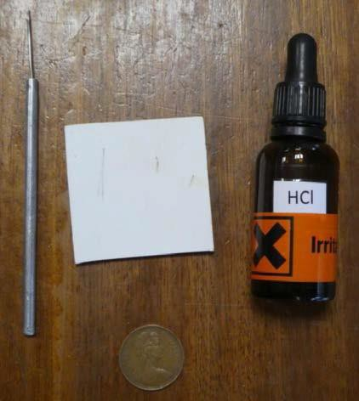
Apparatus:
Mineral testing equipment:
Streak plate/unglazed tile to test the colour of powdered minerals.

Dilute hydrochloric acid (“bench strength” 0.5 mol dm⁻³) in a dropper bottle to test if a mineral is a carbonate.

Copper coin (pre 1992 coins are 97% copper, post 1992 they are copper plated steel), hardness
~3.5 on Mohs’ scale.

Steel pin/needle (dissecting pin from Biology department or steel nail), hardness ~5.5 on Mohs’ scale.

Method:
Learners to also use own fingernail, hardness
~2.5 on Mohs’ scale.

Carry out the appropriate tests and record results.
Complete a table (similar to below) to logically record the results of observations.

Description and identification of mineral specimen X
Colour
Crystal shape
Cleavage
Fracture
Hardness | mineral is scratched by | mineral is softer than
Hardness | mineral is not scratched by | mineral is harder than
Hardness | hardness of mineral is between and on Mohs hardness scale
Density
Streak
Lustre
Reaction with cold dilute HCl
Conclusion: identification of mineral X

Analysis:
- Identify the mineral by appraising the results of the tests.
- Compare the mineral identification reached with published results eg. Eduqas mineral data sheet or other sources.

Description and identification of mineral specimen X
Colour | grey
Crystal shape | some crystals show a definite cubic shape
Cleavage | mineral cleaves along planes parallel to the edges of its cubic crystals
Fracture | none, mineral has cleavage
Hardness | mineral is scratched by copper coin | mineral is softer than
Hardness | mineral is not scratched by fingernail | mineral is harder than
Hardness | hardness of mineral is between ~2.5 and ~3.5 on Mohs hardness scale
Density | no accurate measurement made, but specimen seemed heavy and dense when hefted
Streak | light grey
Lustre | metallic
Reaction with cold dilute HCl | teacher advised me not to carry out this test
Conclusion: identification of mineral X GALENA

Teacher/Technician notes

Practical techniques which may be assessed:
- Use of physical and chemical testing to identify minerals:
  - density test
  - Mohs hardness test

Appropriate tests listed in the specification at F1.1e:

Colour: to be observed in natural light.
Crystal shape: common appearance of the mineral to be observed and use descriptive terms, learners might see individual well shaped crystals (form) or the shape of a mass of crystals when individual crystals cannot be seen when it is massive (habit). Commonly used terms to describe shape include rhombic, cubic, fibrous, kidney shaped.

Cleavage: to be observed and described in terms of number of cleavage planes and if multiple planes to look at how they intersect (e.g. one perfect, two planes at 90° or at 120°).

Fracture: to be observed and use descriptive terms, (e.g. conchoidal, uneven).
Hardness: tested by scratching the specimen with fingernail/copper coin/steel pin, observations can be checked using a hand lens. To be described in relative terms (harder than/softer than and link to figures, e.g. if a mineral is not scratched by a fingernail, but is scratched by a copper coin then it will have a hardness of ~2.5 - ~3.5).
If a mineral cannot be scratched by steel it has a hardness > 5.5.
© WJEC CBAC Ltd.
73

Density: (Hefting) With practice learners may be able to judge which minerals feel heavy or light for their size when they pick up the specimen in their hand. Care must be taken to allow for the size of the specimen. It would be good to have similar sized specimens of quartz, barites, galena etc to compare.

Density: (Calculation) See SP2.

Streak: the colour of a mineral’s powder, to be obtained by rubbing a mineral specimen on an unglazed white porcelain tile/streak plate. To be described using the colour of the powdered mineral (e.g. white, black, greenish black, lead grey, cherry red), or a negative result if the mineral is harder than the tile and scratches it (e.g. scratches streak plate).

Lustre: the way the mineral reflects light, to be observed and recorded using descriptive terms (e.g. vitreous, pearly, silky, resinous, metallic, dull).

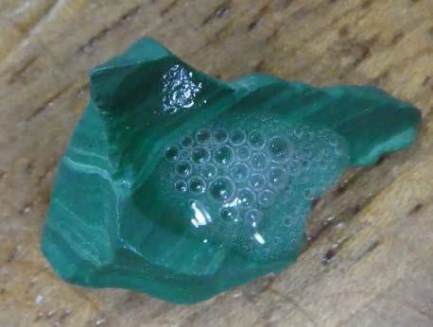
Reaction with cold dilute (0.5 mol dm⁻³) hydrochloric acid: this is to test the mineral for carbonates. Observations to be described in terms of positive reactions (effervesces/fizzes) to identify carbonates, or no reaction to identify non-carbonate.

Minerals not listed on the specification (specified on the mineral data sheet) could also be tested and results observed. The photograph shows the positive reaction to application of cold dilute (0.5 mol dm⁻³) hydrochloric acid and identification as a carbonate.

Health and Safety
- If acid has been applied, then the specimen should be washed afterwards to remove any remaining acid.

- Sulphide minerals should not be tested with acid.

- Learners should wash their hands after handing mineral specimens.

Rock forming minerals listed (as specified on the mineral data sheet) in specification section F1.1e:
quartz, calcite, feldspars (orthoclase, plagioclase), augite, hornblende, olivine, micas (biotite, muscovite), haematite, galena, pyrite, chalcopyrite, fluorite, barite, halite, gypsum, garnet, chiastolite/andalusite.

Title: SP2 Measurement of the density of minerals

Specification reference F1.1e
Density can be investigated using the formula Density =

Mass Volume

Aim: To determine the density of minerals using density formula.

Apparatus:
Samples of individual minerals (individual crystals or masses of crystals of one mineral) Electronic balance
Water
Graduated (Measuring) cylinder

Method:
- Select a mineral sample (individual crystal or mass of crystals of all the same mineral).

- Determine the mass of the sample using an electronic balance. Record the result.

- To determine volume there are 3 possibilities:

- Immerse the specimen in the water in the graduated cylinder. Measure how much the water rises (in ml). Record the result. Convert to cm³. (1ml=1cm³); Record the result.

- Place a beaker of water on a balance, zeroing the reading scale.
Suspend the specimen on a thin thread and record the balance reading (it is important to suspend the specimen in water and not to let it rest on the bottom of the beaker or touch the sides).
This measurement (recorded in grams) can be converted to a volume for the density calculation (1g = 1cm³).

- Where the mineral specimen has a regular shape (e.g. cuboid/rhombic crystals) the volume may be determined directly by measuring the length, width and height of
t h e mineral.

Analysis:

- Calculate the density of the sample using the formula Density =
Mass Volume

- Compare the density value you have calculated with published results e.g. Eduqas mineral data sheet or other sources.

Teacher/Technician notes:
Practical techniques which may be assessed:
- Use of physical and chemical testing to identify minerals:
  - density test
  - Mohs hardness test.

J. Use appropriate apparatus to record a range of quantitative measurements (to include mass, time, volume, temperature and length).

This method cannot be used for minerals embedded in a rock, but only for a single crystal or mass (students could discuss the reasons for this).

Only the volumes of insoluble minerals can be tested by methods A and B.

Title: SP3 Application of classification systems using distinguishing characteristics to identify unknown minerals

Specification reference: F1.1e

Aim: To apply a classification system using distinguishing characteristics to identify unknown minerals.

Apparatus:
Classification system/identification flow chart for minerals Samples of unknown minerals

Method:
Following an identification flow chart perform diagnostic tests on minerals in order to identify them.

Teacher/Technician notes:

Practical techniques which may be assessed:
F. Apply classification systems using distinguishing characteristics to identify unknown minerals and fossils.

- Use of physical and chemical testing to identify minerals:
  - density test
  - Mohs hardness test

Learners should follow a classification system/identification flow chart, and perform tests in order to identify a range of minerals. An example of an identification flow chart is given below, but an alternative could be used.

Learners could also devise their own identification flow charts, with other learners trying them out to test how effective they are.

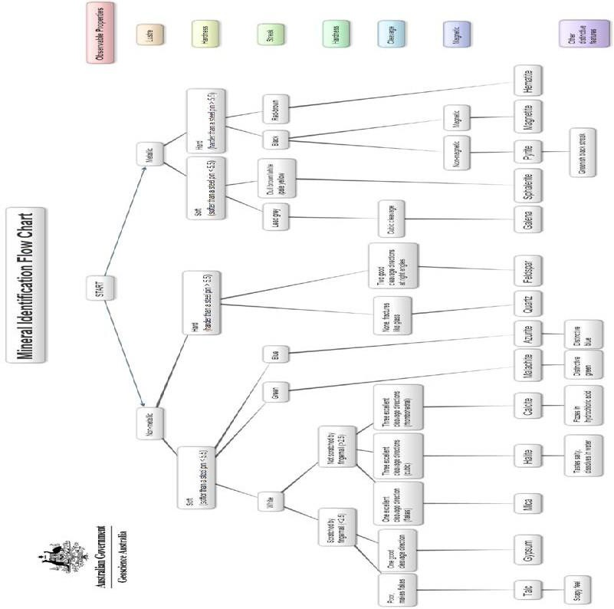

Based on Geoscience Australia material under Creative Commons Attribution 4.0 International License

Title: SP4 Production of scaled annotated scientific drawings of rock samples from hand samples using a light microscope, or hand lens

Specification reference: F1.1.g

Aim: To produce scaled annotated scientific drawings of rock samples from hand samples using a light microscope, or hand lens observation.

Apparatus:
Hand lens or light microscope Ruler
A sediment comparator (for sedimentary rocks) Plain paper
Pencil
A range of igneous, sedimentary and metamorphic rocks

Method:
- Place the rock under a light microscope or hand lens (if using a hand lens, hold the hand lens in front of one eye, keeping your head up to keep the rock specimen illuminated, and bring the rock into focus in front of the hand lens).

- If using a hand specimen, hold a ruler in the field of view in the same hand as the hand specimen, thus giving a scale to the rock texture seen. The use of a scale in this manner is called a fiducial scale. N.B. A fiducial marker or fiducial is an object placed in the field of view of an imaging system which appears in the image produced, for use as a point of reference or a measure as illustrated below.
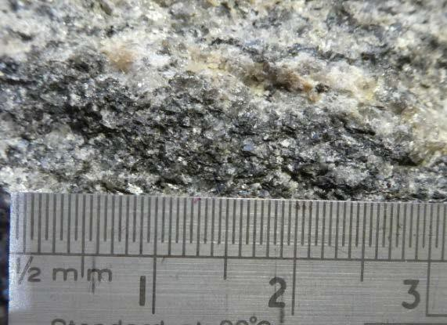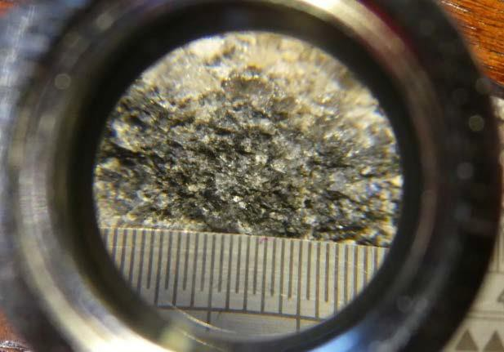

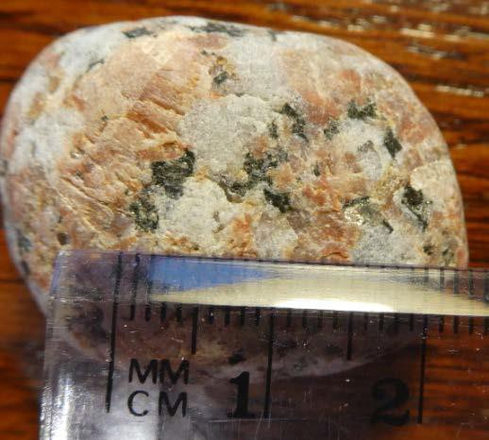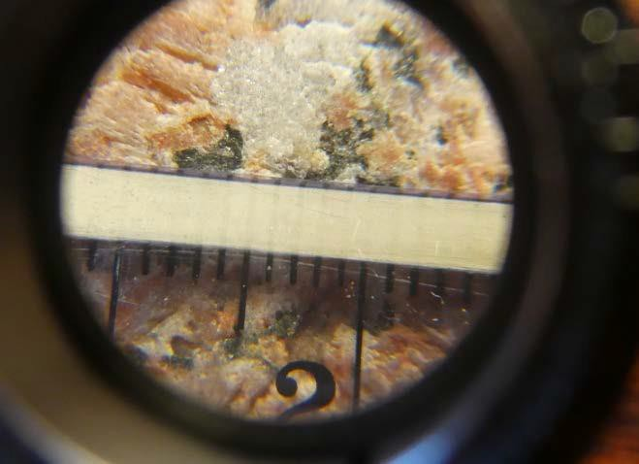

- Draw the textural features of the rock focusing on:
  - whether the rock is crystalline or clastic
  - crystal/grain sizes
  - range of crystal/grain sizes, sorting
  - shape of crystals/grains
  - foliation; mineral alignment/bedding/crystalline banding.
- Put a scale on the drawing.
- Annotate these textural features.
- Identify and annotate component minerals.
- Deduce the mode of origin as igneous, metamorphic or sedimentary.
- Identify the rock.
- Give the diagram a title.

Teacher/Technician notes:
Practical techniques which may be assessed:
- Production of scaled, annotated scientific drawings of fossils or small scale features, from hand samples using a light microscope, or hand lens observation.
J. Use appropriate apparatus to record a range of quantitative measurements (to include mass, time, volume, temperature and length).
L. Use methods to increase accuracy of measurements, such as use of a fiducial (scale in photograph/field sketch).

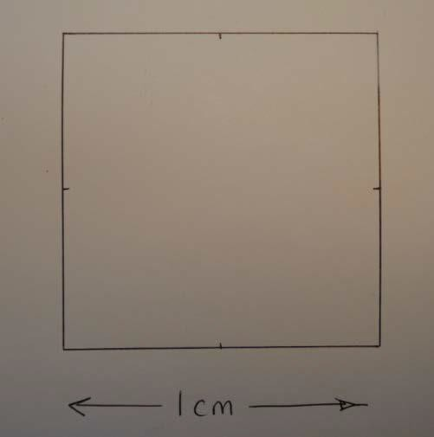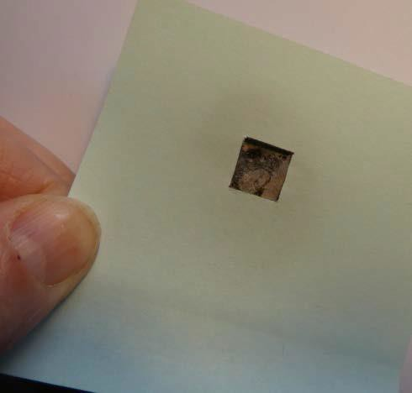Learners could be encouraged to draw scaled diagrams drawing the rock texture in a square box with scale markings (to “scale up”) the sizes of the crystals or grains. The size of the box will vary depending on the size of the crystals/grains in the hand specimen.

Learners could select a suitable area to draw by using a frame, (a “Post-It” note with a square cut out, 1cm or 2cm etc dependent on size of crystals/grains and features of the hand specimen).

Learners should draw a range of rocks (igneous, sedimentary, metamorphic) from those listed on the specification and any others that the teacher sees appropriate (for example those linked to field sites visited during the course).

The drawings should be to scale, and also annotated with the textural and mineralogical features (thus linking parts of the specification).

Learners should finish by identifying the rock type.

Title: SP5 Production of full rock description of macro and micro features from hand specimens and unfamiliar field exposures of sedimentary rocks in order to interpret component composition, colour and textures, to identify rock types and to deduce their environment of deposition

Specification reference: F2.1e

Aim: To produce a full rock description of macro and micro features from hand specimens and unfamiliar field exposures of sedimentary rocks in order to interpret component composition, colour and textures, to identify rock types and to deduce their environment of deposition.

Apparatus:
Hand lens or light microscope Ruler
A sediment comparator
A range of sedimentary rocks

Method:
- Select a hand specimen of a sedimentary rock (or an unfamiliar field exposure of sedimentary rock).

- Describe the texture of the rock:
  - clastic/fragmental/granular
  - grain size (s)
  - grain shape
  - the degree of sorting of the grains.

- Describe features of the composition of the rock:
  - colour(s)
  - identify the minerals within the rock
  - identify the composition of the cement.

- Observe and record any macro features in the sedimentary rock specimen such as sedimentary structures or fossil content.

Analysis:
- Identify the name of the rock using the textural characteristics and compositional information recorded.

- Refer to appropriate sources of information e.g. A level notes and internet sources, to determine the environment of formation of the rock using the evidence gathered.

Teacher/Technician notes:
Practical techniques which may be assessed:
- Produce full rock descriptions of macro and micro features from conserved hand samples and unfamiliar field exposures.

J. Use appropriate apparatus to record a range of quantitative measurements (to include mass, time, volume, temperature and length).

Specimens should be selected to cover the list of sedimentary rocks, features and environments stated in section F2.1d, e and f of the specification.

Sediments may be a useful resource (e.g. a range of sands from beach, river, glacial and desert environments).

N.B. A sediment comparator is a useful tool in describing sedimentary rock texture. However it is not permitted equipment in the examinations and learners should be made aware of this.

Title: SP6 Construction of graphic logs using appropriate scale and symbol sets for unfamiliar geological sequences and exposures to record data relevant to an investigation

Specification reference: F2.1e

Aim: To construct graphic logs using appropriate scale and symbol sets for unfamiliar geological sequences and exposures to record data relevant to an investigation.

Apparatus:
Tape measure Sediment comparator Hand lens
Graphic log template Graphic log key Pencil

Method:
- Select a section of a sedimentary sequence to be logged. If relevant use a sampling method for locating the log, either systematic sampling or random sampling. Ideally the sequence will have continuous exposure. If not it may be necessary to move sideways along the section to find where the beds higher up the sequence are exposed so that a continuous record can be produced.

- Decide on a vertical scale to be used e.g 1:10 (1 cm to 10 cm).

- Begin the graphic log at the base of the sequence.

- Record the following features: bed or rock unit thickness, lithology, grain size, sedimentary structures, colour, fossils and the nature of bed contacts (e.g erosive, gradational or sharp and planar).

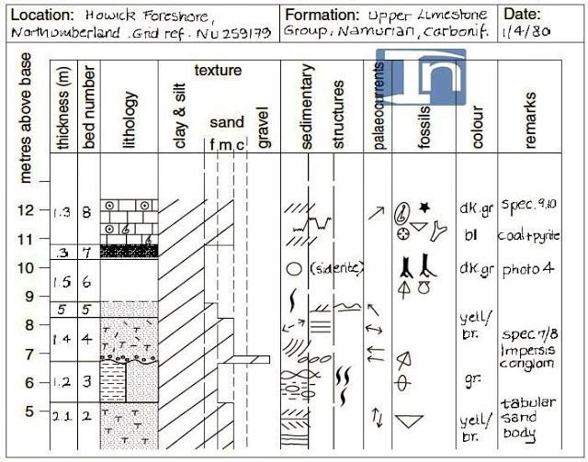
- Other features that may be logged include paleocurrent directions and additional textural features such as grain shape and sorting.
Geology In www.geology.com

Features to be aware of:

Bed or rock-unit thickness
The bed thickness is measured with a tape measure. When the beds are dipping steeply and logging is taking place on a surface oblique to the bedding planes care must be taken to ensure that the true thickness of the beds is recorded.
Where thin beds of the same lithology occur together they can be grouped together into a single unit with one lithology on the log.
Where thin beds of different lithology rapidly alternate, e.g. interbedded sandstones and shales, they can be treated as one unit and notes made of changes in the relative thickness of these beds up the sequence.

Lithology
On the graphic log, lithology is recorded in a column by using an appropriate shading in the key. If two lithologies are thinly interbedded, then the column can be divided in two by a vertical line and the two types of shading entered.

Texture (grain-size)
On the log there should be a horizontal scale for the grain size column. For many rocks this will show mud (clay + silt), sand (divided into fine, medium and coarse) and gravel. Gravel can be divided further if coarse sediments are being logged. Having determined the grain- size of a rock unit, this is marked on the log and the area shaded (the wider the column, the coarser the rock).

Sedimentary structures and bed boundaries
Sedimentary structures within the beds can be recorded in a column by symbols shown in a key. The bed boundaries can be recorded in the lithology column separating one bed from another. These boundaries may be:
  - erosive (shown as a wavy/irregular line)
  - gradational (shown as a dashed line)
  - sharp and planar (shown as a straight line)

Palaeocurrent directions
If required, these can be recorded on the graphic log as an arrow showing the compass direction and the measurements can be recorded separately in a field notebook.

Fossils
Fossils indicated on the graphic log should record the main fossil groups present in the rocks. Symbols which are commonly used are shown in a key and can be placed in the fossil column. The degree of fragmentation of the fossils may be recorded in the ‘remarks’ column of the graphic log.

Colour
The colour of a sedimentary rock is best recorded by a series of abbreviations
e.g. bl = black, li gr = light grey.

‘Remarks’ column
This can be used for extra information regarding sedimentary structures, texture, lithology, fossil preservation as well as cross references to photographs or field sketches.

Analysis:
Each bed should be analysed to determine the processes involved in deposition and the environment of deposition of the sedimentary rock contained.

In this way, changes in the environment of deposition up the sequence (over time) can be determined.

Teacher/Technician notes:
Practical techniques which may be assessed:

- Construct graphic logs using appropriate scale and symbol sets for unfamiliar geological sequences and exposures.

- Use sampling techniques in fieldwork.

J. Use appropriate apparatus to record a range of quantitative measurements (to include mass, time, volume, temperature and length).

An example of a graphic log template (AS and A level)
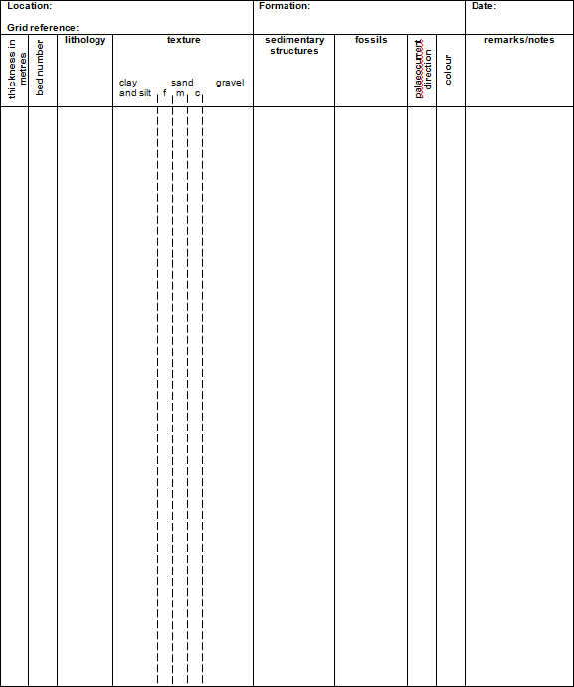

Devise suitable symbols to use for any sedimentary rocks/sediments found in the graphic log.

Siliciclastic sediments |  | Carbonates | Others
Clay/ mudstone | Sandstone (undifferentiated) | Limestone (undifferentiated) | Coal
Shale | Conglomerate | Oolitic limestone | Evaporite
Siltstone | Breccia | Chalk | Volcaniclastic sediment
Devise others as required

Sedimentary structures

Devise suitable symbols to use for any sedimentary structures found in the sedimentary rocks/sediments.

Cross-bedding | Cross-lamination | Asymmetrical ripple marks | Erosive bed boundary
Graded bedding | Desiccation features | Load/Flame casts | Gradational bed boundary
Parallel Lamination | Symmetrical ripple marks | Flute casts | Sharp/planar bed boundary
Devise others as required

Fossils
Devise suitable symbols to use for any fossils found in the sedimentary rocks/sediments.

Brachiopod | Coral-colonial | Graptolite | Burrow
Cephalopod | Coral-solitary | Plant | Track/trail
Bivalve | Trilobite
Devise others as required

A suitable program for drawing and manipulating graphic log data (SEDLOG) can be downloaded free at http://thames.cs.rhul.ac.uk/sedlog/
Graphic logging is basically a list or diary of the rocks and their features in a “standard” format which enables interpretation of processes and environment and any changes.

Graphic logging may be practised in the laboratory prior to it being undertaken on fieldwork by construction of a “mock cliff face”.
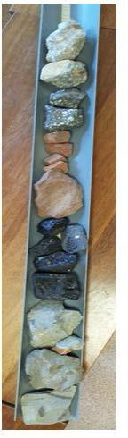
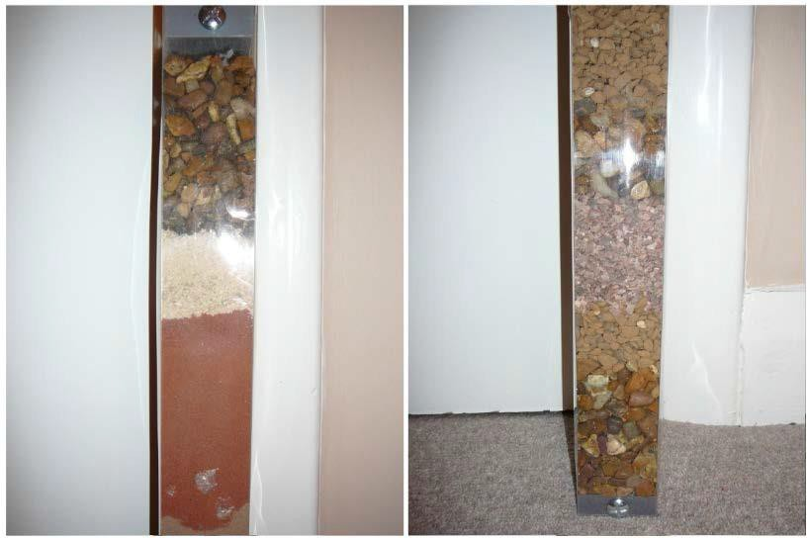

A B

This may be achieved by:
  - putting rocks in a length of gutter to build up a sequence (A) or
  - an alternative method (B) involves a 1 metre (or other) plastic tube (a suitably reinforced container that once housed a curtain pole is ideal) is filled with sediments of different types (to show a variety of mineralogy, textures and colours). To ensure a sharp, rather than a diffuse boundary between fine sediment overlying coarser sediment, it is best if the finer sediment is initially contained in a see-through plastic bag which prevents settlement into the open pore spaces in the coarser sediment below. With care, suitable sedimentary structures can be achieved – load structures, graded beds, cross bedding, imbricate structures etc.

Title: SP7 Use of photomicrographs to identify minerals and rock textures of sedimentary rocks in order to identify rock types and to deduce their environment of deposition

Specification reference: F2.1.e

Aim: To use photomicrographs to identify minerals and rock textures of sedimentary rocks in order to identify rock types and to deduce their environment of deposition.

Apparatus:
Photomicrographs or drawings of photomicrographs of a range of sedimentary rocks Ruler
Mineral data sheet.

Method:
- Select a photomicrograph of a sedimentary rock.

- Describe the texture of the rock:
  - clastic/fragmental/granular
  - grain size (s)
  - grain shape
  - the degree of sorting of the grains.

- Describe features of the composition of the rock:
  - identify the minerals within the rock
  - identify the composition of the cement.

Analysis:
- Identify the name of the rock using the textural and compositional characteristics.

- Refer to appropriate sources of information e.g. A level notes, internet sources to determine the environment of formation of the rock using the evidence of mineralogy and texture.

Teacher/Technician notes:

Practical techniques which may be assessed:
I. Use of photomicrographs to identify minerals and rock textures.

- Use appropriate apparatus to record a range of quantitative measurements (to include mass, time, volume, temperature and length).

If petrological microscopes are available learners could be provided with thin sections of a variety of rock types which could be drawn and annotated.

Alternatively learners could draw and annotate images of thin sections using internet sources or learners could be provided with copies of images for annotation.

Websites containing thin section images of a variety of rocks include:
http://www.earthscienceeducation.com/virtual_rock_kit/DOUBLE%20CLICK%20TO%20S TA RT.htm

https://wwwf.imperial.ac.uk/earthscienceandengineering/rocklibrary/identify.php?itype=4&i st ep=1
https://geohubliverpool.org.uk/resource/photomicrographs-sedimentary-rocks/

Images should be selected to cover the suggested list of sedimentary rocks in section F2.1e of the specification.

Title: SP8 Production of full rock description of macro and micro features from hand specimens and/or unfamiliar field exposures of igneous rocks in order to interpret component composition, colour and textures, to identify rock type and to deduce their cooling history

Specification reference: F2.2.b

Aim: To produce full rock description of macro and micro features from hand specimens and/or unfamiliar field exposures of igneous rocks in order to interpret component composition, colour and textures, to identify rock type and to deduce their cooling history.

Apparatus:
Hand lens or light microscope Ruler
A range of igneous rocks

Method:
  - Select a hand specimen of an igneous rock (or an unfamiliar field exposure of igneous rock).

  - Describe the texture of the rock:
    - crystalline
    - crystal size (s): coarse (>3mm), medium (1-3mm), fine (<1mm)
    - other textural features: equicrystalline, porphyritic, vesicular, glassy, fragmental
    - crystal shape: euhedral, subhedral, anhedral.

  - Describe and identify the minerals within the rock

  - Observe any macro features from the igneous rock specimen/field exposure e.g. pillow structures, aa/pahoehoe surfaces, columnar joints.

Analysis:
- Identify the name of the rock using the textural characteristics and mineralogy.

- Refer to appropriate sources of information e.g. A level notes, internet sources to determine the cooling history of the rock using the evidence from the texture.

Teacher/Technician notes:

Practical techniques which may be assessed:
H. Produce full rock descriptions of macro and micro features from conserved hand samples and unfamiliar field exposures.

J. Use appropriate apparatus to record a range of quantitative measurements (to include mass, time, volume, temperature and length).

Specimens should be selected to cover the suggested list of igneous rocks in the specification section F2.2b. Other specimens may be used.

Title: SP9 Use of photomicrographs to identify minerals and rock textures of igneous rocks to identify rock type and to deduce their cooling history

Specification reference: F2.2.b

Aim: To use photomicrographs to identify minerals and rock textures of igneous rocks to identify rock type and to deduce their cooling history.

Apparatus:
Photomicrographs or drawings of photomicrographs of a range of igneous rocks Ruler
Mineral data sheet

Method:
- Select a photomicrograph of an igneous rock.
- Describe the texture of the rock:
  - crystalline
  - crystal size (s): coarse (>3mm), medium (1-3mm), fine (<1mm)
  - other textural features: equicrystalline, porphyritic, vesicular, glassy, fragmental
  - crystal shape: euhedral, subhedral, anhedral
- Describe and identify the minerals within the rock.

Analysis:
- Identify the name of the rock using the textural characteristics and mineralogy.
- Refer to appropriate sources of information e.g. A level notes, internet sources to determine the cooling history of the rock using the evidence from the texture.

Teacher/Technician notes:

Practical techniques which may be assessed:
I. Use of photomicrographs to identify minerals and rock textures.

- Use appropriate apparatus to record a range of quantitative measurements (to include mass, time, volume, temperature and length).
If petrological microscopes are available learners could be provided with thin sections of a variety of rock types which could be drawn and annotated.
Alternatively learners could draw and annotate images of thin sections using internet sources or learners could be provided with copies of images for annotation.
Websites containing thin section images of a variety of rocks include:
http://www.earthscienceeducation.com/virtual_rock_kit/DOUBLE%20CLICK%20TO%20S TA RT.htm
https://wwwf.imperial.ac.uk/earthscienceandengineering/rocklibrary/identify.php?itype=4&i st ep=1
https://geohubliverpool.org.uk/resource/photomicrographs-igneous-rocks/
Images should be selected to cover the suggested list of igneous rocks in the specification section F2.2b.

Title: SP10 Production of full rock description of macro and micro features from hand specimens and/or unfamiliar field exposures of metamorphic rocks in order to interpret component composition, colour and textures, to identify rock type and to deduce the temperature and pressure conditions of their formation

Specification reference: F2.2.g

Aim: To produce full rock description of macro and micro features from hand specimens and/or unfamiliar field exposures of metamorphic rocks in order to interpret component composition, colour and textures, to identify rock type and to deduce the temperature and pressure conditions of their formation.

Apparatus:
Hand lens or light microscope Ruler
A range of metamorphic rocks

Method:
  - Select a hand specimen of a metamorphic rock (or an unfamiliar field exposure of metamorphic rock).

  - Describe the texture of the rock:
    - crystalline
    - foliated, including type of foliation (slaty cleavage, schistosity and gneissose banding) or non-foliated
    - crystal size (s)
    - porphyroblastic or granoblastic
    - crystal shape

  - Describe and identify the minerals within the rock.

  - Observe any macro features from the metamorphic rock.

Analysis:
- Identify the name of the rock using the textural characteristics and mineralogy.

- Refer to appropriate sources of information e.g. A level notes, internet sources to determine the temperature and pressure conditions of the formation of the rock using the evidence of mineralogy and texture.

Teacher/Technician notes:

Practical techniques which may be assessed:
H. Produce full rock descriptions of macro and micro features from conserved hand samples and unfamiliar field exposures.

J. Use appropriate apparatus to record a range of quantitative measurements (to include mass, time, volume, temperature and length).

Specimens should be selected to cover the suggested list of metamorphic rocks in the

Title: SP11 Use of photomicrographs to identify minerals and rock textures of metamorphic rocks to identify rock type and to deduce the temperature and pressure conditions of their formation

Specification reference F2.2g
Aim: To use photomicrographs to identify minerals and rock textures of metamorphic rocks to identify rock type and to deduce the temperature and pressure conditions of their formation.

Apparatus:
Photomicrographs or drawings of photomicrographs of a range of contact and regional metamorphic rocks
Ruler
Mineral data sheet

Method:
- Select a photomicrograph of a metamorphic rock.
- Describe the texture of the rock:
  - crystalline
  - foliated, including type of foliation (slaty cleavage, schistosity and gneissose banding) or non-foliated
  - crystal size (s)
  - porphyroblastic or granoblastic
  - crystal shape.
- Describe and identify the minerals within the rock.

Analysis:
- Identify the name of the rock using the textural characteristics.
- Refer to appropriate sources of information e.g. A level notes, internet sources to determine the temperature and pressure conditions of formation of the rock using the evidence of mineralogy and texture.

Teacher/Technician notes:
Practical techniques which may be assessed:
I. Use of photomicrographs to identify minerals and rock textures.
- Use appropriate apparatus to record a range of quantitative measurements (to include mass, time, volume, temperature and length).
If petrological microscopes are available learners could be provided with thin sections of a variety of rock types which could be drawn and annotated.
Alternatively learners could draw and annotate images of thin sections using internet sources or learners could be provided with copies of images for annotation.

Websites containing thin section images of a variety of rocks include: https://goo.gl/2n3j6h
https://goo.gl/Nvtmbz https://geohubliverpool.org.uk/resource/photomicrographs-metamorphic-rocks/
Images should be selected to cover the suggested list of metamorphic rocks in the

Title: SP12 Location of geological features onto a base map Specification reference: F2.3.b
Aim: To locate geological features in the field onto a base map using traditional navigation and basic field survey skills but without the use of GPS.

Apparatus:
Simple base map of field area Compass
Pencil

Method:
  - Determine the distance of a geological feature from prominent landmark e.g, a headland, river or bridge by measurement or by pacing. (This can only be undertaken if learners have calculated their typical stride length prior to fieldwork.)

  - Determine the direction of a geological feature from prominent landmarks by taking bearings using a compass as follows:
    - Standing at the geological feature, point the direction of travel arrow of the compass (the long dimension of the compass) at the landmark
    - Turn the compass dial until the North arrow in the base plate of the dial lies under the red “hovering North arrow”
    - Place the compass on the map so that the orienting lines within the base of the compass dial are parallel to the map’s North-South lines (meridians)
    - Move the compass across the map so that the top corner of one long edge ends at the landmark, keeping it aligned with the map’s meridians.
    - Draw a feint line on the map along the edge of the compass from the landmark. The geological feature is somewhere along this line.
    - If a bearing is taken to a second landmark, and the process repeated, the geological feature should be at the point where the two feint lines meet on the map.

  - Locate the geological feature onto the base map using approximate distances and bearings from prominent landscape features.

Information on how to take a bearing can be found at: https://www.youtube.com/watch?v=BADUq3Maqbo

Analysis:
None required.

Teacher/Technician notes:
Practical techniques which may be assessed:
- Location of geological features in the field using traditional navigation and basic field survey skills without the use of GPS.

Simple base maps of field areas should be produced by the teacher prior to fieldwork activity.
These can be simple hand drawn maps, or derived from OS maps (or electronic versions) but all should have a scale and orientation.

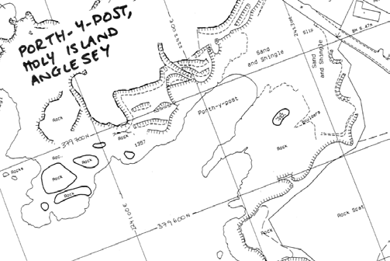

Maps can be derived from looking at map views online (or satellite views) or from traditional paper maps.

Electronic maps are available from Google Earth and Google Maps and Bing Maps. Although the more useful maps have OS map data (e.g. contour lines).

Bing https://www.bing.com/mapspreview

Ordnance Survey view should be selected (tool bar on the top right hand side), scale appears in the bottom right hand corner, and grid lines give orientation. Note that the grid lines often appear at an angle.

“Screen shots” or use of the “snipping tool” can give good base maps.

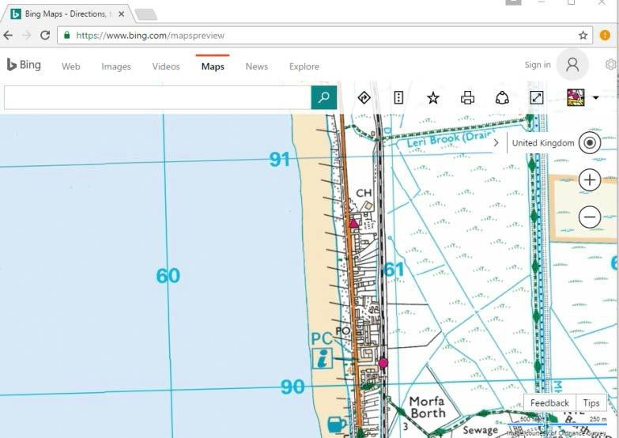
Microsoft bing maps www.bing.com/mapspreview

It may be necessary to number the grid lines if they are not prominently labelled on the selected section.

Many FE colleges have subscribed to the Edina program and have access to Digimap. http://digimapforcolleges.edina.ac.uk/ However this is usually only available within your college.

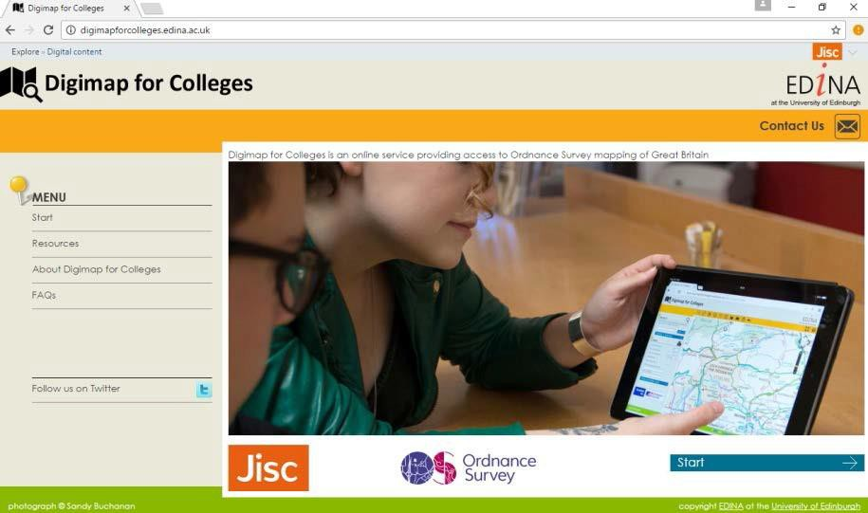

Digimap for Colleges http://digimapforcolleges.edina.ac.uk/

Digimap is a range of Ordnance Survey digital maps, covering the whole of GB. Included are the most detailed maps OS make which show building outlines. These maps are suited to being used for local area studies, studying land use on the high street, locating businesses or planning a new construction site. They are digital versions of traditional OS maps that are commonly used for hill walking and outdoor activities, as well as street-level, road-atlas style and regional maps.

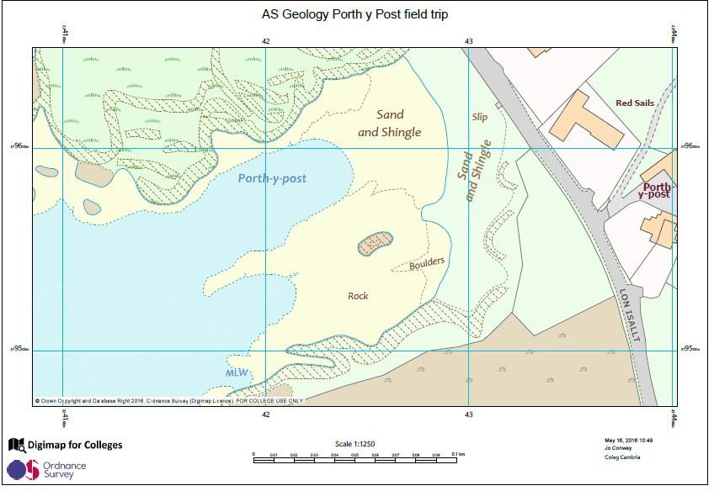
The maps are complemented by a range of tools that allow you to enhance the maps. Measurement tools, Annotation Tools (you can use to add points), Save (save any maps that you create to come back to later) and Print (to create printable PDF or JPG maps). Printable maps can be printed to make hard copies, saved to a computer drive.
Digimap for Colleges http://digimapforcolleges.edina.ac.uk/

Grid lines are parallel with the edge of the paper/box that the map appears in. And scale bars are very sharp and easily used for distances.
“Screen shots” are useful for showing maps at alternative scales.

Title: SP13 Identification of the location of geological features in the field using six figure grid references on maps

Specification reference: F2.3.b

Aim: To identify the location of geological features in the field using six figure grid references on maps.

Apparatus:
Geological features located on a map showing grid squares.

Method:
  - Check that the map has grid lines running up and down the map. (These lines are Eastings and increase in number the further to the right or East, assuming that North is orientated up the map.)

  - Check that the map has grid lines running across the map. (These lines are Northings and increase in number the further up the map, or North, assuming that North is orientated up the map.)

  - Read the numbers along the bottom of the map first (the Eastings) and the numbers up the side of the map second (the Northings).

  - Locate a geological feature in a grid square. Give a four figure grid reference for that square as a whole, with the Easting and Northing values defining the bottom left hand corner of the square e.g. A geological feature adjacent to the Mile Stone MS in the map below is within grid square 6900.

  - To locate a more precise location of a geological feature within a grid square, a six- figure grid reference is used e.g. the geological feature adjacent to the Mile Stone
MS in the map below is at 698002, 8 of the way across and 2 of the way up grid
square 6900. 10 10

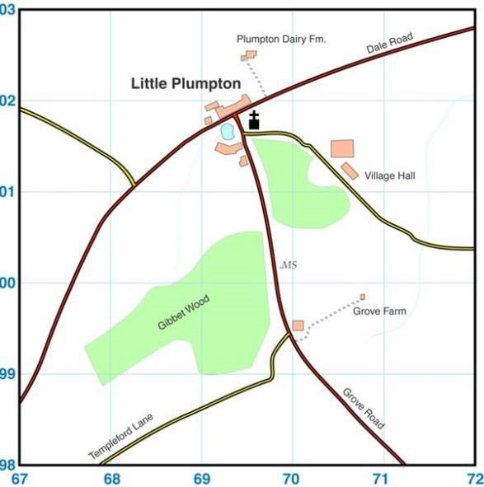
  - The six-figure grid reference for geological features should be recorded in a field notebook and on any field sketches of the features.

N
0
1

Wikimedia Creative Commons http://bit.ly/2j7ElUC
km

© WJEC CBAC Ltd.

100

Analysis:
None required.

Teacher/Technician notes:
Practical techniques which may be assessed:
    - Location of geological features in the field using traditional navigation and basic field survey skills without the use of GPS.

Title: SP14 Production of scaled, annotated field sketches at unfamiliar field exposures to record data relevant to an investigation

Specification reference: F2.3b

Aim: To produce scaled, annotated field sketches at unfamiliar field exposures to record data relevant to an investigation.

Apparatus:
Field notebook or plain paper large enough to be able to include the required amount of drawn and written detail
Pencil (soft) and eraser Clipboard / something to rest on
Metre rule or equivalent (to determine scale) Compass (to determine orientation)

Method:
      - Consider the purpose of the field sketch, i.e. what is to be shown – decide on what is important to include and make prominent in the sketch. Make a list of terms first, then draw.

      - Find a comfortable sheltered position to work from, safe and easily accessible, (and gives the same perspective as the secondary data if needed), and is free from obstruction.

      - Identify a frame for the sketch – holding up a cardboard frame may help to do this. Alternatively define what will form the top and bottom of your sketch e.g. the skyline or top of a cliff, and the base of a cliff.

      - Orientate the paper so that it mirrors the dimensions of the sketch to be drawn e.g. orientate the paper in “landscape” for a sketch that will be wider than tall.

      - Draw a frame, or the features that will form the top and bottom of the sketch, onto the paper.

      - Draw the main features of the sketch which form the most prominent or important geological features first.

      - Draw geological features of finer detail.

      - Add labels and annotations for the geological features.

      - Add a scale for the field sketch.

      - Label the direction, bearing, grid reference and a short written description of the ‘view’.

Considerations
Scale – this can be difficult to assess, particularly when sketching a large landscape area. Starting the sketch with the things furthest away and working towards you will help. Also, add labels to show things of known height (refer to map of the area to find this).

Slope – drawing the correct angle of a slope can be problematic. Try holding a pencil away from you, towards the slope and then transfer it to the paper.

Weather – adverse conditions will have an immediate, preventative effect on the ability to carry out a field sketch!

Use photography to compliment the field sketch. Photos can be used to add detail to the sketch later, which there may not have been time to include or suitable conditions to achieve in the field.

The field sketch needs to be ‘fit for purpose’ to add value to your investigation - this takes some thought and consideration. It’s very easy to just ‘knock out’ the odd quick sketch which adds nothing to an investigation.

Labels should be used to pick out the main features, and annotations to comment on certain aspects in order to bring out the main ‘message' to be conveyed.

Analysis:
None required

Teacher/Technician notes:

Practical techniques which may be assessed:
    - Identification of geological structures in the field recording observations as field sketches.

J. Use appropriate apparatus to record a range of quantitative measurements (to include mass, time, volume, temperature and length).

L. Use methods to increase accuracy of measurements, such as timing over multiple observations, or use of a fiducial (scale in photograph/field sketch).

Learners may practice field-sketching in the classroom prior to fieldwork.
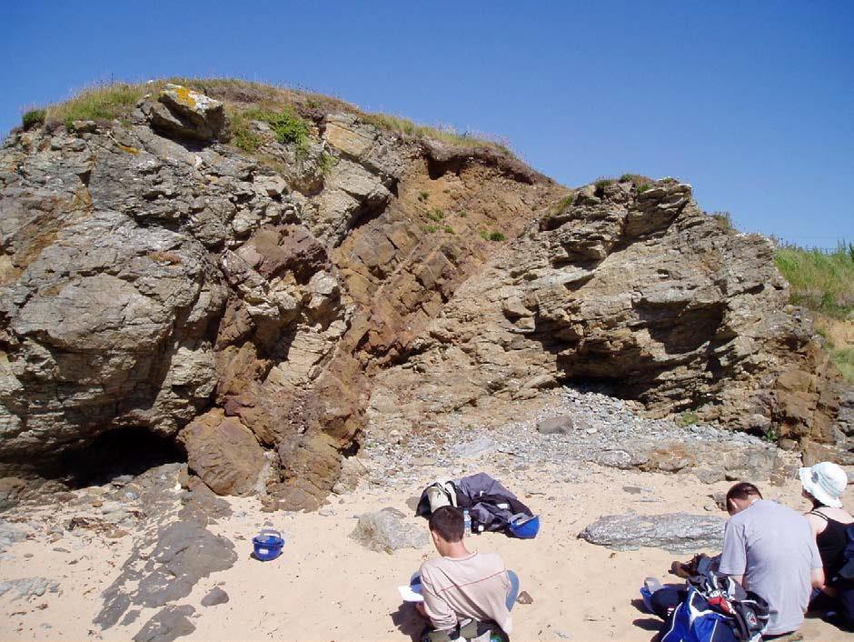
Task 1: In class situations, learners could use photographs to be given practice in how to produce a large field sketch, possibly using tracing paper or a transparency to help. See example below.

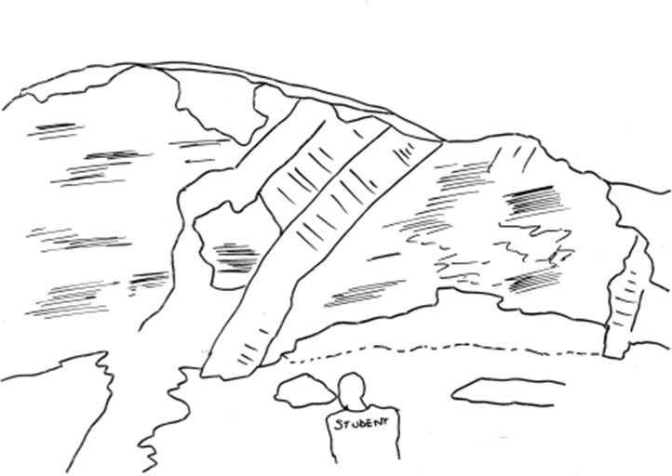
It might look something like this when finished.

From the following description, try to label and annotate your field sketch:
“the area was a beach, with a small shingle storm beach at the top and some vegetation on the area behind. The exposure faced east. In the middle of the exposure there were two basalt igneous intrusions cutting across the country rock (which was a heavily folded schist). The contacts were sharp. There was another dyke to the right of the exposure. The dykes were more coarsely crystalline towards their middles but still fine.”

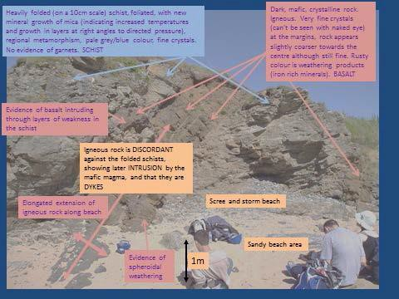
Labels/annotations might look something like this when it is finished.

North South

Task 2: In class situations, learners could use photographs to be given practice in how to produce a small detailed sketch, possibly using tracing paper or a transparency to help. See example below.

Using the photograph below produce a detailed interpretation of the contact between the country rock and the igneous contact, drawing and annotating a field sketch, or annotating the photograph.
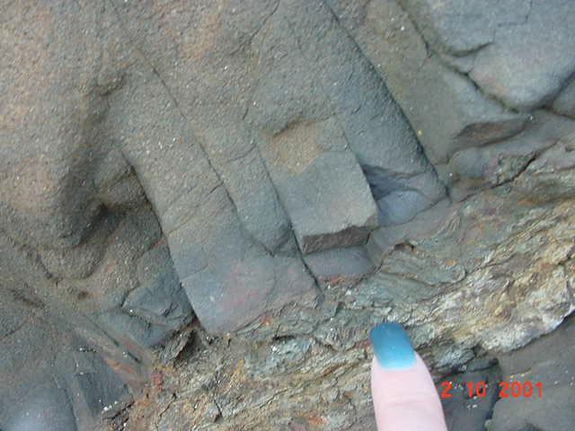

It could look something like this.
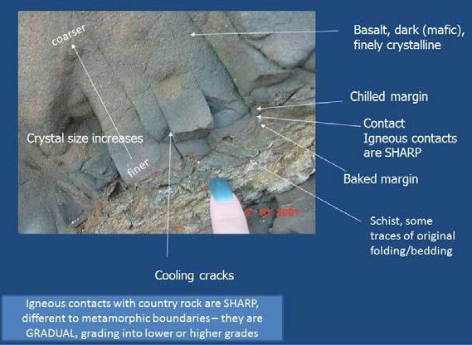

Information on how to construct field sketches can be found at

https://geohubliverpool.org.uk/wp-content/uploads/2019/07/RF18-Field-sketches-how-to- draw-them.pdf

https://earthscience.org.uk/resources/fieldwork-skills/

Title: SP15 Measurement of dip and strike elements: dip angle, dip and strike directions of planar surfaces, relevant to an investigation

Specification reference: F2.3b

Aim: To measure dip and strike elements: dip angle, dip and strike directions of planar surfaces, relevant to an investigation.

Apparatus:
Compass clinometer (or separate compass and clinometer)

Method:

- Strike direction
  - Set the compass clinometer to East-West by turning the bezel so that the values
90 and 270 intersect the markers on the compass which are often a pair of fluorescent dashes. This puts the compass clinometer in clinometer mode.
  - Hold the clinometer vertically and place it on its long edge on the plane (e.g. a bedding plane).
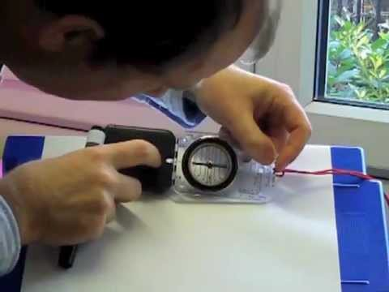
  - Move the clinometer round, on its long edge, keeping it vertical, until the clinometer reading is zero.
Havering sfc YouTube http://bit.ly/2k6DqIC

  - Draw a line on the plane, using chalk in the field. This line is the direction of strike.
  - Turn the compass clinometer horizontal, so that it is now in compass mode.
  - Point the long axis of the compass along the chalk line representing the direction of strike.

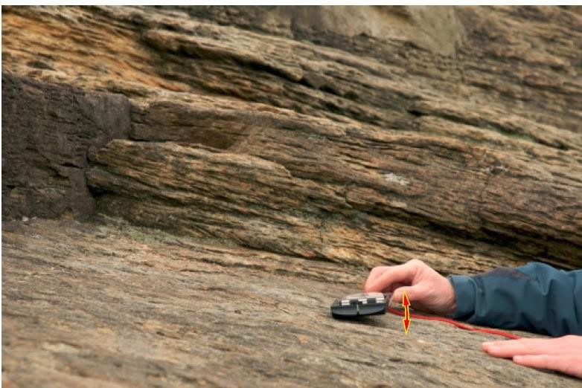
Geology In www.geology.com

  - Turn the dial of the compass (the bezel) so that red suspended arrow overlies the red arrow in the base of the bezel.
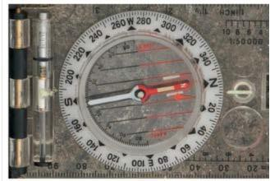
Geology In www.geology.com

  - Read off the direction of the strike on the rim of the bezel where the rim intersects the “marker” which is often a fluorescent “dash”. There are two of these and it does not matter which is used. They will be 180 degrees apart.
  - Record the direction of strike as a 3 digit number. If the directions of strike are 8° and 188°, this is recorded as either 008°or 188°.

Angle of dip
  - Put the compass clinometer into clinometer mode again. (Set the compass clinometer to East-West by turning the bezel so that the values 90 and 270 intersect the markers on the compass which are often a pair of fluorescent dashes.)
  - Hold the clinometer vertically and place it along its long edge on the plane. Move the clinometer round, on its long edge, keeping it vertical and in contact with the rock, until the clinometer reaches its maximum reading. This is the true dip reading and happens when the clinometer is pointing down the plane at 90 degrees to the direction of strike.

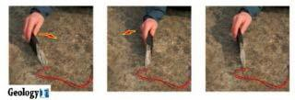
Geology In www.geology.com

  - Read off the dip angle by reading off where the arrow, which hangs down inside the bezel, intersects the scale in the inside of the bezel. The value will be between 0 and 90.
  - Record the angle of dip as a two digit number e.g. 42°.

Direction of dip
  - The direction of dip will be at a bearing of 90° from the direction of strike.
  - It is the direction to which the plane loses height, the direction to which the angle of dip reading was taken.
  - It can be recorded as a compass direction e.g. S, W, NW, SE etc.

A complete dip and strike reading for a planar surface such as a bedding plane should be recorded in the following way.

Strike direction (3 digits)/Dip angle (2 digits)/Dip direction (a compass direction)

e.g. 188/42/E

- Apparent Dip

On occasions it is not possible to place a compass clinometer on a 3-dimensional outcrop of a planar surface and only a 2-dimensional view of a dipping plane is visible e.g.in the face of a cliff. In such cases a plane can be seen to be dipping but it is not possible to determine the direction of strike of the plane, nor therefore to determine the true dip direction.
In these situations all that can be recorded is the angle at which the plane appears to be dipping (recorded as 2-digits) and the direction to which the plane appears to be dipping (recorded as a 3-digit bearing). These readings record the Apparent Dip of the plane rather than the True dip of the plane and this must be noted alongside the readings.

e.g. 32/185 Apparent Dip
Repetition of readings: Planar surfaces in geology are often irregular. For this reason one reading of dip and strike may not be representative of a planar surface or of a series of planar surfaces.
It may be worth taking more than one reading of dip and strike on a plane or on a concordant series of adjacent planes in order to increase the accuracy of measurements.
Sampling: Where a series of dip and strike readings are to be taken for an investigation into a sequence of folds for example, a sampling method should be used to ensure that the readings are representative of those required for the investigation.
The pros and cons of various sampling methods (random, systematic, stratified) should be considered before a sampling strategy is chosen.

Analysis:
Analysis of the data relevant to an investigation

Teacher/Technician notes:

Practical techniques which may be assessed:
C. Use of a compass clinometer to measure two and three-dimensional geological data across a range of scales such as the dip and strike of planar surfaces, or the apparent dip of fold limbs exposed on a hillside or cliff section.

E. Use sampling techniques in fieldwork.

J. Use appropriate apparatus to record a range of quantitative measurements (to include mass, time, volume, temperature and length).

L. Use methods to increase accuracy of measurements such as timing over multiple observations or use of a fiducial (scale in photograph/field sketch).

Video examples of how to take dip angle, strike direction and dip direction can be found on Youtube e.g.
https://www.youtube.com/watch?v=FbXhooadhZw

https://www.youtube.com/watch?v=VCN2q6xwTNk

and also on video clips at https://earthscience.org.uk/resources/fieldwork-skills/

Title: SP16 Application of classification systems using distinguishing charatceristics to identify unknown fossils

Specification reference: F3.1d

Aim: To apply classification systems using distinguishing characteristics to identify unknown fossils.

Apparatus:
Classification system/identification flow chart for fossils Specimens (or specimens and photographs) of unknown fossils

Method:
Learners devise their own identification flow charts using fossils and photographs of a range of examples within individual fossil groups.
The flowcharts are then used by other learners to identify a range of fossils within one fossil group.

Teacher/Technician notes:
Practical techniques which may be assessed:
F. Apply classification systems using distinguishing characteristics to identify unknown minerals and fossils.

Learners devise their own identification flow charts using fossils and photographs of a range of examples within individual fossil groups.
The flow charts should make use of variations in the stated hard parts or additional hard parts for fossil groups listed in the specification.

e.g. A range (4 or 5) brachiopod specimens could be identified using variation in shell shape, symmetry, features of pedicle or brachial valves, the presence or absence of a foramen and relative length and shape of the hinge line.
Suitable brachiopods could include the following:
Spirifer, Rhynchonella, Productus, Leptaena, Lingula, Kirkidium.

  - A range of trilobites could be identified from photographs and specimens using a flow chart which makes use of some or all of the following:
    - relative sizes of cephalon, thorax and pygidium
    - the relative size of the glabella
    - the presence or absence of eyes
    - the relative size, shape or location of eyes
    - The presence or absence of genal spines
    - The relative length of genal spines
    - The presence or absence of thoracic spines
    - the presence or absence of a spine on the pygidium
    - the number of thoracic segments
    - the number of segments in the pygidium.

A series of photographs are included for this exercise. Others could be used.

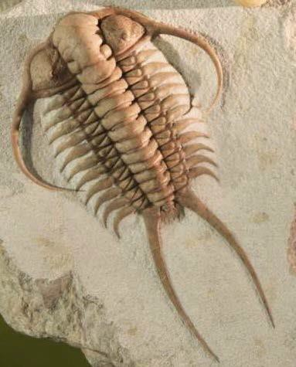
Cheirurus

Wikimedia Creative Commons http://bit.ly/2jqm9Wd

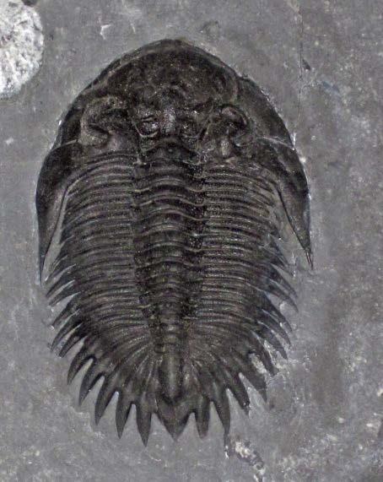
Bellacartwrightia

Flickr Creative Commons http://bit.ly/2ieukaF

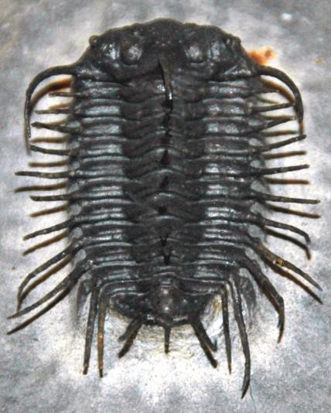
Isoprusia

Flickr Creative Commons http://bit.ly/2jyOSMV

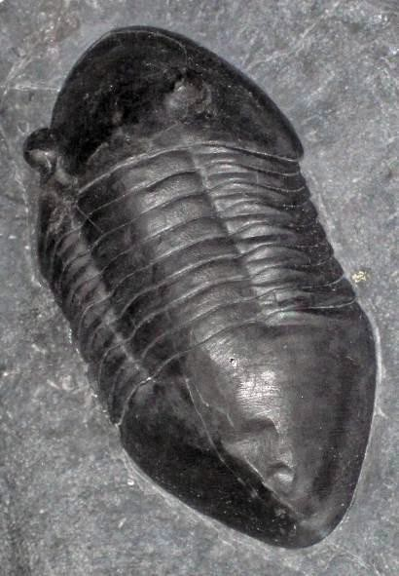
Isotelus

Wikimedia Creative Commons http://bit.ly/2jisPqa

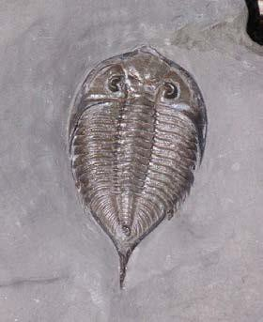
Dalmanites

Wikimedia Creative Commons http://bit.ly/2j3GKmT

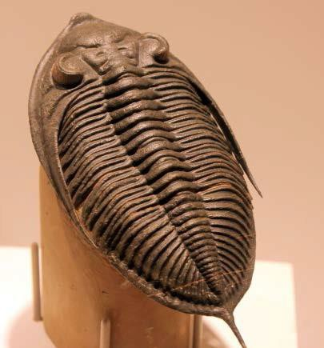

Zlichovaspis

Wikimedia Creative Commons http://bit.ly/2jyV7jG

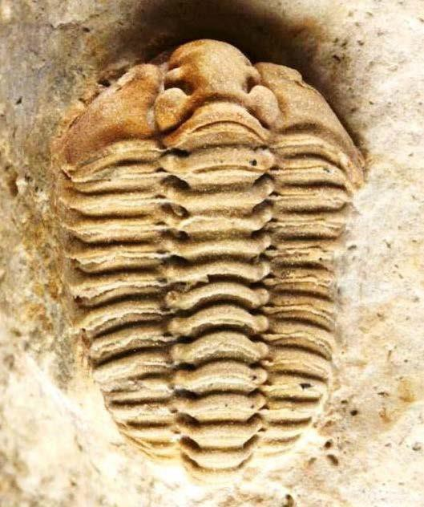

Calymene

Wikimedia Creative Commons http://bit.ly/2ifQ1ni

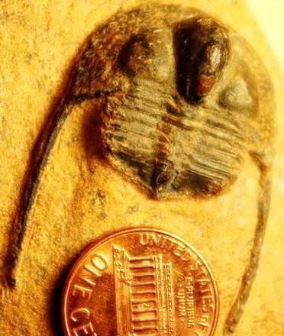
Onnia

Wikimedia Creative Commons http://bit.ly/2jqiqIp

Title: SP17 Production of scaled, annotates scientific drawings of fossils, using a light microscope, or hand lens observation

Specification reference: F3.1d

Aim: To produce scaled, annotated scientific drawings of fossils, using a light microscope, or hand lens observation.

Apparatus:
Hand lens or light microscope Ruler
Plain paper
Soft pencil and eraser A range of fossils

Method:
- Place the fossil in a position which offers the best view of the distinctive features of the fossil.

- If appropriate, plan to draw more than one view of the fossil from differing orientations.

- For observation of finer details a light microscope or hand lens should be used. (If using a hand lens, hold the hand lens in front of one eye, keeping your head up to keep the fossil illuminated, and bring the fossil into focus in front of the hand lens.)

- Draw the key features of the fossil focusing on:
  - The overall shape, considering relative length and height so that the fossil does not appear too short or too elongate in either dimension
  - The location/size/shape of major features
  - The number and shape of minor features.

- Put a scale on the drawing.

- Label or annotate the major and minor features.

- Identify the fossil.

- Give the diagram a title.

Analysis:
None required.

Teacher/Technician notes:
Labels/annotations should include those listed hard parts for relevant fossil groups in the specification section F3.1d.

Title: SP18 Measurement of densities of representative samples of Earth layers (e.g. granite, basalt)

Specification reference: F4.1a

Aim: To measure densities of representative samples of Earth layers (e.g. granite, basalt).

Apparatus:
Samples of rocks representative of Earth layers such as granite, basalt and peridotite. Electronic balance
Water
Graduated (Measuring) cylinder

Method:
- Select a rock sample.

- Determine the mass of the sample using an electronic balance. Record the result.

- To determine volume there are 3 possibilities

  - Immerse the rock sample in the water in the graduated cylinder. Measure how much the water rises (in ml). Record the result. Convert to cm³. (1ml=1cm³); record the result.

  - Place a beaker of water on a balance, zeroing the reading scale.
Suspend the rock sample on a thin thread and record the balance reading. (It is important to suspend the sample in water and not to let it rest on the bottom of the beaker or touch the sides.)
This measurement (recorded in grams) can be converted to a volume for the density calculation (1g = 1cm³).

  - Where the rock sample has a regular shape e.g. cuboid, the volume may be determined directly by measuring the length, width and height of the sample.

- Repeat the process for samples of other rocks representative of Earth layers.

Analysis:

- Calculate the density of the rock samples using the formula Density =

Mass Volume

- Compare the density values you have calculated with published results.

- Discuss possible reasons for any discrepancies found with published results.

Teacher/Technician notes:

Practical techniques which may be assessed:
J. Use appropriate apparatus to record a range of quantitative measurements (to include mass, time, volume, temperature and length).

SP19: Investigation of the relationships between earthquake data (focal depth, magnitude and distance from plate boundaries) using data on Google EarthTM

Specification reference: F4.2b

Aim: To Investigate the relationships between earthquake data (focal depth, magnitude and distance from plate boundaries) using data on Google EarthTM.

Apparatus:
Google Earth Files on computer

Preparation: Go to the following web location:
https://www.usgs.gov/natural-hazards/earthquake-hazards/google-earth-kml-files where links to the following can initially be found.

- Download and install Google Earth
  - Select Download Google Earth (or go direct to https://www.google.com/earth/)

- Download and install the KML file “Tectonic Plate Boundaries”
  - Select Tectonic Plate Boundaries (or go direct to https://www.usgs.gov/media/files/plate-boundaries-kmz-file
- Download and install the KML earthquake data file from:
  - Select Real-Time Earthquakes (or go direct to https://earthquake.usgs.gov/earthquakes/feed/v1.0/kml.php

Recommended is
  - Past 30 Days M2.5+ Earthquakes (automatic feed – updates every 1 minute)
  - Within this there are options for earthquake epicentres to be coloured by age or
depth (both recommended to be downloaded).
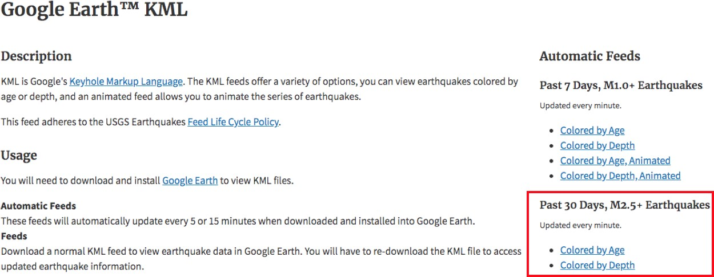

OR

  - Search Earthquake catalog direct from https://earthquake.usgs.gov/earthquakes/search/ From here you can filter for magnitude, date, geographic region and output (lists, KML for mapping on Google Earth, or CSV files for manipulation in Excel)
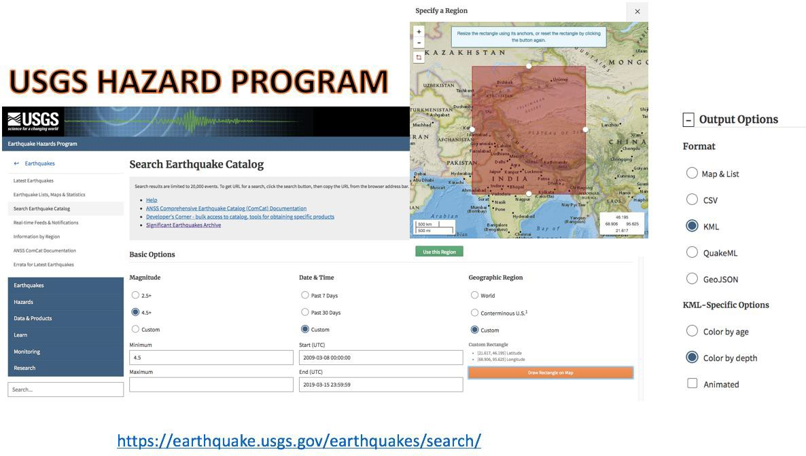

These are the choices as of April 2020.

Method for using the data:

- Select a suitable plate boundary to investigate subduction (e.g. Nazca – South American plate subduction) or not (e.g. Transform – San Andreas Fault).
- Using a suitable sampling technique (if required – depending upon the number of earthquakes available), select individual epicentres and record two variables:
  - depth (obtained by clicking on the epicentre)
  - distance to the plate boundary on the surface (e.g. trench, mid ocean ridge, transform fault).
This can be measured (using the ruler from the menu bar) from the epicentre at right angles to the plate boundary or parallel to the direction of relative motion of the plate as indicated – this could lead to good evaluation on the merits of either.
Ideally a minimum of 30 should be recorded for significant analysis.

(Note: a random or systematic sample can be undertaken on data coloured by age (all the same colour) or a stratified sample on data coloured by depth. In reality, all data may have to be collected if data points are limited, though discussing the options is a good educational experience.)

Analysis:

- Data can be plotted onto a scatter graph to show correlation. Find the best fit line by eye (or by mathematics – slope of a straight line).

- Apply a statistical test to confirm significance – e.g. Spearman’s Rank Correlation Coefficient.

- Conclusions; A comparison of contrasting plate boundaries is very profitable e.g. South America v San Francisco.

Evaluation:

A critical evaluation of the data collection and analysis could be undertaken, in particular the sampling method and the measurement from the epicentre to the plate boundary. (Where actually is the plate boundary on the surface? Is this significant at this scale? Should measurement be at 90º to plate boundary or parallel to the direction of plate movement? Is this significant at this scale?)

Additional options:

Is there any correlation between other variables – e.g. magnitude and depth, magnitude and distance from plate margin?

Teacher/Technician notes:

Practical techniques which may be assessed:
J. Use appropriate apparatus to record a range of quantitative measurements (to include mass, time, volume, temperature and length).

- Use of ICT to:
  - Compile and analyse geological data sets through to visualisation using geographic information system(GIS)
  - Collect, process and model geological data.

Screen shots (5th December 2016)

Nazca Plate/South American subduction earthquakes >2.5
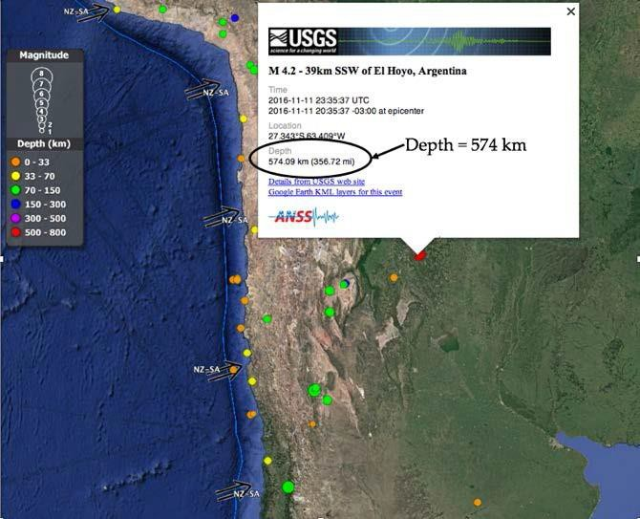
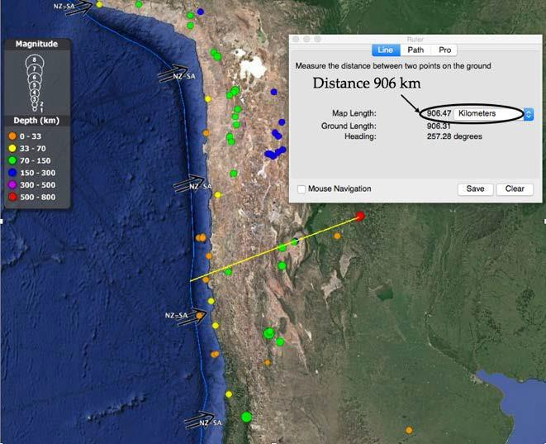
www.google.com/earth

Scatter Graph of the relationship between depth of earthquake foci and the distance of epicentres from the Peru–Chile Trench indicating subduction at a convergent plate boundary.
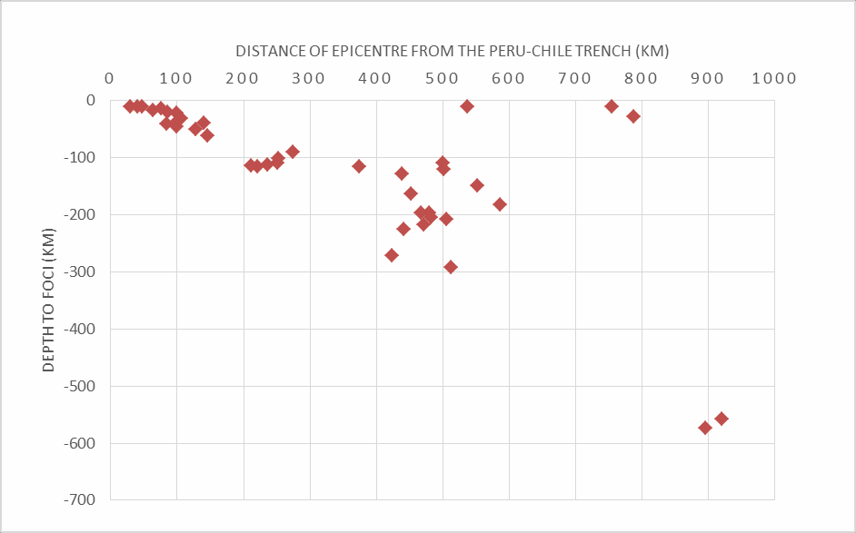
(Data selected from Google Earth on 6th December 2016)
Spearman’s Rank Correlation Coefficient

Depth to earthquake foci (km) | Rank | Distance to plate boundary (km) | Rank | Difference (d) | Difference squared (d²)
-574 | 1 | 895 | 2 | -1 | 1
-558 | 2 | 920 | 1 | 1 | 1
-10 | 38.5 | 755 | 4 | 34.5 | 1190.25
-28 | 31 | 788 | 3 | 28 | 784
-217 | 6 | 471 | 14 | -8 | 64
-292 | 3 | 512 | 8 | -5 | 25
-197 | 9.5 | 468 | 15 | -5.5 | 30.25
-204 | 8 | 482 | 12 | -4 | 16
-208 | 7 | 506 | 9 | -2 | 4
-197 | 9.5 | 480 | 13 | -3.5 | 12.25
-163 | 12 | 452 | 16 | -4 | 16
-225 | 5 | 441 | 17 | -12 | 144
-271 | 4 | 423 | 19 | -15 | 225
-182 | 11 | 587 | 5 | 6 | 36
-149 | 13 | 552 | 6 | 7 | 49
-121 | 15 | 501 | 10 | 5 | 25
-110 | 20 | 500 | 11 | 9 | 81
-114 | 18 | 211 | 26 | -8 | 64
-115 | 17 | 375 | 20 | -3 | 9
-128 | 14 | 439 | 18 | -4 | 16
-90 | 23 | 275 | 21 | 2 | 4
-109 | 21 | 251 | 23 | -2 | 4
-113 | 19 | 236 | 24 | -5 | 25
-102 | 22 | 252 | 22 | 0 | 0
-116 | 16 | 221 | 25 | -9 | 81
-10 | 38.5 | 537 | 7 | 31.5 | 992.25
-31 | 30 | 106 | 30 | 0 | 0
-21 | 32 | 100 | 31.5 | 0.5 | 0.25
-20 | 33 | 86 | 34 | -1 | 1
-10 | 38.5 | 29 | 40 | -1.5 | 2.25
-17 | 34 | 64 | 37 | -3 | 9
-39 | 29 | 141 | 28 | 1 | 1
-41 | 27.5 | 97 | 33 | -5.5 | 30.25
-46 | 26 | 100 | 31.5 | -5.5 | 30.25
-61 | 24 | 146 | 27 | -3 | 9
-51 | 25 | 128 | 29 | -4 | 16
-41 | 27.5 | 84 | 35 | -7.5 | 56.25
-14 | 35 | 76 | 36 | -1 | 1
-11 | 36 | 48 | 38 | -2 | 4
-10 | 38.5 | 41 | 39 | -0.5 | 0.25

d2 = 4059.5

r_{s} = 1− 6Σd ²
n³ − n

rs = 1− 24357/63960 rs = 1 − 0.38
rs = 0.62

This shows a strong positive correlation that is significant at the 99.9% confidence level.

Therefore, the Null Hypothesis (H0) that “there is no significant correlation between the depth of earthquake foci and distance of the epicentres from the plate boundary” can be rejected with a <0.1% probability that this correlation could have occurred by chance.

Title: SP20 Investigation of contact metamorphism using the Metamorphic Aureole simulation experiment

Specification reference: G1.2b

Aim: To investigate contact metamorphism using the Metamorphic Aureole simulation experiment.

In this experiment an intrusion is represented by a tin containing boiling water, and the country rock by sand.

Apparatus:
A large sand-filled container e.g. a plastic sweet tub
A range of tins of varying sizes (all smaller than the large container) Rubber bungs or lids or discs, with holes in, which fit the smaller tins Boiling water
Polystyrene tile or equivalent (to prevent heat loss downwards) inside the base of the tub 5 thermometers (or data logger)
Timer

Method:
- Place the small tin in the centre of the sand-filled container.

- Place four thermometers in the sand as shown in the diagram. Each thermometer should be placed so that the bulb is about 5 cm below the surface.

- Record the temperature shown by each of the four thermometers before pouring the water into the small tin.

- Pour boiling water into the tin and quickly put on the lid.

- Place the fifth thermometer in the hole in the tin lid so that the bulb is 5cm below the lid.

- Record the temperature of the water.

- Start the timer and start recording the temperature shown by each thermometer every two minutes until all thermometers show a decrease in temperature.

- Repeat the experiment using tins of varying sizes.

- The experiment may be repeated using sand with varying levels of water content.

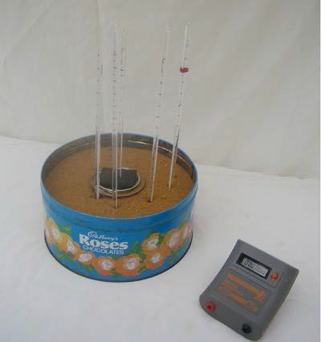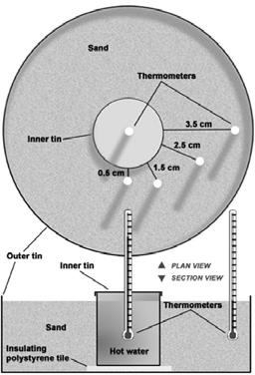

Photograph of the apparatus with digital timer Diagrammatic plan and section view
Earth Science Teachers’Association (ESTA). Reproduced with kind permission of ESTA for use in WJEC material only.

Analysis:
- Plot the data on graph paper or enter the data into a spreadsheet and use it to plot the graphs.

- Determine the peak temperature and time for each thermometer. Where a thermometer maintains a peak time over more than one reading, the peak time can be considered the centre of the peak time range.

Conclusions:
- Consider how temperature changes with distance away from the intrusion.
- Consider how the size of the intrusion affects the size of the metamorphic aureole.
- Consider how the size of the intrusion affects the thermal gradient across the aureole.
- Consider how the temperature at any one place changes with time.
- Consider how the size of the intrusion affects cooling rate.
- Consider how the varying water content of the country rock affects the heat loss from the intrusion and heat transfer within the metamorphic aureole.

Evaluation:
Consider how the experiment might be improved or any additional experiments that could be carried out.

Consider how closely this experiment mirrors heat transfer away from intrusions in metamorphic aureoles. To what extent does this experiment have validity? Do the results obtained reflect what happens to the temperature of the rocks around an intrusion as it cools?

Consider other factors that might affect the rate and extent of heat flow other than the size of an intrusion and the water content of country rocks.

Teacher/Technician notes:

Practical techniques which may be assessed:
J. Use appropriate apparatus to record a range of quantitative measurements (to include mass, time, volume, temperature and length).

- Use methods to increase accuracy of measurements, such as timing over multiple observations, or use of a fiducial (scale in photograph/field sketch).

- Use of ICT to:
  - Compile and analyse geological data sets thought to visualisation using geographic information system(GIS)
  - Collect, process and model geological data.

Details of the experiment, and background teacher/technician notes may be found at: http://www.earthlearningidea.com/PDF/252_Metamorphic_aureole.pdf
A virtual experiment produced by the Earth Science Teachers’ Association (ESTA) is currently supported by the University of Liverpool ‘GeoHub Liverpool’ website, amongst many other online resources for teachers and students on this site. It can be found at:

www.geohubliverpool.org.uk/met/index.htm

It is expected that learners would devise their own data collection tables for this experiment. The experiment is time consuming. It might take up to 90 minutes each time it is undertaken. Consequently, learners may share results related to varying sizes of “intrusion”. When varying water content of the country rock is to be considered, the experiment may need to be run more than once. Data collected in this way may then be compared with that obtained by the virtual experiment simulation and the results evaluated.

