GCSE and GCE
Summer 2022

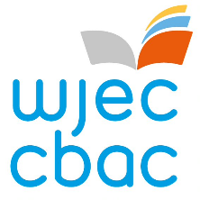

Centre declaration form for NEA Contingencies

Centre Name…………………………………........ Centre Number………………………………………

Subject……………………………………………… Level………………………………………………….

This declaration form should be completed and signed by the teacher where learners have been given permission to undertake work at home, in accordance with the notice-to-centres for WJEC Approved GCSEs, AS and A levels, NEA Contingencies for Summer 2022.

Candidate Name | Candidate Number

DECLARATION BY TEACHER

I certify that the above named candidates are eligible to access the contingency arrangements outlined in the notice-to-centres and that the work has been conducted under the conditions specified in the notice by WJEC.

Teacher signature …………………………………..……....... Date……………………….

