GCSE Applied Science (Double Award) Specified Practical Results
Below are specimen results for the specified practical tasks included in the GCSE Applied Science (double award) specification. They are provided for the purpose of data analysis only. They should not be considered to be model results as there is much possible variation in the set-up described for many of the tasks.

There are a total of 20 specified practicals but two of them do not require results to be collected.

1.1.1 Investigation of the factors that affect the rate of respiration

Concentration of glucose (%) | Number of bubbles produced in 2 minutes
Concentration of glucose (%) | Trial 1 | Trial 2 | Trial 3 | Mean
2 | 18 | 16 | 24 | 19
4 | 24 | 30 | 28 | 27
6 | 32 | 30 | 28 | 30
8 | 44 | 38 | 32 | 38
10 | 42 | 36 | 36 | 38

1.1.2 Investigation into factors affecting enzyme action
Temperature (°C) | Time taken for iodine solution to stay orange/ brown (s)
Temperature (°C) | Trial 1 | Trial 2 | Trial 3 | Mean
20 | 360 | 330 | 360 | 350
30 | 210 | 240 | 180 | 210
40 | 120 | 120 | 120 | 120
50 | 60 | 90 | 90 | 80
60 | 60 | 60 | 90 | 70

1.2.1 Investigation of the efficiency of energy transfer in electrical contexts
Time (s) | Temperature (°C)
0 | 20
60 | 21.5
12 | 23
180 | 24.4
240 | 25.8
300 | 27.2
360 | 28.5
420 | 29.8
480 | 31.1
540 | 32.3
600 | 33.4

1.2.2 Investigation of the factors affecting the output from a solar panel

Distance of solar panel from lamp (cm) | Voltage (V)
Distance of solar panel from lamp (cm) | Trial 1 | Trial 2 | Trial 3 | Mean
20 | 39.9 | 40.0 | 40.1 | 40.0
40 | 24.8 | 24.9 | 24.9 | 24.9
60 | 16.0 | 16.0 | 15.9 | 16.0
80 | 13.1 | 13.0 | 13.2 | 13.1
100 | 10.0 | 10.2 | 10.1 | 10.1

1.2.3 Investigation of the methods of heat transfer
Radiation experiment
 | Time (minutes) | Temperature (ºC)
Black paper | 0 | 15
Black paper | 10 | 35

 | Time (minutes) | Temperature (ºC)
Silver foil | 0 | 15
Silver foil | 10 | 25

Conduction experiment
Metal | Time (s)
copper | 30
brass | 60
iron | 120
aluminium | 40
steel | 140

1.2.4 Investigation of the current-voltage (I-V) characteristics for a component
Filament of a lamp
Current (A) | Voltage (V)
0.00 | 0.0
0.23 | 1.0
0.46 | 2.0
0.61 | 3.0
0.76 | 4.0
0.85 | 5.0
0.94 | 6.0
0.98 | 7.0
1.02 | 8.0
1.04 | 9.0
1.06 | 10.0
1.07 | 11.0
1.08 | 12.0

1.3.1 Determination of the amount of hardness in water using soap solution

Water sample | Number of 1 cm³ volumes  of soap solution added | Total volume  of soap solution added (cm³)
A |  | 2
B | 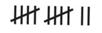 | 12
C |  | 13
D |  | 16
E |  | 13
A - boiled |  | 2
B - boiled |  | 13
C - boiled |  | 3
D - boiled |  | 15
E - boiled |  | 6

1.3.2 Preparation of a biopolymer including the effect of a plasticiser
No results are collected in this practical

1.3.3 Preparation of useful salts (e.g. zinc sulfate)
No results are collected in this practical

2.1.2 Investigation into factors affecting the distribution and abundance of a species
Quadrat number | Number of daisies
1 | 5
2 | 6
3 | 4
4 | 5
5 | 6
6 | 7
7 | 3
8 | 4
9 | 5
10 | 6
11 | 3
12 | 8
13 | 5
14 | 6
15 | 6
16 | 4
17 | 8
18 | 9
19 | 2
20 | 3
21 | 4
22 | 6
23 | 8
24 | 9
25 | 9

2.2 Investigation into how indicator species and changes in pH and oxygen levels may be used as signs of pollution
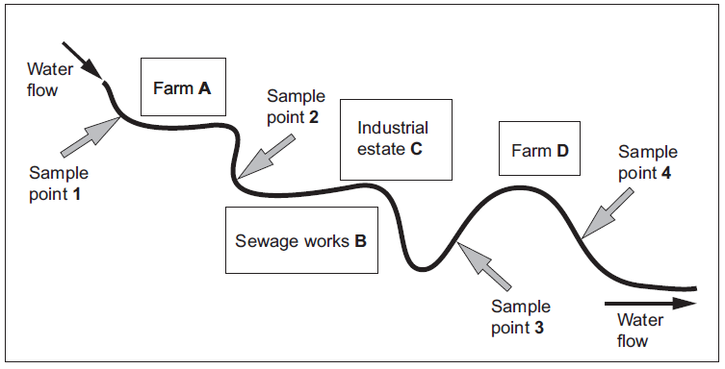
p.t.o.
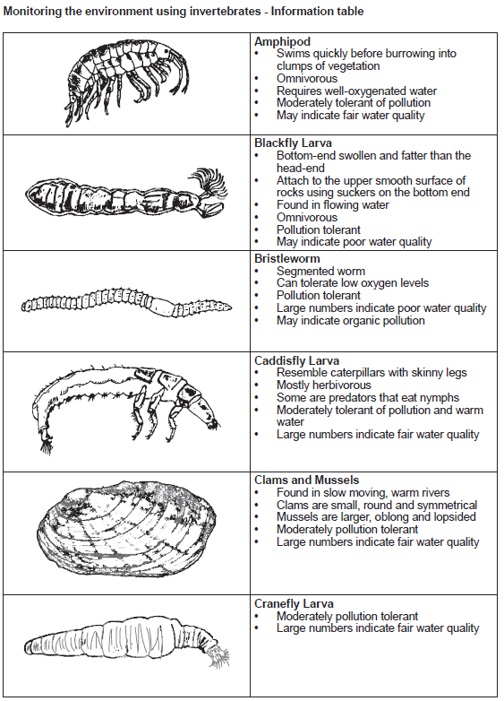
p.t.o
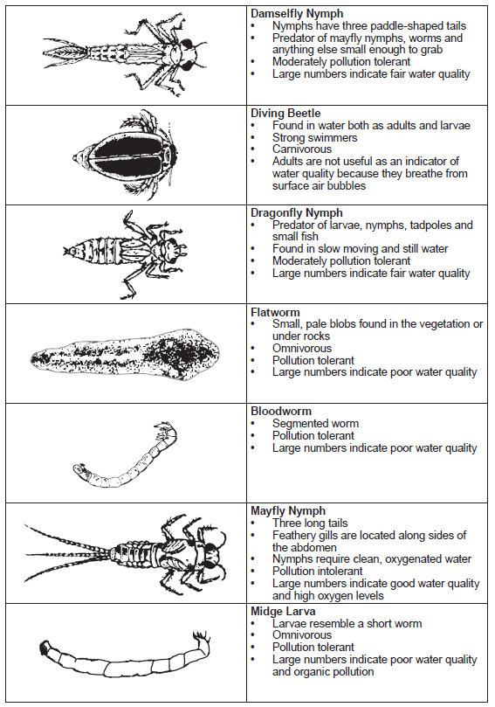
p.t.o

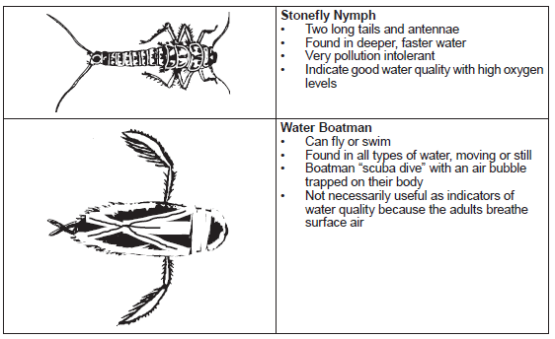
p.t.o

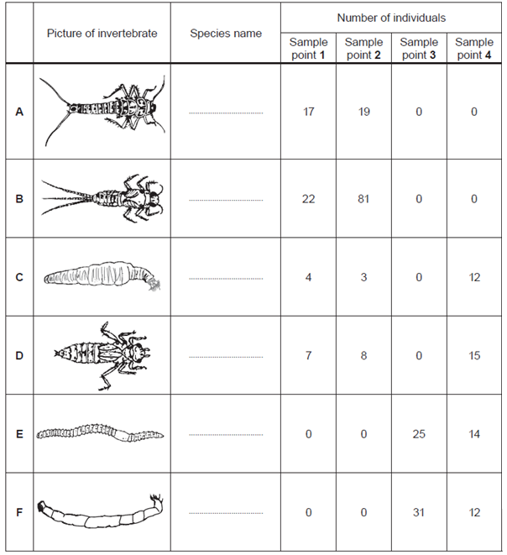

2.3.1 Investigation of the energy content of foods

Type of food | Mass of food (g) | Temperature at start (ºC) | Temperature at end (ºC)
Pasta | 3 | 22 | 65
Rice krispies | 3 | 22 | 44
Chocolate biscuits | 3 | 22 | 75
Wotsit | 3 | 22 | 72
Pea | 3 | 22 | 25

2.3.2 Determination of the half-life of a model radioactive source, e.g. using dice
Roll number | Number of dice remaining |  |  |  |  | Overall class results
Roll number | Group 1 | Group 2 | Group 3 | Group 4 | Group 5 | Overall class results
0 | 50 | 50 | 50 | 50 | 50 | 250
1 | 38 | 42 | 42 | 45 | 45 | 212
2 | 34 | 36 | 39 | 31 | 37 | 177
3 | 30 | 29 | 31 | 26 | 29 | 145
4 | 27 | 25 | 26 | 18 | 23 | 119
5 | 24 | 22 | 22 | 12 | 20 | 100
6 | 20 | 17 | 17 | 9 | 19 | 82
7 | 17 | 15 | 13 | 6 | 15 | 66
8 | 15 | 14 | 10 | 6 | 14 | 59
9 | 12 | 11 | 10 | 4 | 10 | 47
10 | 9 | 9 | 6 | 2 | 6 | 32

2.3.3 Investigation into the effect of antibiotics on bacterial growth

Sample | Brand | Diameter of clear zone (mm)
A | Tesco Value handwash | 15
B | Dove | 9
C | Carex (brand leader) | 10
D | Imperial leather | 5

2.3.4 Determination of the acceleration of a moving object

 | Time (s)
Ramp height (cm) | Trial 1 | Trial 2 | Trial 3 | Mean
10 | 2.95 | 2.90 | 2.94 | 2.93
15 | 2.16 | 2.17 | 2.12 | 2.17
20 | 1.70 | 1.73 | 1.75 | 1.73
25 | 1.49 | 1.52 | 1.23 | 1.41

3.1 Investigation of the thermal conductivity of metals
Metal | Time (s)
copper | 30
brass | 60
iron | 120
aluminium | 40
steel | 140

3.2.1 Investigation of the factors affecting photosynthesis

Distance from lamp (cm) | Number of bubbles produced in one minute
Distance from lamp (cm) | Trial 1 | Trial 2 | Trial 3 | Mean
5 | 79 | 70 | 75 | 75
10 | 60 | 65 | 66 | 46
15 | 34 | 34 | 30 | 33
20 | 17 | 18 | 19 | 18
25 | 17 | 18 | 19 | 18

3.3 Titration of a strong acid against a strong base using an indicator

 | Trial run | Run 2 | Run 3
Final volume (cm³) | 25.90 | 24.10 | 47.95
Initial volume (cm³) | 1.30 | 0.15 | 24.10
Titre (cm³)
Mean titre (cm³)

3.3 Identification of unknown substances using paper chromatography
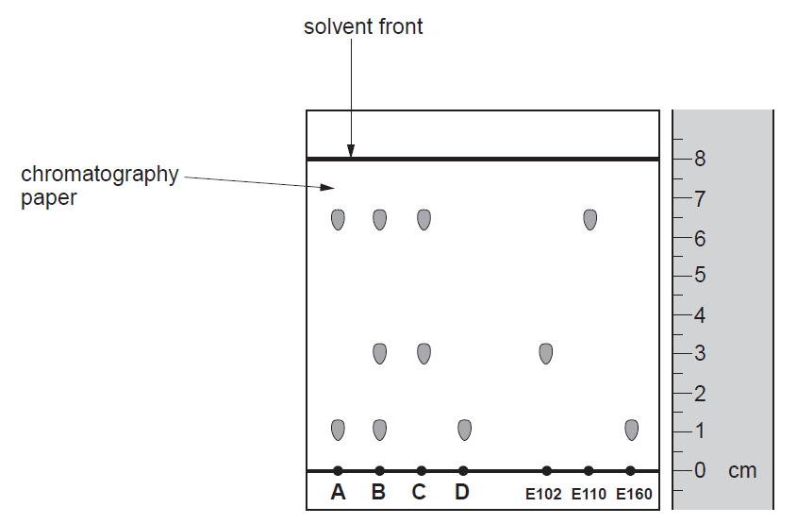

3.3 Identification of unknown ionic compounds using flame tests and chemical tests for ions

Sample | Observations |  |  | Compound
Sample | Flame test | Test for carbonate ions | Test for Group 7 ions | Compound
A | brick-red flame | no change | white precipitate
B | red flame | no change | white precipitate
C | yellow-orange flame | fizzing,  limewater turns milky
D | lilac flame | no change | yellow precipitate
E | lilac flame | no change | cream precipitate

3.4.1 Investigation of the factors that affect the rate of a reaction

Temperature of sodium thiosulfate solution (°C) | Time taken for cross to disappear (s)
15 | 251
25 | 98
35 | 78
45 | 60
55 | 43

