WJEC GCE Religious Studies

A guide to setting your own 'exam-type' questions

The 5 point plan to setting your own AO1 questions

An example of how to set your own test questions using the specification.

Designing AO1 part (a) questions - AO1 expects candidates
to demonstrate knowledge and understanding of religion and belief…

1. START

Decide which area of the specification you wish to test for AO1.
For example…

AS Unit 1: An Introduction to the Study of Buddhism

Theme 2A: The three lakshanas

2. Decide which AO1 Strands you want your questions to focus on
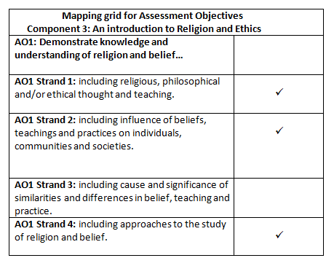

3. Selecting the most appropriate command word for your question

Now select the command word which allows you to fulfil the criteria identified in 1. and 2.

The command words are …..

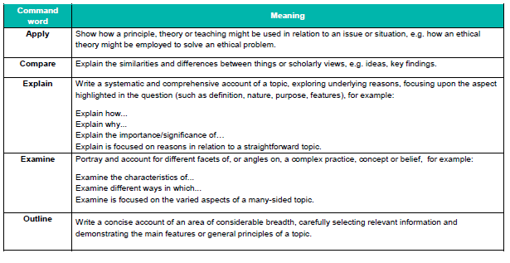

NB Remember that 'Outline' can only be used at AS level.

In this particular case the best fit was .. Examine
Using this command word devise a question which directs candidates to produce the type of response you are expecting in your mark scheme.

Examine Buddhist teachings about anicca and dukkha.

4. Check the wording/demands of your question

When writing a question consider the following as a checklist:

1. Does it meet the specification requirements (clearly related to the specification) and not
go beyond it?
2. Is the terminology used appropriate for 17/18 year olds?
3. Is the language clear and precise?
4. Are both the sentence structure and focus of the question clear?
5. Ask at least two other people to give you feedback on the paper you have set and amend where necessary.

Once you have done the above and made any amendments you need to move on to the next step which is producing the mark scheme.

5. Producing an AO1 mark scheme

Try to develop a mark scheme that is reasonably comprehensive. However, it must be recognised that candidates may produce creditworthy material in their response which are not listed in the mark scheme.
For example, in response to …
Examine Buddhist teachings about anicca and dukkha.
Candidates could include some of the following, but other relevant points will be credited:

- Anicca and dukkha are two of the three lakshanas, marks or
characteristics of existence.
- Anicca means impermanence and insubstantiality and applies to all that is
conditioned. It means that everything is in a constant state of flux; cause
and effect; nothing lasts forever.
- Buddhists see all things (people, objects, states of mind, relationships,
qualities, everything) as being dependent on causes and conditions, and
are therefore constantly changing.
- Dukkha is the first of the Four Noble Truths and is one of the three marks
of existence. Expect candidates to focus on the difficulty with the
translation of ‘dukkha’ into English. It means more than suffering. It is a
diagnosis of the human condition and involves a general dissatisfaction
- with life. Dukkha means a spectrum of experiences from
- unsatisfactoriness through to suffering.
- Dukkha is not only about good things coming to an end. It is about everything being fundamentally imperfect, even if only slightly.
- Candidates may develop the idea of dukkha into three types: dukkha arising from suffering, dukkha arising from mental/emotional pain and dukkha arising from impermanence.
- Buddhists believe that ignorance arises from the failure to appreciate the truth of anicca and dukkha and their universal application.
- Anicca and dukkha are taught so that Buddhists can seek and find enlightenment. They offer diagnoses of the human condition.
This is not a checklist, please remember to credit any valid alternatives.
Check each bullet point against the question to ensure that it is relevant.
When feeding back to students share your mark scheme with them.

The 3 point plan to setting your own AO2 questions

When setting an AO2 question you have TWO options:
- Remember that there are only two command word phrases used for any AO2 questions:
Either "Evaluate the view that…" (before a statement)" or Evaluate this view …." (after a given statement)
3. Devise an AO2 mark scheme.
2a. EITHER
Select one of the bullets that link to the selected area of the spec for (a) e.g.
'The three lakshanas are negative.’
Evaluate this view.
2b. OR
Devise an AO2 question of your own which you think would naturally arise from the area you have used for your AO1 question.

Setting AO2 questions

- Remember that there are only two command word phrases used for any AO2 questions:
Either "Evaluate the view that…" (before a statement)"
or Evaluate this view …." (after a given statement)

2. Either select one of the bullets that link to the selected area of the spec for (a) e.g.
'The three lakshanas are negative.’
Evaluate this view.

(adapted from 2nd AO2 bullet on the AS Spec Theme 2)

Or
Devise an AO2 question of your own which you think would naturally arise from the study of the content in Theme 2.

When writing a question consider the following as a checklist:
1. Does it meet the specification requirements (clearly related to the specification) and not go beyond it?
2. Is the terminology used appropriate for 17/18 year olds?
3. Is the language clear and precise?
4. Are both the sentence structure and focus of the question clear?
5. Ask at least two other people to give you feedback on the paper you have set and amend where necessary.

Once you have done the above and made any amendments you need to move on to the next step which is producing the mark scheme.

3. Devising an AO2 Mark Scheme
Apply the same principles when devising the mark scheme as you did for AO1 – make sure there are examples of clear lines of reasoning and the points made are relevant to the question being asked.
For example:
'The three lakshanas are negative.’
Evaluate this view.

Candidates could include some or all of the following, but other relevant points will be credited.

- Candidates may argue that not everything in life is negative or associated with suffering or unsatisfactoriness. There are happy and pleasant events. The Buddha said that pleasant and happy events were real, but temporary and insubstantial.
- Candidates may argue there are enduring features of life such as human love, inspiring presence of nature, the nature of great art or the desire to do good. The Buddha argued that though enduring, these features were not eternal.
- The idea that Buddhism is negative derives from the problematic mistranslation of the term dukkha as suffering.
- Candidates may argue that it is not negative, just realistic. They may argue that a failure to appreciate the three lakshanas is the cause of a great deal of greed, delusion and suffering.
- Buddhism is realistic in its diagnosis of the human condition; Buddhism is highly positive because it teaches a way out of suffering.
- They may argue that from a Buddhist perspective, seeing the truth of the lakshanas is a significant part of the journey to enlightenment, so rather than being negative it is soteriologically positive.
- A positive feature of anicca (impermanence) for Buddhists is that nobody is fixed as they are, and all have the ability to change and grow. Overall, candidates are expected to engage with the debate and come to a substantiated evaluation regarding the issue.

Overall, candidates should engage with the debate and come to a substantiated evaluation regarding the issue raised.

Setting a complete mock paper for WJEC AS Unit 1 Study of Religion Options A to F

Repeat the process identified in the previous pages but before doing so:
- Decide which Theme you wish to use for Section A of your paper.
- Identify which AO1 strands you will be targeting in your (a) questions – try to include a variety of strands across the questions set in each Unit.
- Once you've completed your Section A questions review them and make sure your Q1 and Q2 are of similar demand.
- Your remaining three questions Q3, Q4 & Q5 must come from the three remaining themes not used in Section (A)
You can either
- (i) set a question on a topic from each of the remaining themes
e.g. if Section A was based on Theme 2, then you could choose
1 x Theme 1, 1 x Theme 3, 1 Theme 4
Or

(ii) set more than one question on one theme e.g. 2 x Theme 3, 1x Theme 4 and leave out Theme 1 completely.
- Once you've completed Section B questions review them and make you’re your Qs 3, 4 and 5 are of similar demand.
- Ask at least two other people to give you feedback on the paper you have set and amend where necessary.

Setting a complete mock paper for WJEC for AS Unit 2
Section A (An Introduction to Religion and Ethics)
or
Section B (An Introduction to Philosophy of Religion)

- Decide which Theme or Themes you wish to use for the two questions needed for Section A or B. Questions can be taken from anywhere within the specification.

- Identify which AO1 strands you will be targeting in your (a) questions – try to include some variety of strands across the questions set in each Unit.

- Once you've completed your Section A questions review them and make sure your Q1 and Q2 are of similar demand.

- Once you've completed Section B questions review them and make you’re your Q3 and Q4 are of similar demand.

- Ask at least two other people to give you feedback on the paper you have set and amend where necessary.

Setting a question or a complete mock paper
WJEC for A level Units 3, 4 and 6.
The process of setting A level questions / a mock paper is similar to AS apart from the fact that:
For Section A
- This section contains AO1 type questions only.
- Only two of these questions are needed for Section A.
- The command word 'Outline' will not be used at A level.
For Section B
- This section contains AO2 questions only.
- Four questions are needed for Section B.
- Questions for this section cannot be taken from exactly the same area of the specification as those used in Section A.

Setting a question or a complete mock paper
WJEC for A level Unit 5 Philosophy of Religion
The process of setting A level questions / a mock paper is similar to AS apart from the fact that:
For 2021 Unit 5 only, due to an approved adaptation of the specification, no questions should be set on Theme 4:Religious Language (Part 2). Please do not include this theme when creating your mock paper.

For Section A
- This section contains AO1 type questions only.
- Only two of these questions are needed for Section A.
- The command word 'Outline' will not be used at A level.
For Section B
- This section contains AO2 questions only.
- Four questions are needed for Section B.
- Questions for this section cannot be taken from exactly the same area of the specification as those used in Section A.

